Introduction and Transport-Layer Services
The purpose of the transport layer is to connect the network layer’s delivery service between two end systems to a delivery service between two application-layer processes running on the end systems.
The transport layer provides logical communication between application processes running on different end hosts. Logical communication means that from the application's perspective, the two processes appear to be directly connected and exchanging messages, even if they are physically separated by vast networks with numerous routers and various link types.
Application processes use the logical communication provided by the transport layer to send messages to each other, free from the worry of the details of the physical infrastructure used to carry these messages.
Key Responsibilities:
- Process-to-Process Communication: Enables applications on different hosts to exchange data seamlessly.
- Message Segmentation: Breaks application messages into smaller chunks called segments.
- Header Addition: Adds a transport-layer header to each segment to manage communication.
Implementation and Function
- Implemented in End Systems: Transport-layer protocols (like TCP and UDP) are only implemented and run in the end systems (the hosts), not in the network routers.
- Segmentation: On the sending host, the transport layer takes application-layer messages and divides them into smaller transport-layer segments. It adds a transport-layer header to each chunk before passing the segments down to the network layer.
- Encapsulation: The network layer then encapsulates the transport-layer segment within a network-layer packet (a datagram) and routes it toward the destination.
- Router Behaviour: Network routers only examine the network-layer header for IP address in datagram to determine the route. they ignore the transport-layer segment data inside the datagram.
- Delivery: On the receiving host, the network layer extracts the segment and passes it up to the transport layer, which then makes the data available to the correct receiving application process.
Protocol Options
The Internet offers two main transport-layer protocols:
- TCP (Transmission Control Protocol): Provides reliable, connection-oriented communication.
- UDP (User Datagram Protocol): Provides simple, connectionless datagram service.
Applications choose between TCP and UDP based on their specific requirements for reliability, timing, and overhead.

Relationship Between Transport and Network Layers
Transport layer relies on network layer’s services to send and receive messages. Transport layer enhances Network layer services.
Household Analogy:
- Two houses (East Coast & West Coast) = Hosts/End systems
- 12 kids in each house = Application processes
- Letters between kids = Application messages
- Ann & Bill (who collect/distribute mail within each house) = Transport layer
- Postal service (moves mail between houses) = Network layer
Each kid writes a letter to each kid living in other house. Total of 144 letters are sent every week from each house to the other house.
From East Coast house, Ann is responsible for collecting mail from all kids in the house and handing it to the postal service. When the mail arrives to the East Coast from West Coast, Ann is again responsible for collecting mail from the postal service/mail man and distributing it to the kids in the house correctly. Bill has the same responsibilities in the West Coast house.
Transport Layer (Ann & Bill):
- Operates only within end systems (like Ann and Bill work only inside their houses)
- Does not exist in network routers (just as Ann and Bill don't work at postal sorting facilities)
- Moves data between application processes (brothers & sisters) and the network layer/edge (postal service/mail man)
- Can offer different service models (like different cousins might provide different mail handling)
Network Layer (Postal Service):
- Moves data between hosts (houses) across the entire network
- Routers only examine network-layer headers (postal workers only look at external addresses)
- Cannot read transport-layer information (postal workers don't open envelopes)

Transport vs. Network Layer
The core difference lies in the scope of communication:
- Network Layer (Host-to-Host): Provides logical communication between hosts (end systems). In the analogy, this is the postal service, which reliably moves mail from one house (host) to another.
- Transport Layer (Process-to-Process): Provides logical communication between application processes running on those hosts. In the analogy, this is the mail organizer (Ann or Bill) within each house, who collects mail from and delivers it to the individual kids (processes).

Service Relationship
- Transport layer services are constrained by network layer capabilities:
  - If network layer can't guarantee delivery time, transport layer can't either
  - If network layer has limited bandwidth, transport layer is similarly limited
- But transport layer can enhance network services:
  - Can provide reliability even over unreliable networks (via retransmissions)
  - Can add encryption even if network layer doesn't provide confidentiality
  - Can implement flow control regardless of network conditions
  - Can offer multiple transport protocols (like TCP and UDP)
  - Can provide different service models (e.g., reliable, unreliable, different delays) to application processes.

Overview of the Transport Layer in the Internet
The Internet provides applications with two primary transport-layer protocols: UDP and TCP, which enhance the network layer services.
The Underlying Network Layer (IP)
Before discussing UDP and TCP, it is essential to understand the Internet's network layer:
- Protocol: IP (Internet Protocol).
- Service Model: Best-Effort Delivery Service. IP attempts to deliver data between end hosts but provides no guarantees. IP is said to be an unreliable service.
- Unreliability: IP does not guarantee segment delivery, orderly delivery, or data integrity (it is an unreliable service). Every host is identified by an IP address. Every host has at least one IP address

Two Transport Protocol Options:
- UDP (User Datagram Protocol): Unreliable, connectionless service
- TCP (Transmission Control Protocol): Reliable, connection-oriented service
1. User Datagram Protocol (UDP)
UDP provides only two basic services beyond IP:
- Service Model: Unreliable, Connectionless Service.
- Services Provided:
  - Process-to-Process Data Delivery via sockets: Extends IP's host-to-host delivery service to a process-to-process delivery service for applications running on the hosts using a mechanism called multiplexing/demultiplexing.
  - Error Checking: Includes error-detection fields in its header to ensure data integrity.
- Nature: UDP is an unreliable service, just like IP. It offers no guarantees of delivery, order, or flow control. Applications using UDP can send data at any rate they choose (unregulated).
3. Transmission Control Protocol (TCP)
- Service Model: Reliable, Connection-Oriented Service.
- Services Provided:
  - Process-to-Process Data Delivery and Error Checking (like UDP).
  - Reliable Data Transfer: Uses techniques like sequence numbers, acknowledgments, timers, and flow control to guarantee that data is delivered correctly and in order, converting IP's unreliable end-to-end delivery into a reliable process-to-process delivery.
  - Congestion Control: A "service for the general good" that regulates the sending rate of connections to prevent a single connection from overwhelming the network links and routers.
Terminology Note: Both the TCP and UDP transport-layer packets are commonly referred to as segments to avoid confusion with the network-layer packet, which is called a datagram.
Key Differences:
Feature | UDP | TCP
Reliability | Unreliable | Reliable
Connection | Connectionless | Connection-oriented
Delivery Guarantees | None | In-order, error-free delivery
Congestion Control | No | Yes
Traffic Regulation | Unregulated | Rate-controlled
Complexity | Simple | Complex

Multiplexing and Demultiplexing
Multiplexing and Demultiplexing are the fundamental processes that allow the transport layer to extend the network layer's host-to-host delivery service to a process-to-process delivery service.
The Problem:
- A host runs multiple applications simultaneously (e.g., web browser, email, FTP)
- When data arrives from the network, the transport layer must deliver it to the correct application process
- Each process has one or more sockets (communication endpoints)
The Solution:
- Multiplexing (Sender Side): The transport layer at the source host collects data chunks from different application sockets, adds a transport-layer header (including essential addressing information) to each data chuck, and passes the resulting segments down to the network layer.
  - Multiplexing requires (1) that sockets have unique identifiers, and (2) that each segment have special fields that indicate the socket to which the segment is to be delivered. These special fields are the source port number field and the destination port number field.
- Demultiplexing (Receiver Side): The transport layer at the destination host receives segments from the network layer. It is responsible for examining the segment header and directing the data to the correct socket and the application process attached to it.
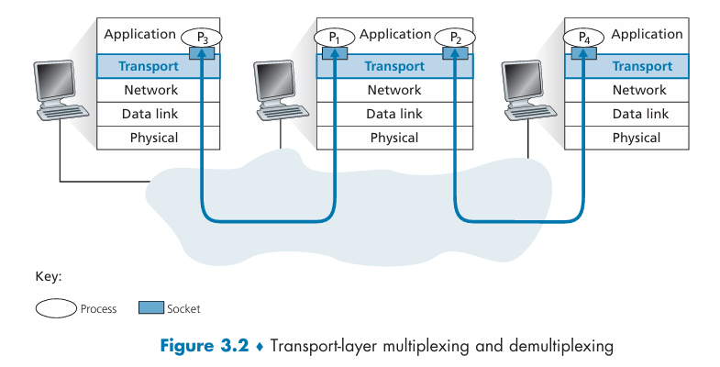
The transport layer in the middle host must demultiplex segments arriving from the network layer below to either process P1 or P2 above; this is done by directing the arriving segment’s data to the corresponding process’s socket. The transport layer in the middle host must also gather outgoing data from these sockets, form transport-layer segments, and pass these segments down to the network layer.

How it works in UDP
The transport layer performs demultiplexing using two key fields in the segment header: Port Numbers.
- Sockets and Identifiers: An application process uses one or more sockets as a "door" to the network. Every socket on a host must have a unique identifier. For both UDP and TCP, this identifier includes port numbers.
- Port Number Fields: Every transport-layer segment contains a source port number and a destination port number. These are 16-bit numbers (0 to 65535). Ephemeral/temporary ports - dynamically assigned for client applications.
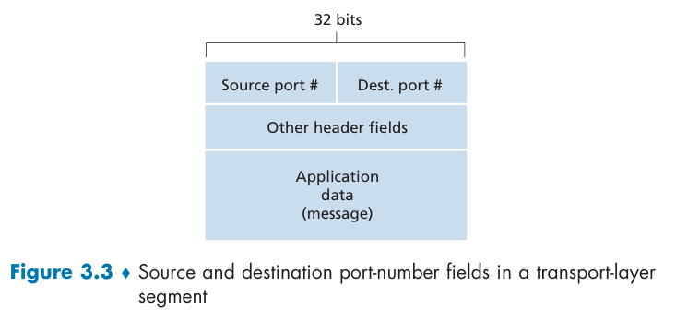
- Well-Known Ports: Port numbers 0 to 1023 are reserved as well-known ports for standard applications (e.g., HTTP uses 80, FTP uses 21). Applications that you develop must use unreserved port numbers.
- The Process:
- At the Sender (Multiplexing):
- Gather data from multiple application sockets
- Add transport header with source/destination port numbers (later used for demultiplexing)
- Pass segments to network layer
- At the Receiver (Demultiplexing):
- Examine destination port number in incoming segment
- Direct segment to the socket associated with that port
- Data passes through socket to the correct application process
- In detail:
  - Host receives IP datagrams:
    - Each datagram has source and destination IP address
    - Each datagram carries one transport-layer segment
    - Each segment has source and destination port number
  - Host uses IP addresses & port numbers to direct segment to appropriate process
This port-number system is the basic mechanism used by UDP to direct data to the correct application process.

Connectionless Multiplexing and Demultiplexing
The User Datagram Protocol (UDP) provides a connectionless method for directing data to the correct application process on a host. UDP provides simple, connectionless multiplexing and demultiplexing using port numbers.

UDP: Stateless
- Meaning: The server does not remember any information about previous interactions with clients.
- How it works:
  - Each UDP segment is processed independently
  - The server handles each incoming datagram without any knowledge of previous datagrams
  - No connection establishment or teardown
  - No memory of which clients have communicated with it
- Example: A UDP server receiving multiple requests from the same client treats each request as completely new and unrelated.
- UDP = Postal Mail: Each letter is independent; the post office doesn't remember your previous letters.

An ephemeral port is a temporary port number automatically assigned by an operating system to an outbound network connection, typically for client-side communication. They are temporary and dynamically assigned, making them less predictable than well-known ports. They are crucial for client-initiated connections, handling client-to-server communications and the return traffic from the server.

1. Assigning Port Numbers to Processes
- Sockets as Doors: Every application process that wants to send or receive data creates a UDP socket. This socket is the "door" through which data enters or leaves the network.
- Port Numbers: The transport layer associates a port number (a 16-bit identifier) with each UDP segment.
  - Servers: Typically use well-known port numbers (0-1023) so clients always know where to find the service (e.g., a DNS server uses port 53).
  - Clients: Usually let the operating system automatically assign an ephemeral port number (1024-65535) that is currently unused.
- Automatic Port Assignment:
  - Transport layer automatically assigns an unused port number between 1024-65535 on client side.
- Manual Port Assignment:
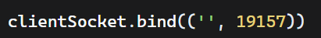

2. The Demultiplexing 2-tuple Key
It is important to note that a UDP socket is fully identified by a two-tuple consisting of a destination IP address and a destination port number.
Crucial Rule for UDP:
If two different UDP segments arrive at a host, even if they originated from different source IP addresses and different source ports, they will be directed to the same destination process via the same destination socket as long as they share the same destination IP address and destination port number.

How UDP Multiplexing/Demultiplexing Works
Scenario: Process in Host A (port 19157) sends data to Host B (port 46428)
At Sender (Host A) - Multiplexing:
- Creates UDP segment with:
  - Application data
  - Source port: 19157
  - Destination port: 46428
- Passes segment to network layer for delivery
At Receiver (Host B) - Demultiplexing:
- Examines destination port number in arriving segment (46428)
- Delivers segment to the process bound to port 46428
- Multiple processes can run simultaneously, each with different port numbers

3. Why is the Source Port Needed?
When creating a datagram to send into UDP socket, we must specify destination IP address and port #, but the source IP address and port # are automatically filled in by the network and transport layers. While the destination port handles demultiplexing, the source port number is essential for a reply. The source port serves as a "return address".
- When Host B receives a segment from Host A, it extracts the source port from the incoming segment.
- If Host B needs to send a reply back to Host A, it uses that extracted source port number as the destination port number in the return segment.
This ensures the reply segment is delivered back to the exact client process that initiated the conversation.
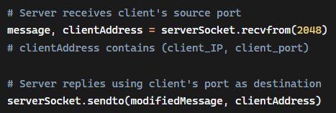
Key Characteristics of UDP Multiplexing
- Connectionless: No connection establishment
- Stateless: Server doesn't maintain connection state
- Simple: Based only on destination IP and port
- Bidirectional: Source port enables two-way communication

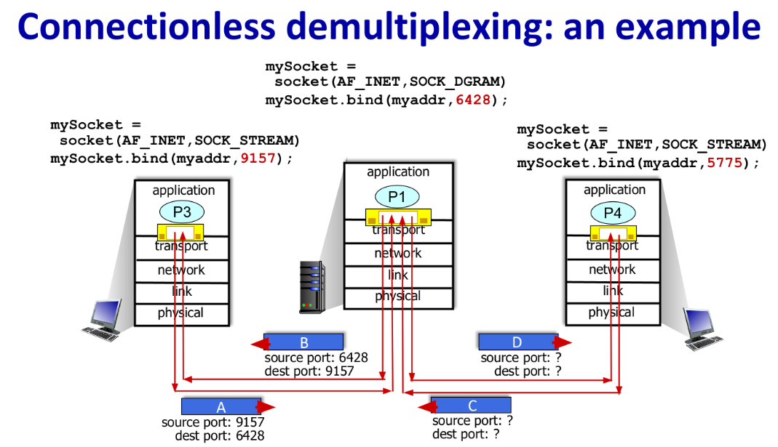

Example:
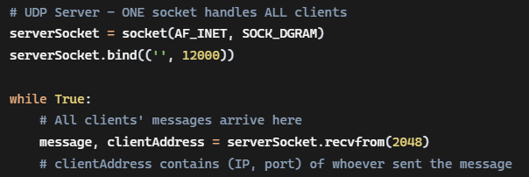
- Requests from Client A, Client B, Client C all arrive at the same socket
- The server must manually track which client is which using their source (IP, port) tuple
- No automatic connection tracking - the server does the demultiplexing manually
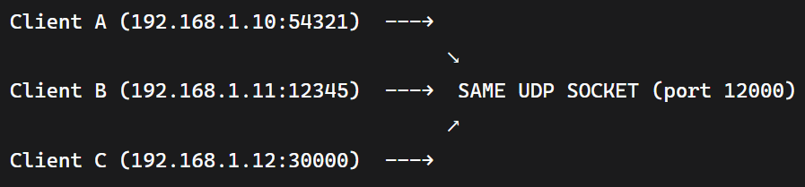
All messages from all clients arrive at the same recvfrom() call. All clients block each other on the same recvfrom().
The server must:
- Extract client identity from each received message
- Manually track state if needed (unlike TCP which does this automatically)
- Send responses to the correct (IP, port) tuple
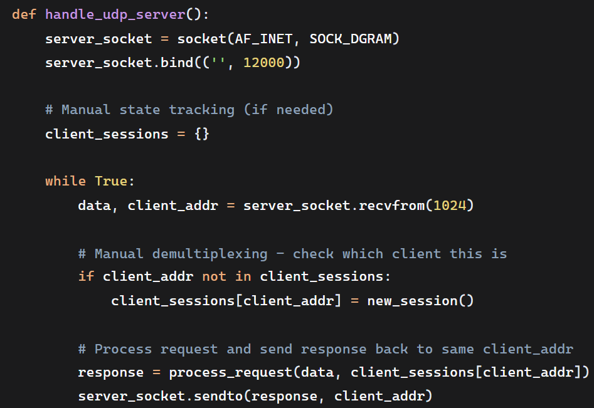
TCP | UDP
Each connection → New socket | All clients → Same socket
Automatic demultiplexing | Manual demultiplexing
OS tracks connections | Application tracks clients
accept() creates new sockets | recvfrom() gets all messages

Connection-Oriented Multiplexing and Demultiplexing
The Transmission Control Protocol (TCP) uses a more sophisticated method for demultiplexing because it is connection oriented.

TCP: Stateful
- Meaning: The server maintains state information about each connection as long as the connection is not closed. State is maintained ONLY during the connection's lifetime. Once a TCP connection is fully closed, all state information is destroyed. The server does not remember anything about closed connections.
- TCP is connection-stateful but session-stateless. It meticulously maintains state during a connection but completely forgets everything after the connection closes. Each new connection starts with a clean slate, regardless of previous interactions with the same client.
- How it works:
  - Connection Establishment: Remembers the three-way handshake
  - Sequence Numbers: Tracks which bytes have been sent/received
  - Acknowledgments: Remembers what data has been acknowledged
  - Flow Control: It ensures the sending application doesn't transmit data faster than the receiving application can process it. Maintains window size information. The receiver advertises a buffer size, the window size, to the sender to indicate how much data receiver can receive before needing an acknowledgment from the receiver. Once the sender transmits the maximum amount of data allowed by the window size, it must stop and wait for an acknowledgment (ACK). When the receiver is ready for more data, it sends an Acknowledgment (ACK) segment back to the sender. The ACK not only confirms receipt of data but also includes the next byte the receiver expects, allowing the sender to continue.
  - Connection Termination: Manages the graceful connection close
- Example: A TCP server knows exactly where you are in a file transfer, what data you've received, and what should come next.

TCP Socket Identification
- A TCP socket is identified by a four-tuple:
  - Source IP address
  - Source port number
  - Destination IP address
  - Destination port number
- Unlike UDP: Two arriving TCP segments with different source IPs or source ports will be directed to different sockets (except for initial connection requests).

The Key Distinction from UDP
- In UDP, two segments arriving from different sources but going to the same destination port are sent to the same socket in the same process.
- In TCP, if two arriving segments differ in any one of the four values (Source IP, Source Port, Destination IP, or Destination Port), they are automatically directed to different sockets in the same process. This strict matching ensures that data for different connections never gets mixed up. A single process can have a practically unlimited number of sockets, as the limit is set by system resources like memory and file descriptors, not by a theoretical maximum.
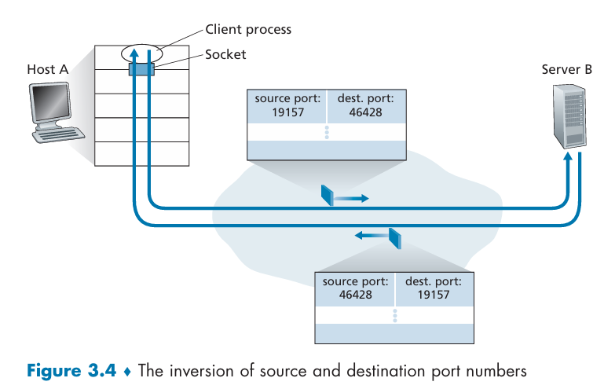
The Server's Role in Establishing a Connection
The process uses two types of sockets:
- Welcoming Socket: A server starts with a "welcoming socket" that waits on a specific, well-known port (e.g., port 80 for HTTP). This socket is responsible for listening for connection requests.
- Connection Establishment: When a client sends a connection request segment:
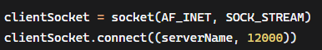
  - The server's host receives the segment (identified by its destination IP and the welcoming port).
  - The server process creates a brand-new connection socket and notes the four-tuple from the request segment.
  - This new socket is instantly bound to the four-tuple extracted from the incoming request segment.
  - All subsequent segments for this specific conversation will now be demultiplexed (directed) to this new, unique connection socket.
This mechanism allows a single server host to simultaneously manage many separate TCP connections, even if they all share the same destination port number (like port 80) and destination IP address.
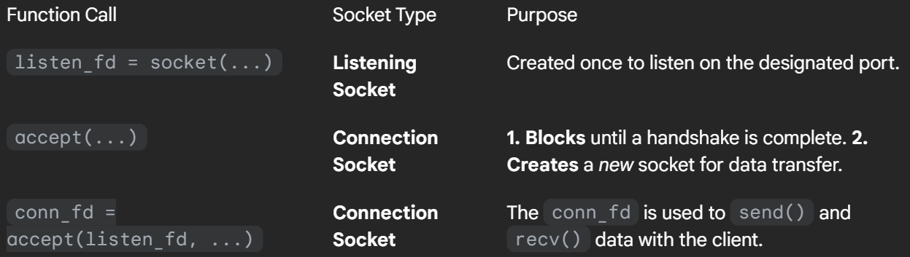
Example Scenario:
- Host C establishes 2 HTTP connections to Server B:
  - Connection 1: (C_IP, 26145, B_IP, 80)
  - Connection 2: (C_IP, 7532, B_IP, 80)
- Host A establishes 1 HTTP connection to Server B:
  - Connection 3: (A_IP, 26145, B_IP, 80)
Key Insight: Even though Connections 1 and 3 have the same source port (26145), they have different source IP addresses, so Server B can distinguish them and direct them to different sockets.
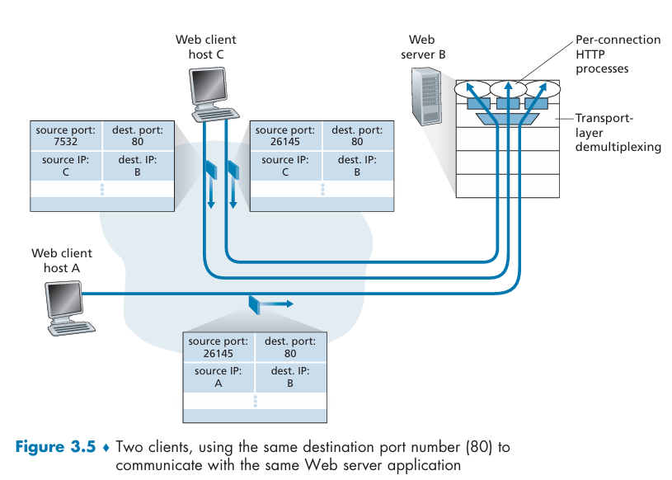

Web Servers and TCP
Web servers, such as Apache, typically run on the well-known port 80 (or 443 for HTTPS). Because a server might handle thousands of clients simultaneously, it must efficiently manage all these concurrent TCP connections.
1. Distinguishing Clients
When multiple clients (browsers) connect to the server:
- Common Destination: All incoming segments—for initial connection and for HTTP messages—have the same destination port (80) and the same destination IP address (the server's IP).
- Unique Identification: The server uses the client's unique source IP address and source port number to distinguish between different clients. The combination of these four values (the four-tuple) ensures each conversation goes to the correct internal socket.
2. Managing Connections Internally
High-performance Web servers efficiently manage connections in one of two ways:
- Processes (Older/Simpler): The server could spawn a completely new process for every new client connection. Each process would have its own unique connection socket.
- Threads (Modern/High-Performance): Modern servers often use only one main process but create a new, lightweight thread (a subprocess) and a new connection socket for each client. This approach is more efficient as threads share resources within the main process.
3. Persistent vs. Non-Persistent HTTP
- Persistent HTTP: If the client and server use persistent connections, they exchange all HTTP messages (requests and responses) using the same TCP connection and the same server socket.
- Non-Persistent HTTP: A new TCP connection (and thus a new connection socket) is created and immediately closed for every single request-response cycle. This frequent creation and destruction of sockets can negatively impact the performance of a busy server.
In essence, the server relies on TCP's four-tuple addressing scheme to manage hundreds of simultaneous, distinct conversations all directed at the same single port (80).

Connectionless Transport: UDP
UDP takes messages from the application process, attaches source and destination port number fields for the multiplexing/demultiplexing service, adds two other small fields (length & checksum), and passes the resulting segment to the network layer.
The network layer encapsulates the transport-layer segment into an IP datagram and then makes a best-effort attempt to deliver the segment to the receiving host. If the segment arrives at the receiving host, UDP uses the destination port number to deliver the segment’s data to the correct application process. Note that with UDP there is no handshaking between sending and receiving transport-layer entities before sending a segment. For this reason, UDP is said to be connectionless. DNS is an example of an application-layer protocol that typically uses UDP.
UDP Segment Structure
Its header has only four fields, each two bytes long, resulting in a total header overhead of just 8 bytes.
- Only 8 bytes of header overhead (vs TCP's 20 bytes)
- Contains: source port, destination port, length, checksum

Why Applications Choose UDP
1. Application Control & Timing
- Immediate sending - no delays from congestion control
- No retransmissions - important for real-time applications
- Predictable timing - critical for voice/video
2. No Connection Setup
- Zero handshake delay - DNS would be much slower over TCP
- QUIC protocol builds reliability in application-layer on top of UDP to avoid TCP delays
3. No Connection State
- Servers support more clients - no per-connection state to maintain
- Stateless - scales better for simple request-response
4. Small Header Overhead in Segment
- 8 bytes vs 20 bytes in TCP segment
- Less bandwidth consumed

Common UDP Applications
- DNS: Avoids connection setup delays
- Real-time multimedia: Voice, video conferencing, streaming
- SNMP: Network management (must work when network is stressed)
- QUIC Protocol (Quick UDP Internet Connection): Google's reliable protocol built over UDP

Important Considerations
Congestion Control Problem:
- UDP has no built-in congestion control
- Can overwhelm networks and crowd out TCP traffic
- Researchers recommend adding congestion control to UDP applications
Reliability When Needed:
- Applications can build their own reliability on top of UDP
- QUIC implements retransmissions and flow control at application layer
- Allows reliability without TCP's rate constraints

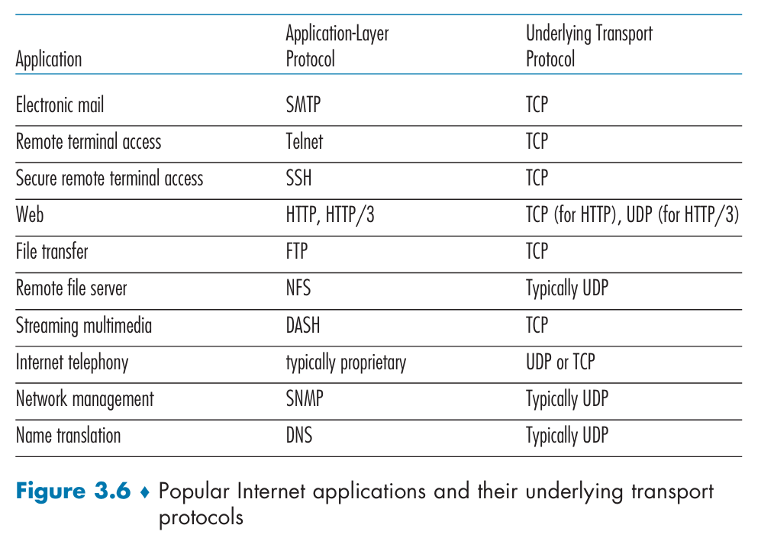

UDP Segment Structure
The UDP header is the simplest of the transport protocols, consisting of only four fields, each 2 bytes long, totaling 8 bytes of overhead.
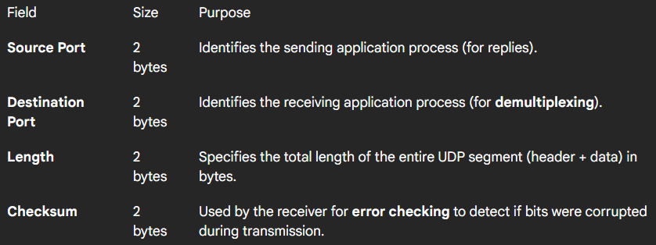
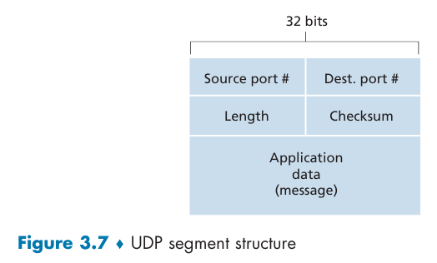
Key Characteristics
- Fixed 8-byte header (vs TCP's 20+ bytes)
- No sequence numbers, ACKs, or flow control
- Simple structure = fast processing
- Explicit length field needed for variable payload sizes
The application data is contained in the Data Field immediately following this 8-byte header. The explicit Length field is necessary because the amount of application data can vary from one segment to the next.

UDP Checksum
The UDP Checksum is an error detection field used to determine if any bits in the UDP segment have been altered (corrupted) during transit, possibly by noise or while the segment was stored in a router's memory.
Calculation and Verification
- Sender Calculation:
  - The sender treats the entire segment (header and data) as a series of 16-bit words.
  - It calculates the 1s complement of the sum of all these 16-bit words, wrapping any overflow back into the sum.
  - This final result is placed into the 2-byte Checksum field of the UDP header.
- Receiver Verification:
  - The receiver adds all four 16-bit words together, including the received checksum.
  - If the result is (all ones), the segment is considered error-free.
  - If any bit is a 0, the receiver knows that errors were introduced.
Importance (The End-End Principle)
The checksum is necessary because UDP implements error detection on an end-to-end basis.
- Why it's needed: Even though many lower-layer protocols (like Ethernet at the link layer) also provide error checking, there is no guarantee that all links use error checking, nor is there a guarantee that errors won't occur when the segment is briefly stored in a router's memory.
- Result: Because error detection must be done end-to-end to be useful, UDP provides it at the transport layer as a safety measure.
Error Recovery
UDP provides error detection but no error recovery. If the checksum indicates an error, the UDP implementation on the receiving host typically either:
- Simply discards the corrupted segment.
- Passes the damaged segment to the application with a warning.
Why UDP Needs Its Own Checksum
1. Not All Links Provide Error Checking
- Some link-layer protocols don't have error detection
- Cannot rely on every link in the path to check for errors
2. Router Memory Errors
- Bits can be corrupted when stored in router memory
- Link-layer checks happen before storage, not after
3. End-to-End Principle
- Critical functionality should be implemented at the endpoints
- Lower-layer error checking may be redundant or incomplete
- End-to-end checking catches errors that occur anywhere along the path
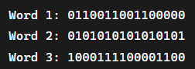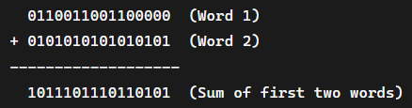
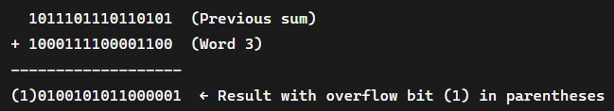
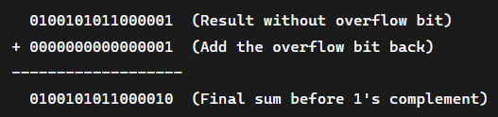
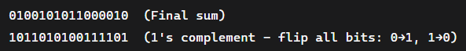
Verification at Receiver
Add all four words (original data + checksum):
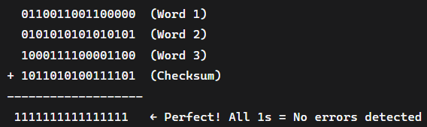
Check is performed at multiple layers in networking:
Layer 2 (Data Link Layer)
- Protocol example: Ethernet.
- Function: Verifies the integrity of data frames within a local network segment, providing a basic error check.
- Scope: The checksum covers all fields in the Layer 2 frame.
Layer 3 (Network Layer)
- Protocol example: IP (Internet Protocol).
- Function: Checks the integrity of the IP header, ensuring that the routing information is accurate.
- Scope: The IP checksum typically covers only the IP header itself.
Layer 4 (Transport Layer)
- Protocol examples: TCP (Transmission Control Protocol) and UDP (User Datagram Protocol).
- Function: Guarantees the integrity of the entire segment, including both the transport layer header and the payload data.
- Scope: This checksum covers the header, the data, and a "pseudo-header" with information from the IP layer.

Principles of Reliable Data Transfer
TCP is a reliable data transfer protocol that is implemented on top of an unreliable (IP) end-to-end network layer. Reliable data transfer protocols must add mechanisms to detect and recover from the unreliability of lower layers, which creates the illusion of a perfect communication channel for upper layers.
Reliable data transfer is a fundamental networking problem that occurs at multiple layers (transport, link, application). The goal is to create a reliable channel from an unreliable underlying channel.
- We use "packet" instead of "segment" since these principles apply broadly
- The concepts work for link-layer, transport-layer, and application-layer protocols

The Reliable Channel Service Model
The goal of an RDT protocol is to create a reliable channel abstraction over an unreliable underlying channel (like IP). A reliable channel guarantees:
- No data corruption (bits aren't flipped)
- No data loss
- In-order delivery (data arrives in the same sequence it was sent)
- This is exactly what TCP provides to Internet applications

How RDT is Implemented at Transport Layer
RDT protocols (like TCP) must implement this reliable service on top of a lower layer (the unreliable point-to-point channel) that might:
- Corrupt bits in packets.
- Lose entire packets.
The RDT protocol achieves reliability by having the sender and receiver exchange control packets (acknowledgements) back and forth, in addition to the data packets.
- Unidirectional Focus: Although RDT is often discussed in terms of unidirectional data flow (data from sender to receiver), it still requires bidirectional control packets to manage reliability.
- Interfaces: The reliable protocol uses functions like rdt_send() and rdt_rcv() to interact with the applications and the unreliable channel below (udt_send()).
End-to-End Problem: RDT is a problem that appears at multiple layers (transport, link, application), making the principles developed here crucial for all of networking.

Protocol Framework & Interface
1. Function: rdt_send()
- Used by: Application Layer (or upper layer)
- When called: When the application has data to send reliably
- Purpose: Initiates reliable data transfer
2. Function: udt_send()
- Used by: Reliable Data Transfer (RDT) Protocol (transport/link layer)
- When called: When the protocol needs to send anything over the unreliable channel
- Purpose: Send packets (data or control) via the underlying unreliable channel
3. Function: rdt_rcv()
- Used by: Network layer (or lower layer)
- When called: When a packet arrives from the lower unreliable channel
- Purpose: Process incoming packets (data or control)
4. Function: deliver_data()
- Used by: Reliable Data Transfer (RDT) Protocol (transport/link layer)
- When called: When the protocol has successfully received and verified data
- Purpose: Deliver reliable data to the upper layer
Data Flow:
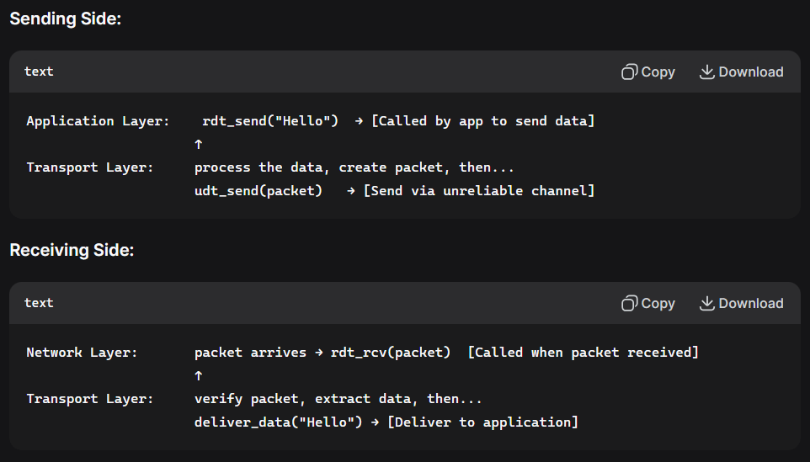
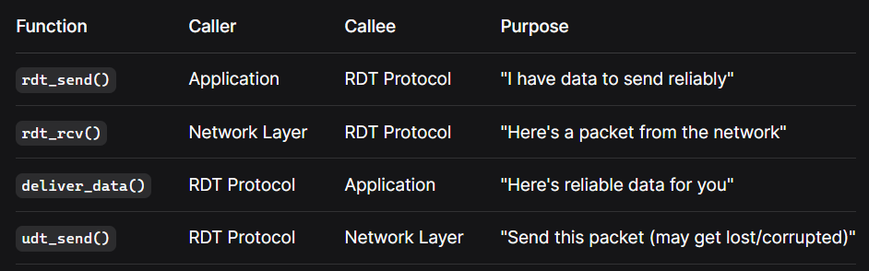
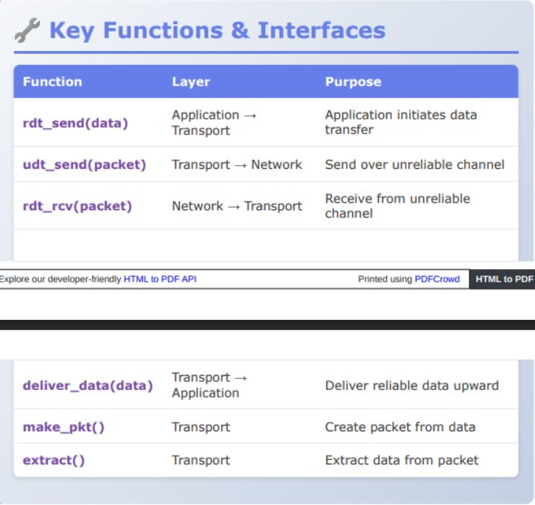
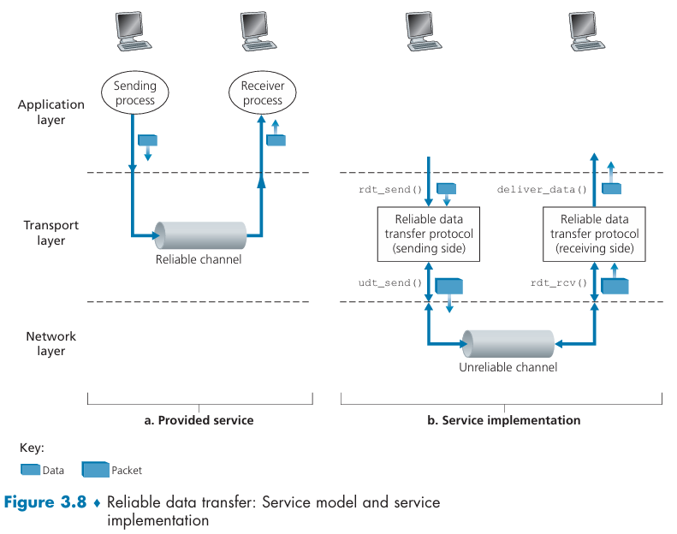
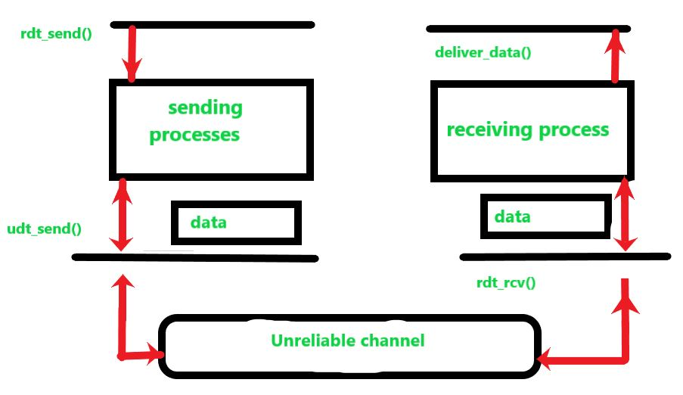

Building a Reliable Data Transfer Protocol
We will step through a series of protocols, each one becoming more complex, arriving at a flawless, reliable data transfer protocol.

Reliable Data Transfer over a Perfectly Reliable Channel: rdt1.0
The protocol rdt1.0 assumes the underlying channel never corrupts or loses data. It is implemented at transport layer.
This transfer of data is shown by using FSM (finite state machine). In RDT 1.0, there is only one state each for sender and receiver.
Finite State Machines (FSMs)
- Separate FSMs for sender and receiver
- One state each - the simplest possible protocol
- Transitions: Shown with arrows, events above line, actions below line
- Initial state: Indicated by dashed arrow
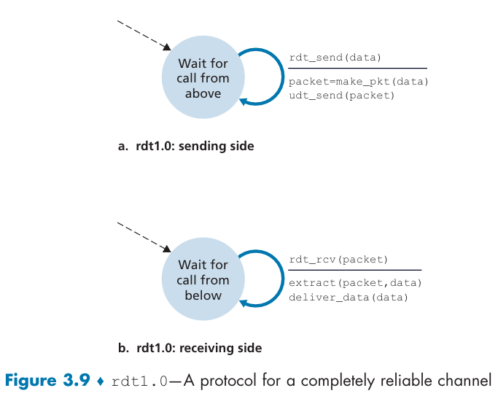
Sender Side: When the sender sends data from the application layer, RDT simply accepts data from the upper layer via the rdt_send(data) event. Then it puts the data into a packet (via the make_pkt(packet,data) event) and sends the packet into the channel using the udt_send(packet) event.
Receiving Side: On receiving data from the channel, RDT simply accepts data via the rdt_rcv(data) event. Then it extracts the data from the packet (via the extract(packet, data)) and sends the data to the application layer using the deliver_data(data) event.

rdt1.0 Sender FSM
On occurrence of events by upper layer (Application Layer) and lower layer (Network Layer), the RDT (Transport Layer) takes some actions.
Single State: "Wait for call from above"
Transition:
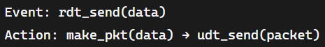
What happens:
- Application calls rdt_send(data) with data to send
- Sender (RDT) creates packet: make_pkt(data)
- RDT Sends packet into channel: udt_send(packet)
- Returns to same state (waiting for next call)

rdt1.0 Receiver FSM
Single State: "Wait for call from below"
Transition:
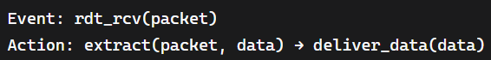
What happens:
- Underlying channel (Network layer) sends packet upwards: rdt_rcv(packet)
- Receiver (RDT) extracts data: extract(packet, data)
- RDT Delivers data to application: deliver_data(data)
- Returns to same state (waiting for next packet)

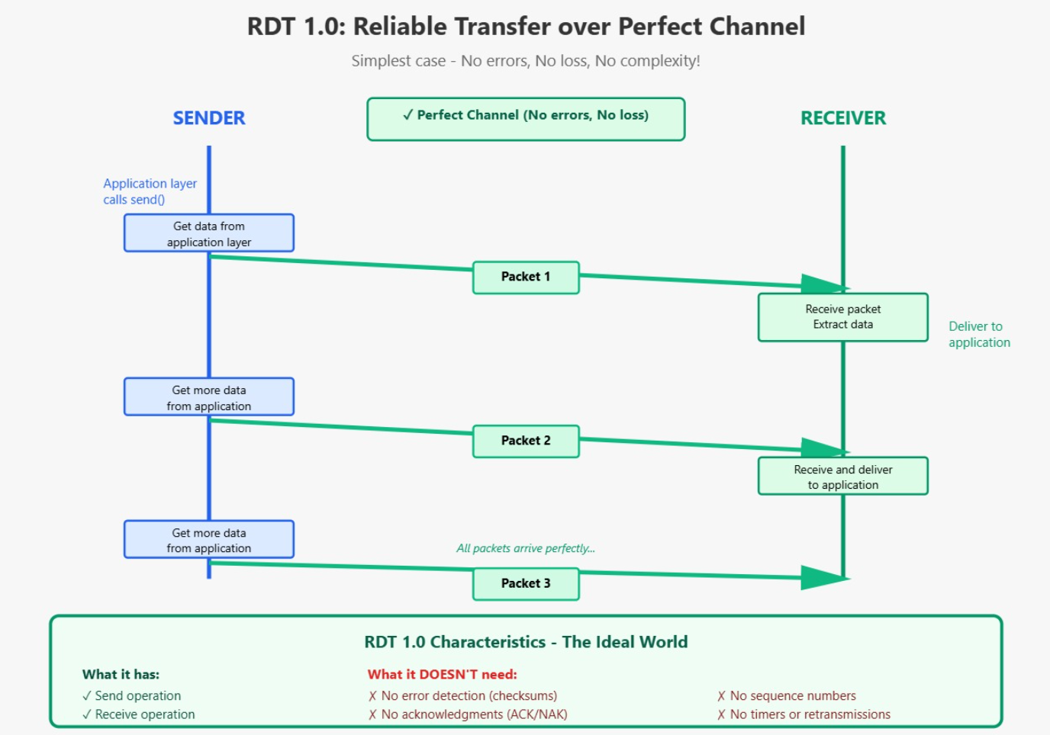
Significance
rdt1.0 serves as a baseline - we'll build more complex protocols by adding mechanisms to handle:
- Bit errors (rdt2.0)
- Packet loss (rdt3.0)
- Real-world constraints

Reliable Data Transfer over a Channel with Bit Errors: rdt2.0
The protocol rdt2.0 is designed for a channel that can corrupt (flip) bits within a transmitted packet, although it is still assumed that packets are never lost and arrive in order.
To handle bit errors, rdt2.0 is an ARQ (Automatic Repeat reQuest) protocol, requiring three essential mechanisms:
RDT 2.0 requires the following three features:
- Error detection: Extra bits (like a checksum) are added to the packet to allow the receiver to determine if the packet has been corrupted.
- Receiver Feedback: ACKs, NAKs - the receiver must send control messages back to the sender to report the status of the incoming packet. Can be as small as 1 bit (0=NAK, 1=ACK)
- Retransmission: Buffer - the sender retransmits a packet from the buffer if the receiver reports an error. Otherwise, discard the stored packet from buffer.
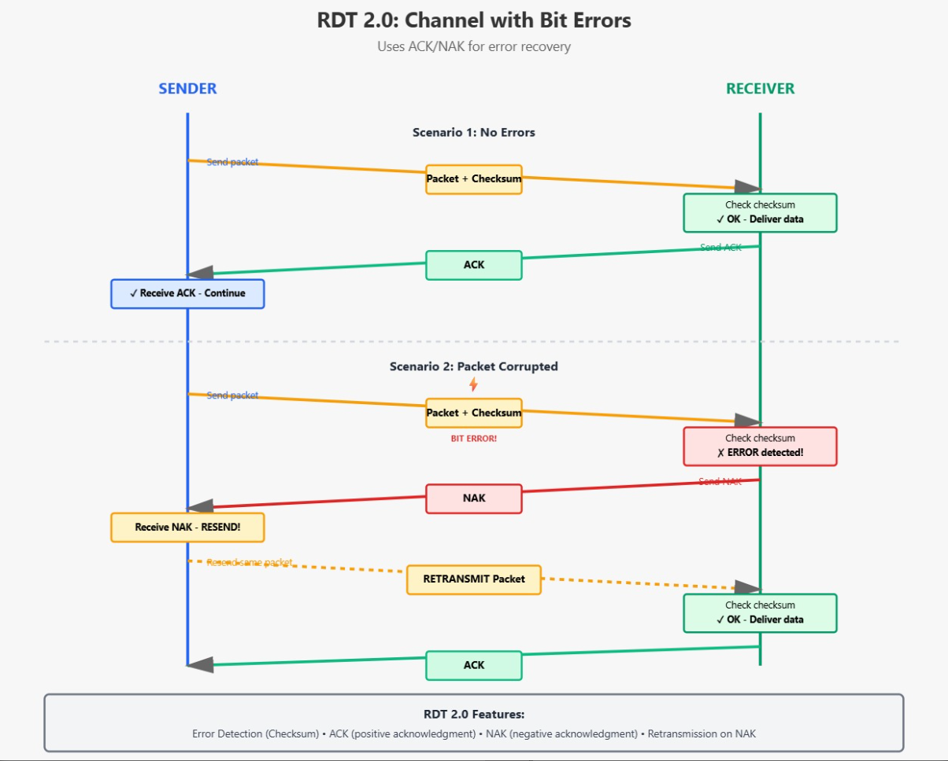
How it works:
The sender side of rdt2.0 has two states. In the leftmost state, the send-side protocol is waiting for data to be passed down from the upper layer. When the rdt_send(data) event occurs, the sender will create a packet (sndpkt) containing the data to be sent, along with a packet checksum and then send the packet via the udt_send(sndpkt) operation. In the rightmost state, the sender protocol is waiting for an ACK or a NAK packet from the receiver.
If an ACK packet is received (the notation rdt_rcv(rcvpkt) && isACK(rcvpkt) in Figure 3.10 corresponds to this event), the sender knows that the most recently transmitted packet has been received correctly and thus the protocol returns to the state of waiting for data from the upper layer. If a NAK is received, the protocol retransmits the last packet stored in buffer and waits for an ACK or NAK to be returned by the receiver in response to the retransmitted data packet.
It is important to note that when the sender is in the wait-for-ACK-or-NAK state, it cannot get more data from the upper layer; that is, the rdt_send() event can not occur; that will happen only after the sender receives an ACK and leaves this state. Thus, the sender will not send a new piece of data until it is sure that the receiver has correctly received the current packet. Because of this behaviour, protocols such as rdt2.0 are known as stop-and-wait protocols.
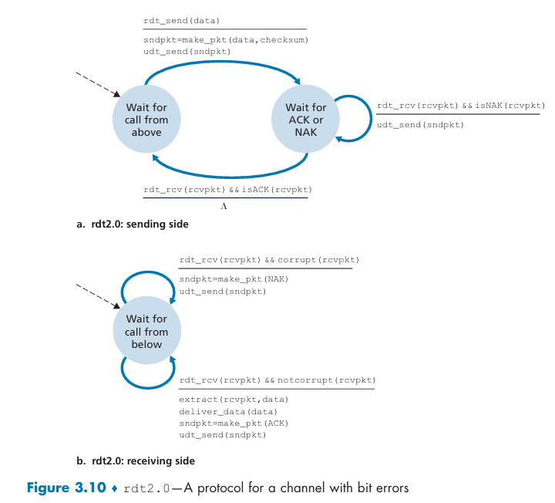
Key Protocol Characteristics
Stop-and-Wait Behavior:
- Sender transmits one packet at a time
- Must wait for acknowledgment before sending next packet
- Blocks upper layer during waiting period
Bidirectional Communication:
- Data flows: Sender → Receiver
- Control flows: Receiver → Sender (ACKs/NAKs)
Assumptions:
- No packet loss (only bit errors)
- Packets arrive in order
- ACK/NAK packets themselves don't get corrupted (addressed in rdt2.1/2.2)

Reliable Data Transfer over a Channel with Bit Errors: rdt2.1
What if the ACK and NAK packets are corrupted, that is, what if the bits in ACK and NAK packets flipped?
rdt2.0 has a critical flaw: it doesn't handle corrupted ACK/NAK packets. This leads to the development of rdt2.1 and rdt2.2 with important improvements.
The following functions are required in rdt2.1.
- Error detection
- Feedback
- Retransmission
- Sequence number

The Fatal Flaw in rdt2.0
Problem: If ACK or NAK packets get corrupted, the sender doesn't know if the receiver got the data correctly.
Three Possible Solutions Considered:
- Ask "What did you say?" - Request repeat of ACK/NAK
  - Problem: Infinite loop if "What did you say?" also gets corrupted
- Stronger error correction - Recover from errors in ACK/NAK
  - Problem: Doesn't scale well, adds overhead
- Resend data when ACK/NAK corrupted - The chosen approach
  - Problem: If the sender receives a garbled ACK/NAK, it cannot determine if the receiver got the data correctly. The most straightforward response—resending the data—introduces a new problem: duplicate packets.
The receiver, having already processed the data, cannot tell if the latest arriving packet is a retransmission or a new piece of data.
  - The Fix: Sequence Numbers (rdt2.1)
The solution is to add a Sequence Number field to the data packets.
- For the simple stop-and-wait protocol, a 1-bit sequence number (alternating between 0 and 1) is sufficient.
- Receiver Action: The receiver checks the sequence number. If it matches the last one received, it discards the packet as a duplicate; if it's different, the packet is new data.
- Protocol State: Both the sender and receiver now have two states (waiting for/sending sequence or packets), hence the transition from one state in rdt2.0 to two states in rdt2.1.

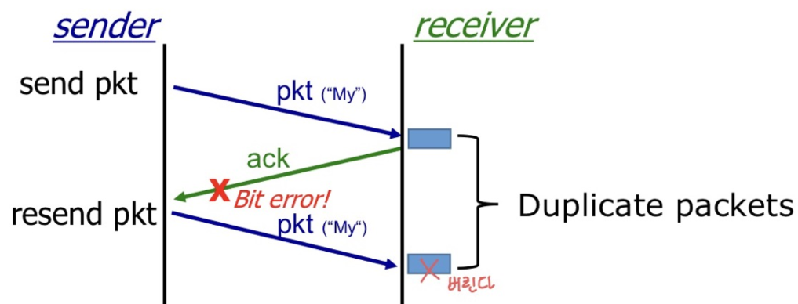

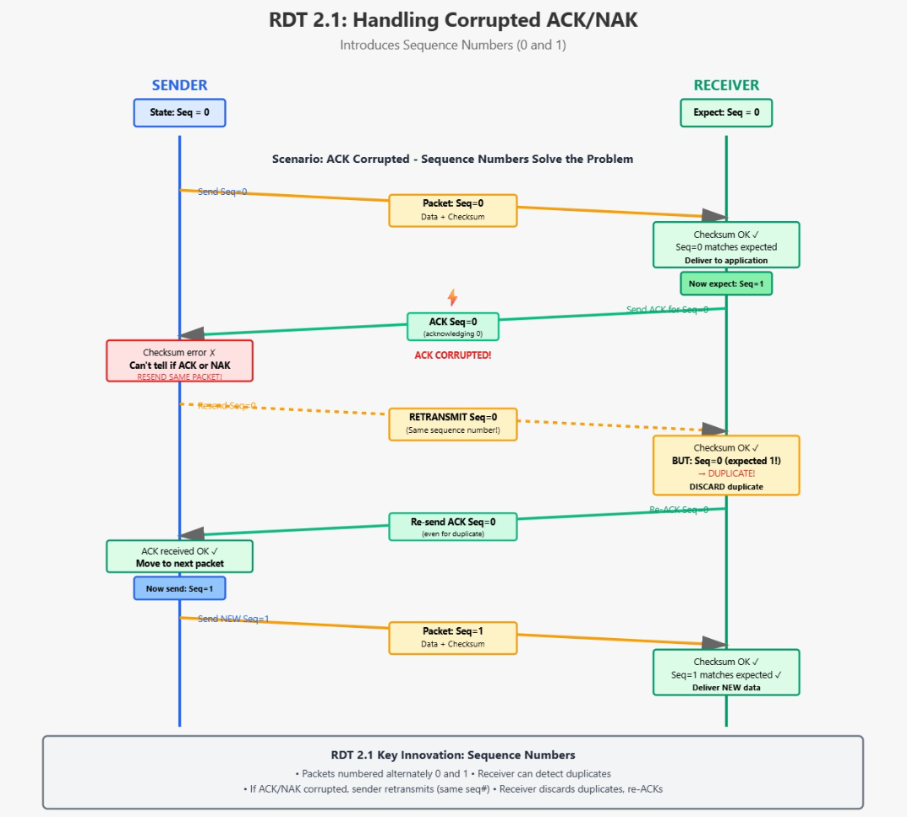
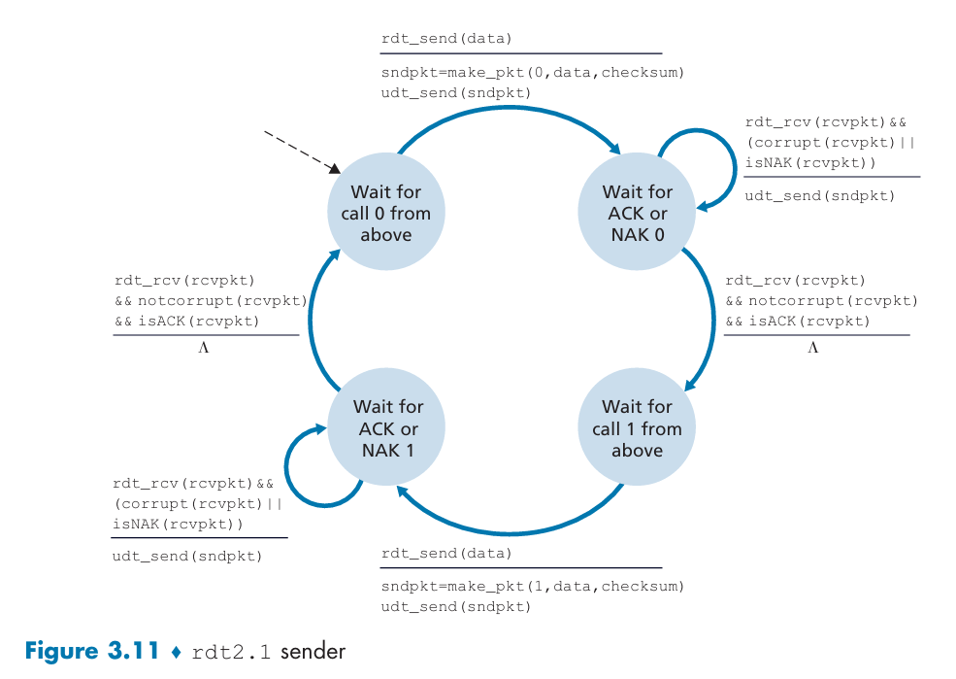
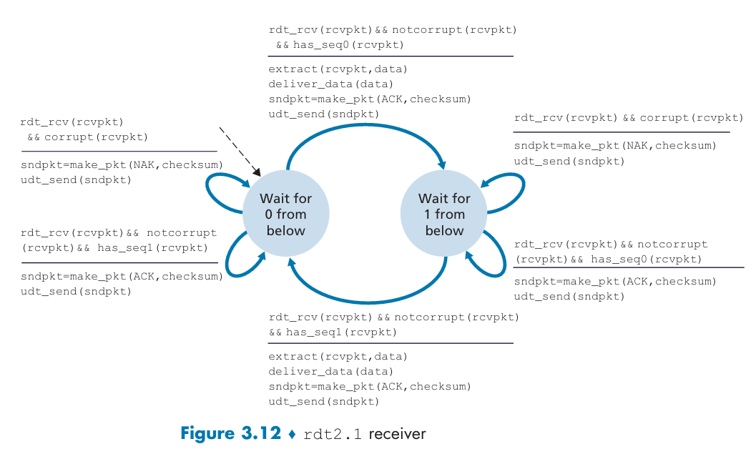

Reliable Data Transfer over a Channel with Bit Errors: rdt2.2 (No NAKS used):
Instead of using NAKs, we can use ACKs only by including the sequence number of the packet being acknowledged.
Key Idea:
- Receiver sends ACK with sequence number of last correctly received packet
- If sender receives duplicate ACK (same sequence number twice), it knows something went wrong
- Duplicate ACK = implicit NAK
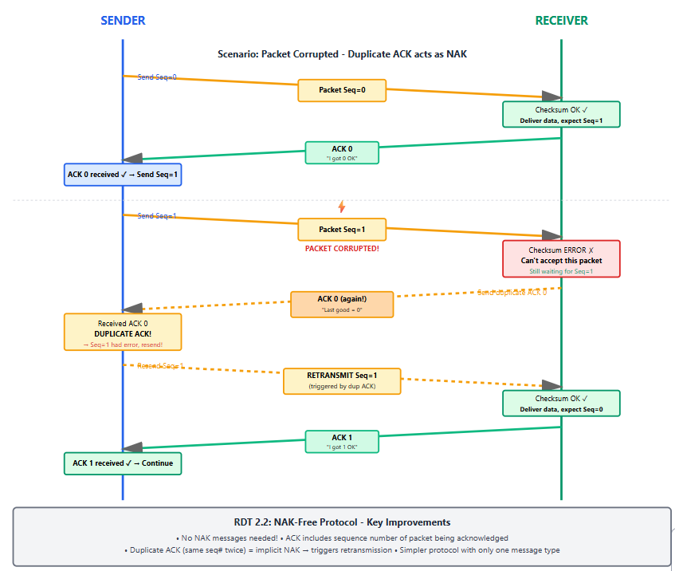

Reliable Data Transfer with Bit Errors and Loss: rdt3.0 (Timeout Mechanism):
New Challenge:
The underlying channel can now:
- Corrupt bits (like RDT 2.x)
- Lose packets entirely (packet never arrives)
Problem:
If a packet is lost, the receiver never sends an ACK. The sender will wait forever!
Solution - New Mechanism:
Timeout Timer: Sender starts a timer when sending a packet. If ACK doesn't arrive before timeout, sender assumes packet was lost and retransmits.
Key Components:
- Sequence numbers (0 and 1)
- ACKs with sequence numbers
- Checksums for error detection
- Countdown timer for detecting loss
- Retransmission on timeout
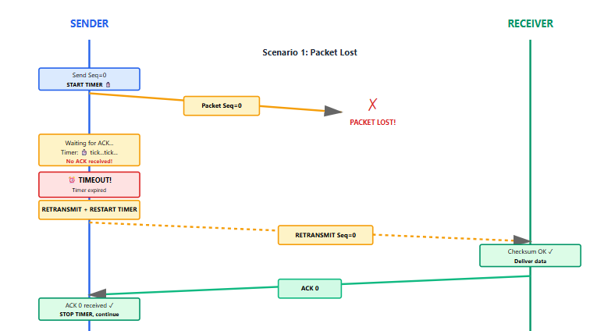
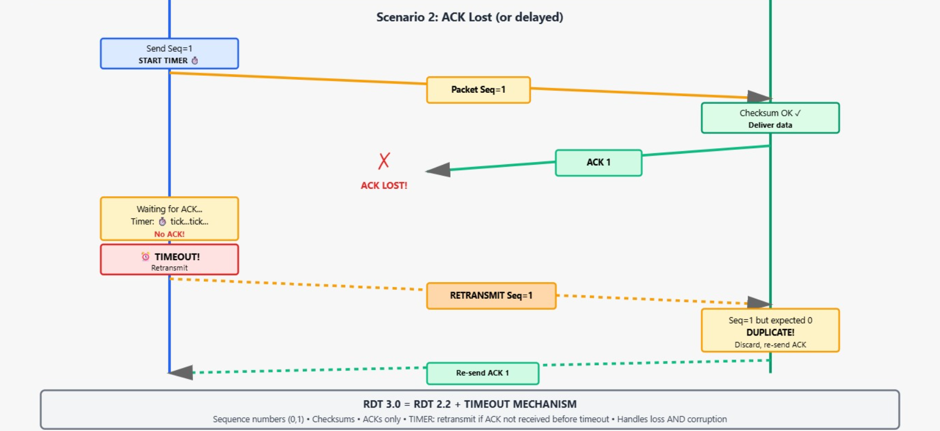
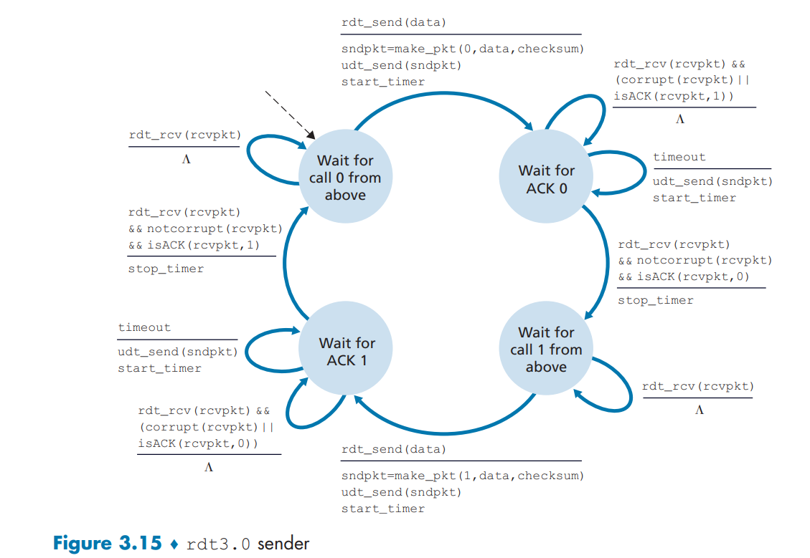

Pipelined Reliable Data Transfer Protocols:
To understand pipelining, we must first see the limitation it solves. Stop-and-Wait Protocol (Rdt 3.0) has a fundamental performance issue:
- The sender transmits one packet.
- It then must stop and wait for the corresponding Acknowledgement (ACK) for that packet.
- Only after receiving the ACK does it send the next packet.
This creates a severe under-utilization of the available network capacity. The sender is idle for a long time—the entire Round-Trip Time (RTT)—waiting for the ACK to come back.
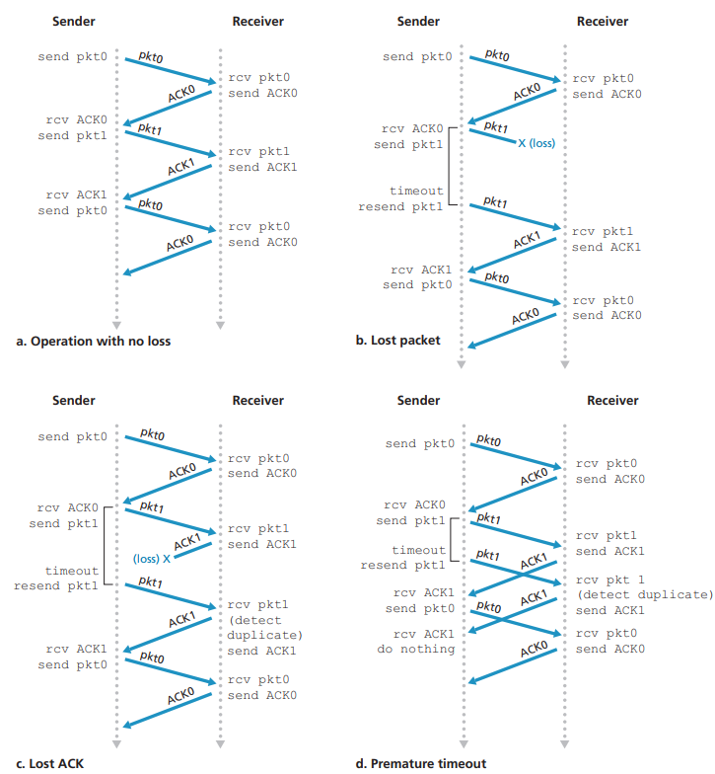
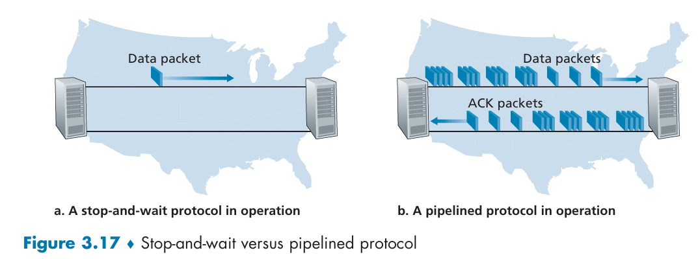
The "Stop-and-Wait" Rule
Consider an idealized case of two hosts, one located on the West Coast of the United States and the other located on the East Coast. The time needed to actually transmit the packet into the 1 Gbps link is:
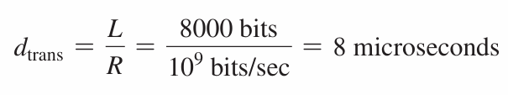
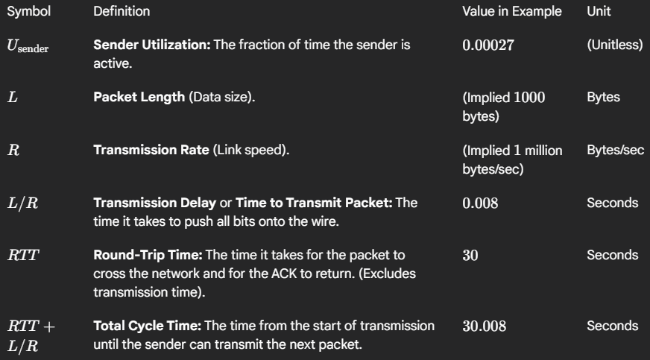
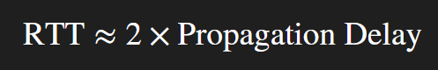
If the sender begins sending the packet at t = 0, then at t = L/R = 8 microseconds, the last bit enters the channel at the sender side. The packet then makes its 15-msec cross-country journey, with the last bit of the packet emerging at the receiver at t = RTT/2 + L/R = 15.008 msec.
Assuming for simplicity that ACK packets are extremely small (so that we can ignore their transmission time) and that the receiver can send an ACK as soon as the last bit of a data packet is received, the ACK emerges back at the sender at t = RTT + L/R = 30.008 msec. At this point, the sender can now transmit the next message. Thus, in 30.008 msec, the sender was sending for only 0.008 msec.
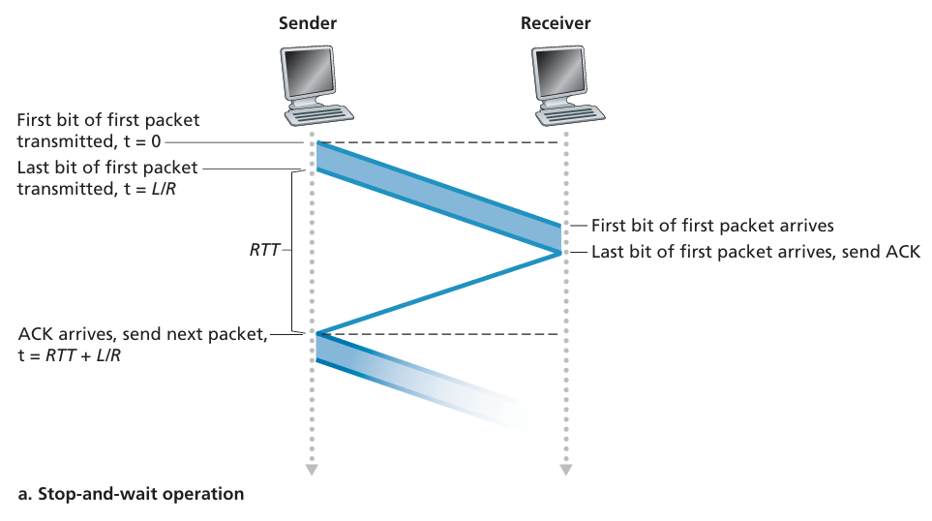
If we define the utilization of the sender (or the channel) as the fraction of time, the sender is actually busy sending bits into the channel as U_{sender}. So, the Utilization for the whole packet transfer from Sender to Receiver and then ACK from Receiver to Sender will be:

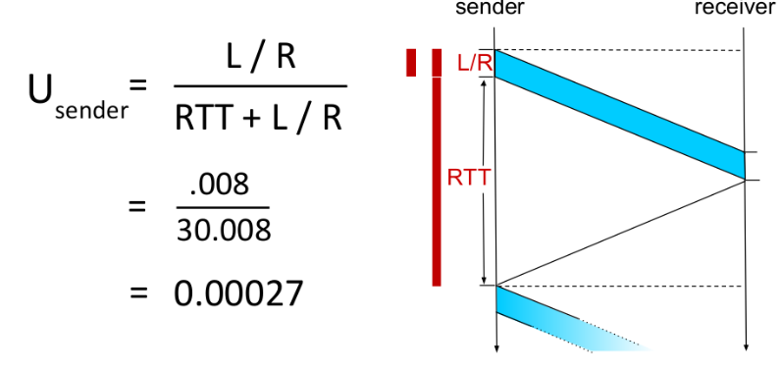
This result means the sender is only utilized about 0.027% of the time. This demonstrates the extremely poor efficiency of a basic Stop-and-Wait protocol when the network delay (RTT) is much, much larger than the time it takes to actually send the data (L/R). This inefficiency is the primary reason why protocols like TCP use pipelining (sending multiple packets before waiting for an ACK) instead of Stop-and-Wait.
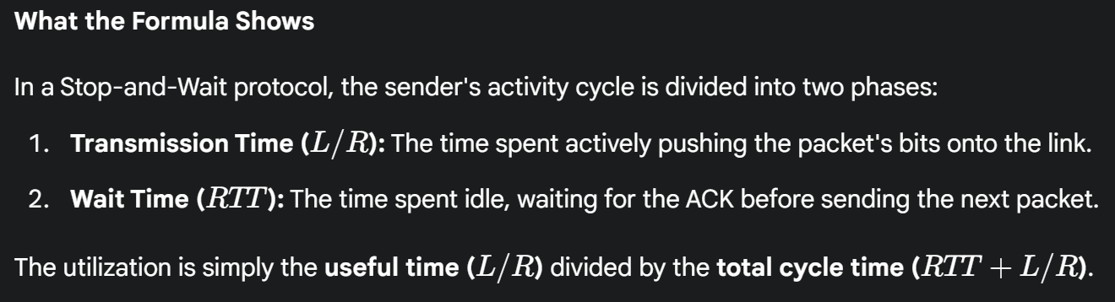
Throughput Formula:
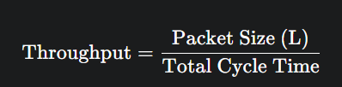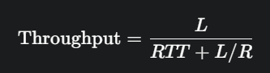
Effective Throughput Calculation:
To understand the practical impact, let's calculate the effective throughput:
Effective Throughput = U_{sender} × R
Effective Throughput = 0.00027 × 1 Gbps
Effective Throughput = 270 kbps
This shows that even though the link can transmit at 1 Gbps, the actual useful data rate (throughput) is only 270 kbytes/sec because the protocol spends so much time waiting for ACKs.
The Solution: Pipelining
Pipelining is the solution to this inefficiency. The core idea is to allow the sender to have multiple in-flight packets that are yet to be acknowledged.
Analogy: Now, we allow multiple cars to be on the highway at the same time. This fully utilizes the road's capacity and delivers much more data (cars) per unit of time.
Key Consequences of Pipelining:
- Increased Utilization: The sender is kept busy, dramatically increasing the throughput of the connection.
- Range of Sequence Numbers Required: We can no longer get by with just 1-bit (0/1) sequence numbers. The sequence number range must be at least as large as the number of packets that can be in flight to avoid ambiguity.
- Buffering at Sender and Receiver:
  - The sender must be able to buffer packets that have been sent but not yet acknowledged, as they may need to be retransmitted.
  - The receiver may need to buffer packets that are received correctly but out-of-order (depending on the protocol's design).
- Two Fundamental Approaches for Error Recovery: The book introduces two core techniques for handling lost or corrupted packets in a pipelined context: Go-Back-N (GBN) and Selective Repeat (SR).
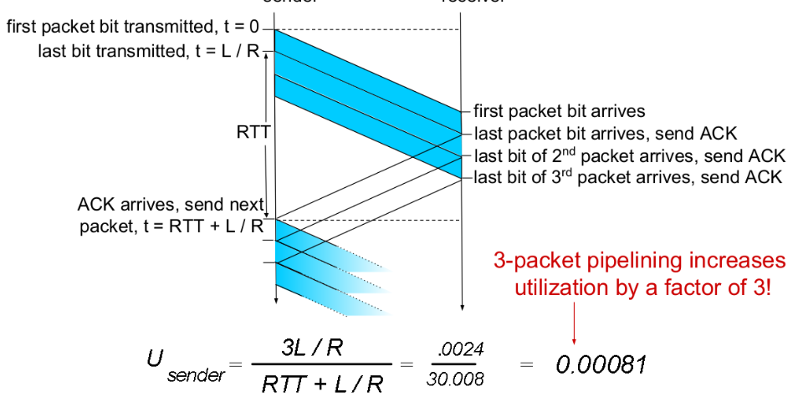
After using Pipelining, the utilization has increased by 0.081% instead of 0.026%, also the idle time is reduced.

Go-Back-N (GBN)
In a Go-Back-N (GBN) protocol, the sender is allowed to transmit multiple packets (when available) without waiting for an acknowledgment but is constrained to have no more than some maximum allowable number, N, of unacknowledged packets in the pipeline.
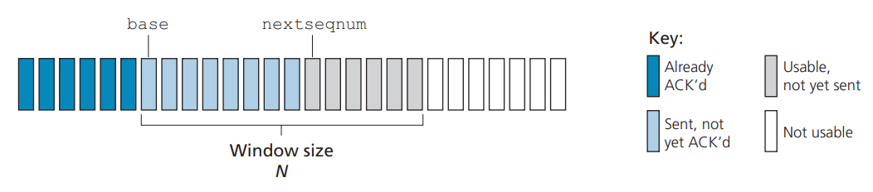
Sender's View:
- The sender maintains a sliding window:
  - Base: The sequence number of the oldest unacknowledged packet.
  - NextSeqNum: The smallest unused sequence number (the next packet to be sent).
  - Window Size (N): The maximum number of unacknowledged packets allowed.
- The window slides forward as ACKs are received. GBN uses cumulative acknowledgements. An ACK for sequence number n is interpreted as an acknowledgement for all packets up to and including n.
- The sender has a single timer for the entire window, tracking the oldest unacknowledged packet (the one at base).
- If a timeout occurs, the sender retransmits all packets in the window, from base to nextSeqNum-1.
- Example: If packets 1–5 are sent and packet 3 is lost, then packets 3, 4, and 5 are retransmitted.
Receiver's View:
- The receiver is very simple. It only accepts packets in perfect order.
- If an expected packet n arrives, it is delivered to the upper layer, and a cumulative ACK for n is sent.
- Sends cumulative acknowledgments (ACK n means "I've received all frames up to n")
- If a packet arrives out-of-order (e.g., it receives n+1 before n), the receiver discards it immediately and re-sends a duplicate ACK for the last in-order packet (ACK for n-1).
How It Works
- Normal Operation: Sender transmits frames 0, 1, 2, 3 (window size = 4). Receiver sends ACK 0, ACK 1, ACK 2, ACK 3 as each arrives correctly.
- When Error Occurs: If frame 2 is lost:
  - Receiver gets frames 3, 4, 5... but discards them (out of order)
  - Receiver sends ACK 1 repeatedly (last correctly received frame)
  - Sender's timer expires or receives duplicate ACKs
  - Sender goes back to frame 2 and retransmits frames 2, 3, 4, 5...
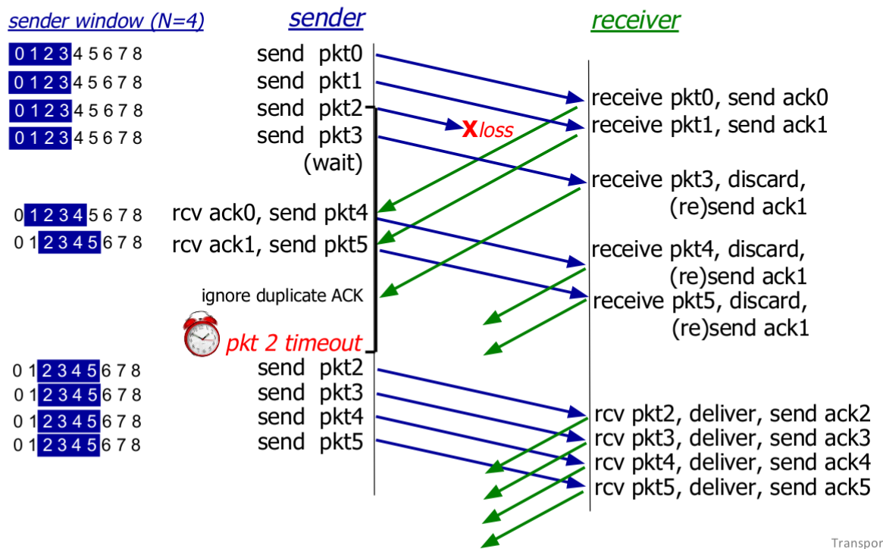
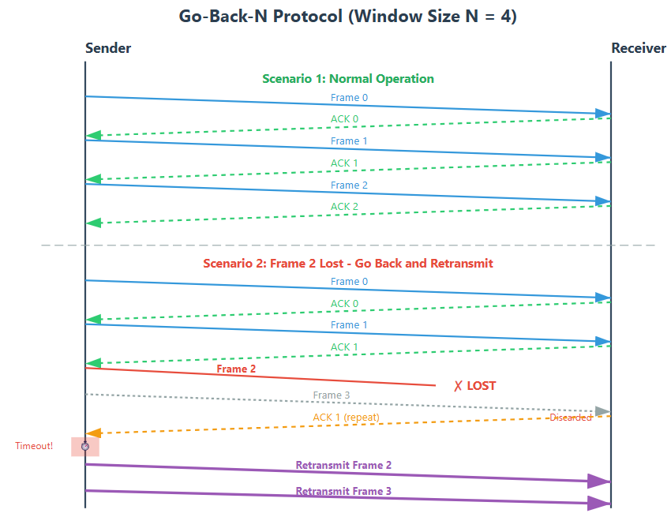
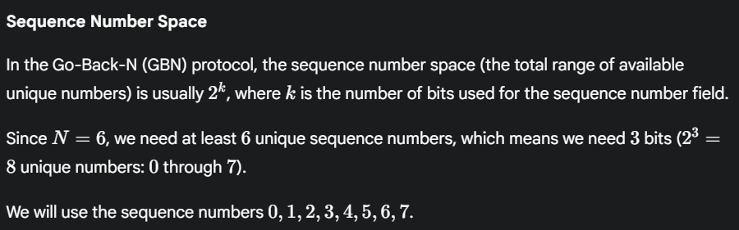
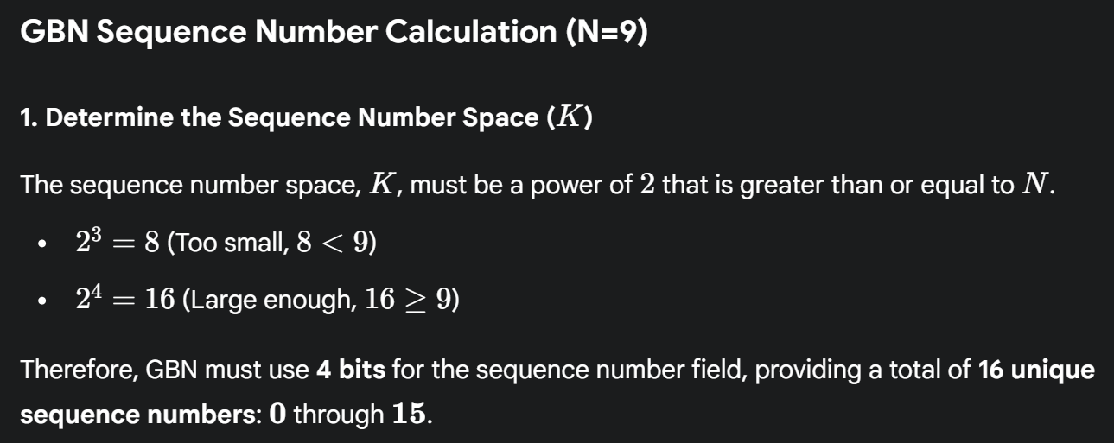
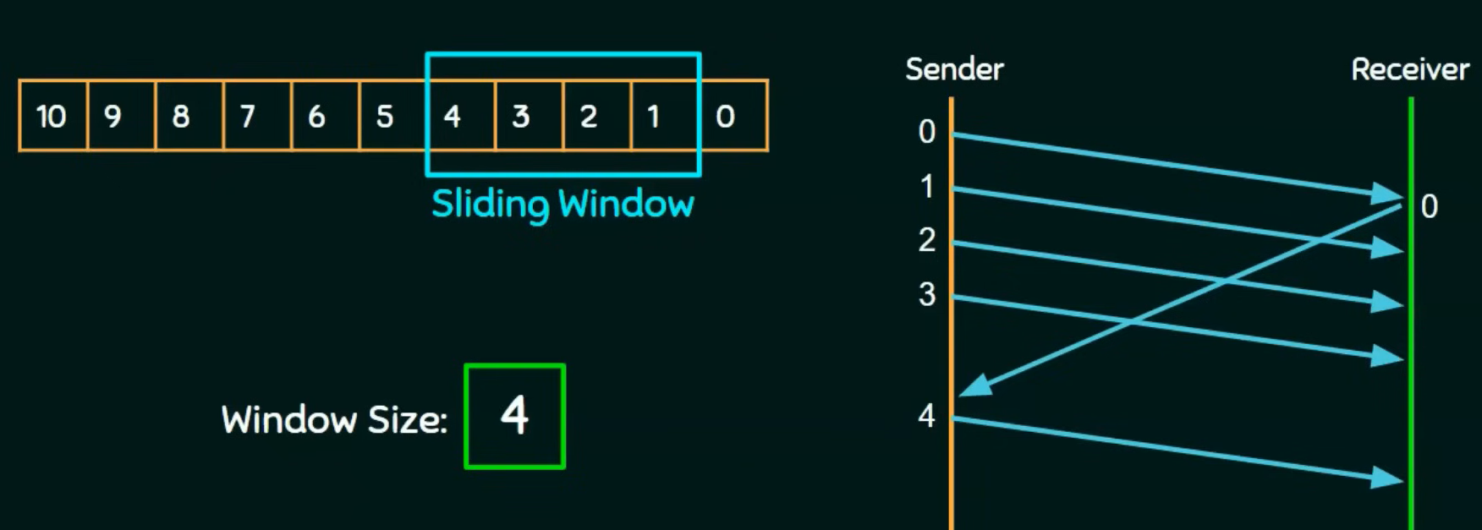
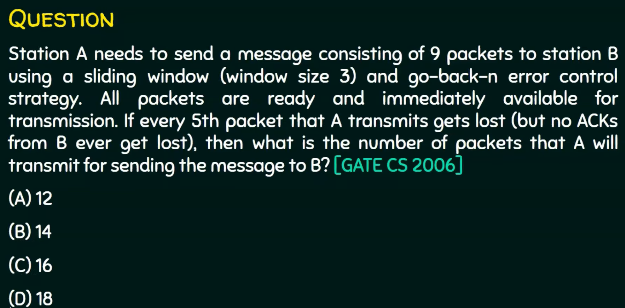
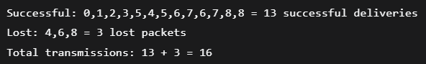
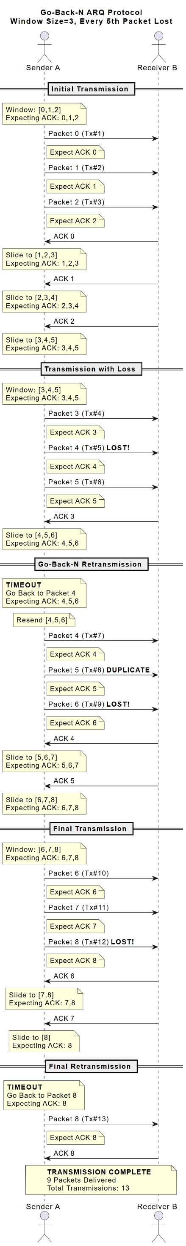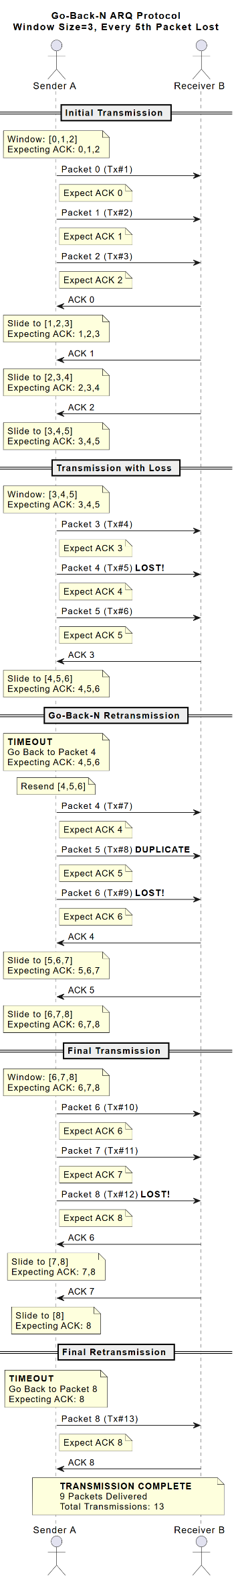
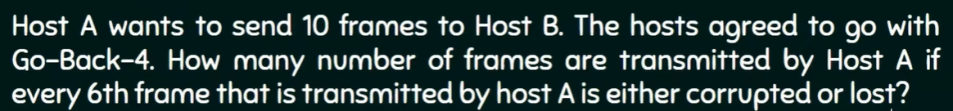
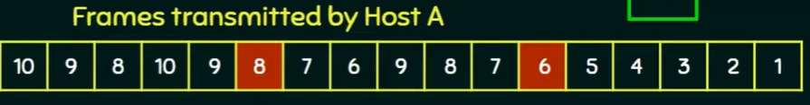

Selective Repeat (SR):
Selective Repeat (SR) is a sliding window protocol that improves upon Go-Back-N by retransmitting only the frames that are lost or damaged, rather than retransmitting all subsequent frames. This makes it more efficient, especially in networks with higher error rates.
Sliding Window: Both sender and receiver maintain a window of size N. The sender can transmit up to N unacknowledged frames, and the receiver can accept N out-of-order frames.
Sender Behavior:
- Maintains a window of N frames that can be sent
- Each frame has its own independent timer
- When a timeout occurs or NAK is received, only that specific frame is retransmitted
- Window slides forward as acknowledgments are received
- Tracks which frames have been acknowledged individually
Receiver Behavior:
- Accepts out-of-order frames (major difference from Go-Back-N)
- Buffers correctly received frames that arrive out of order
- Sends individual acknowledgments for each correctly received frame
- Delivers frames to the upper layer only in sequential order
- Must maintain a buffer to store out-of-order frames
How It Works
- Normal Operation: Sender transmits frames 0, 1, 2, 3. Receiver acknowledges each frame individually as they arrive.
- When Error Occurs: If frame 2 is lost:
  - Receiver gets frames 3, 4, 5 and buffers them (not discarded!)
  - Receiver sends ACK 3, ACK 4, ACK 5 for the correctly received frames
  - Frame 2's timer expires at the sender
  - Sender retransmits only frame 2 (selective retransmission)
  - Once frame 2 arrives, receiver can deliver frames 2, 3, 4, 5 in order to upper layer
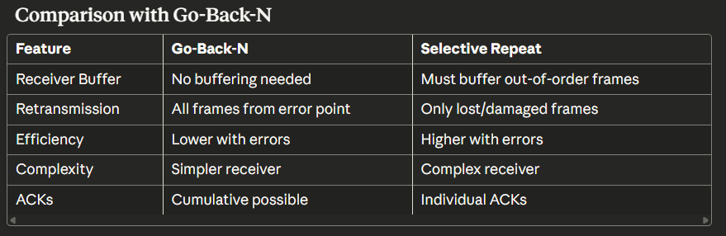
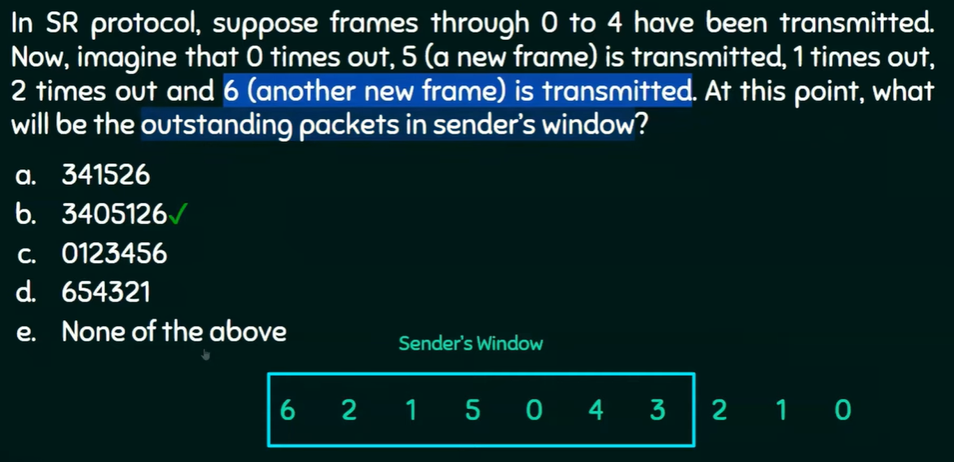
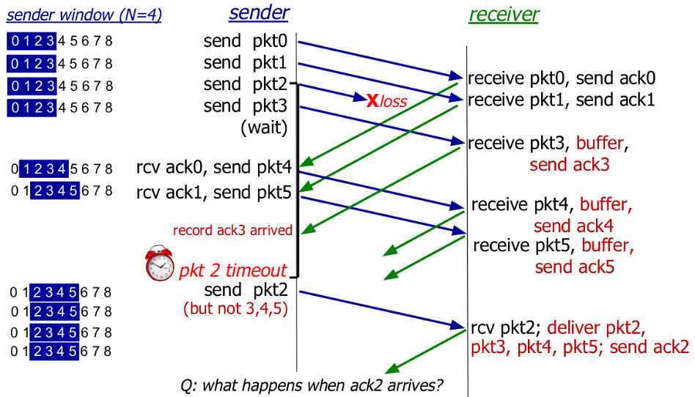
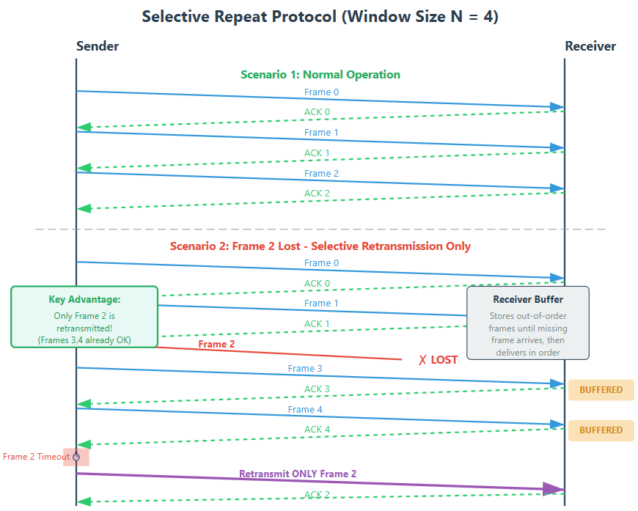

Selective Repeat Dilemma:
The Selective Repeat Dilemma is a critical problem that arises when the window size is too large relative to the sequence number space. This can cause the receiver to be unable to distinguish between new frames and retransmissions of old frames.
The Core Problem
Scenario Setup
- Sequence numbers: 0, 1, 2, 3 (then wraps around to 0, 1, 2, 3...)
- Window size: 4 frames
- Question: Can the receiver tell if Frame 0 is NEW or a RETRANSMISSION?
Why the Confusion Happens
The receiver cannot always distinguish between:
- Old Frame 0 being retransmitted (from the first window)
- New Frame 0 being sent (from the second window, after wraparound)
This creates ambiguity that can lead to:
- Accepting old data as new data
- Rejecting new data thinking it's old data
- Data corruption and protocol failure!
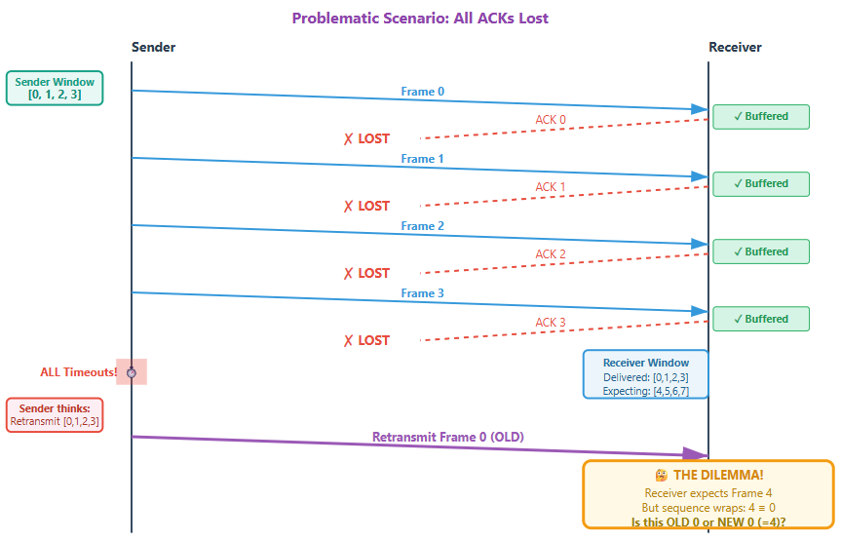

Mathematical Explanation
The Problem in Numbers
With sequence numbers modulo N and window size W:
Ambiguity occurs when:
- Sender's window: [0, 1, 2, 3]
- All ACKs lost
- Sender retransmits Frame 0
- Receiver has moved to window: [4, 5, 6, 7]
- But 4 mod 4 = 0, so Frame 0 could mean either:
  - OLD Frame 0 (retransmission)
  - NEW Frame 4 (which appears as 0 after wraparound)
Why This is Catastrophic
If the receiver accepts OLD Frame 0 as NEW Frame 4:
- Data corruption: Old data overwrites or replaces new expected data
- Protocol failure: The receiver's data stream becomes corrupted
- Impossible to recover: The receiver has no way to know it made an error
The Solution
Mathematical Rule
For Selective Repeat to work correctly:
Window Size (W) ≤ Sequence Number Space / 2
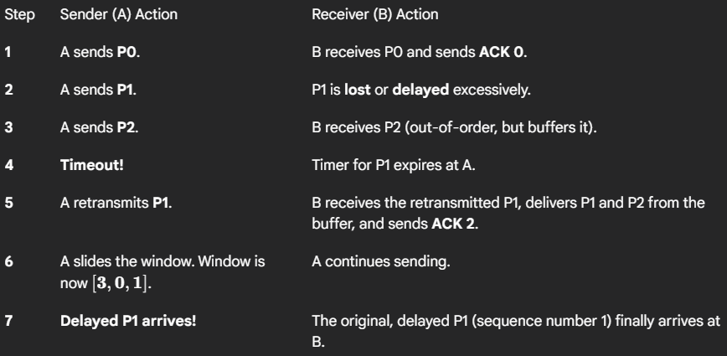
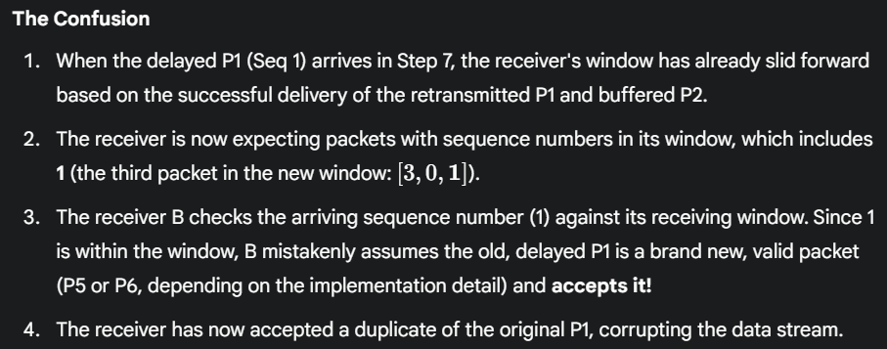
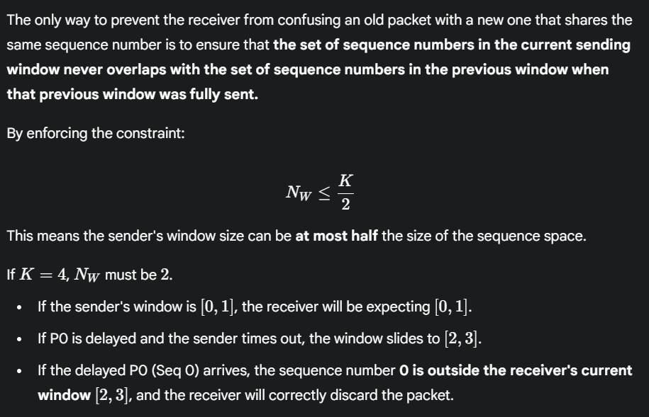

3.5.1 The TCP Connection:
A TCP connection is not a physical circuit like a telephone line. Instead, it's a logical, virtual connection between two processes (applications) running on two different hosts. This connection provides a reliable, byte-oriented, full-duplex service.
Key Characteristics of a TCP Connection
1. Connection-Oriented
2. Point-to-Point
3. Reliable, In-Order Byte Stream
4. Full-Duplex Service
MMS: Maximum Segment Size, is a parameter in computer networks that specifies the largest amount of data that can be sent in a single TCP segment, excluding TCP and IP headers.
Note that the MSS is the maximum amount of application-layer data in the segment, not the maximum size of the TCP segment including headers. MTU - The largest link-layer frame that can be sent on all links from source to destination. When TCP sends a large file, such as an image as part of a Web page, it typically breaks the file into chunks of size MSS.
Maximum Transmission Unit is the largest size, in bytes, of a single data packet that can be sent over a network without being fragmented. Commonly use an MTU of 1500 bytes
MSS = MTU - (Size of IP Header + Size of TCP Header)
For a standard Ethernet network:
MSS = 1500 bytes - (20 bytes IP + 20 bytes TCP) = 1460 bytes

3.5.2 TCP Segment Structure:
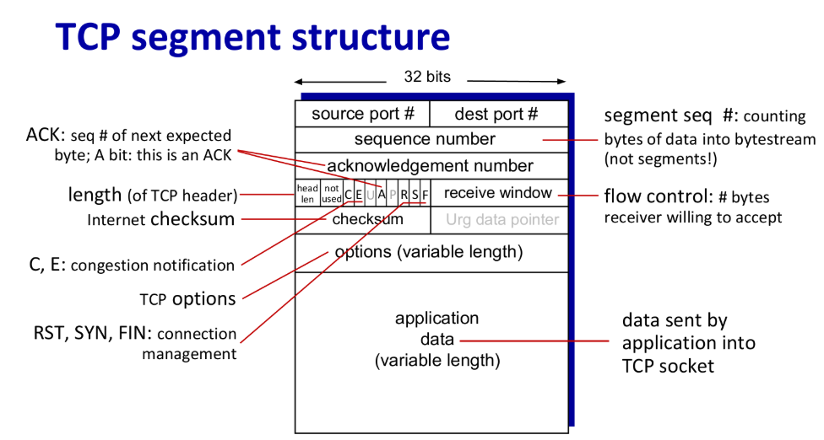
TCP Sequence and Acknowledgment Numbers
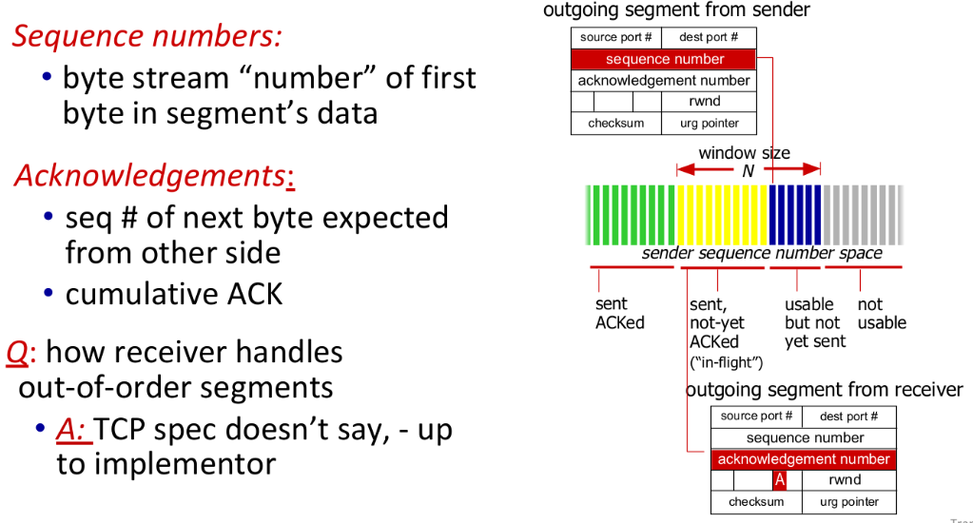

Sequence Numbers
The most important concept to grasp about TCP is that it treats data as an unstructured, ordered stream of bytes, not individual messages.
- Definition: A segment's Sequence Number is the byte-stream number of the very first byte of data carried in that segment.
- Counting by Bytes: TCP does not count segments; it counts bytes.
- Example:
  - 500,000 byte file with 1,000-byte segments
  - Segment 1: bytes 0-999 → sequence number = 0
  - Segment 2: bytes 1000-1999 → sequence number = 1000
  - Segment 3: bytes 2000-2999 → sequence number = 2000
Acknowledgment Numbers
- Purpose: Indicate what data the receiver is expecting next
- Value: Sequence number of the next expected byte
- Cumulative: Acknowledges all bytes up to the first missing one
- Examples:
  - Received bytes 0-535 → acknowledgment number = 536
  - Received bytes 0-535 AND 900-1000 (missing 536-899) → still sends ACK 536
Out-of-Order Segments
- Scenario: Receive segment 3 (bytes 900-1000) before segment 2 (bytes 536-899)
- Options:
  - Discard out-of-order segments (simpler)
  - Keep out-of-order bytes in buffer and wait for gaps to fill ← Used in practice
Initial Sequence Numbers (ISNs)
- Not starting at 0: Both sides randomly choose initial sequence numbers
- Reason: Prevent confusion from old connection segments still in the network
- Security: Avoids mistaking old segments for current connection data
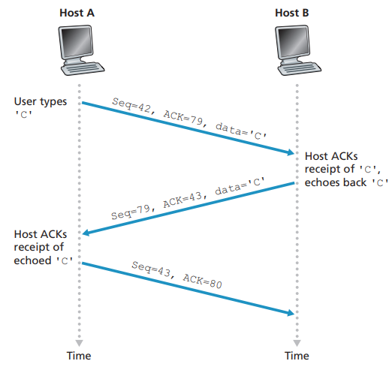
Initial State Assumptions
Before this exchange, the TCP connection is already established via a three-way handshake. We can infer the initial sequence numbers from the data:
- Host A's Initial Sequence Number (ISN) was some value that led to the first data byte being sequence number 42.
- Host B's Initial Sequence Number (ISN) was some value that led to its first data byte being sequence number 79.
Step-by-Step Explanation
Step 1: User types 'C' on Host A
- Host A needs to send the character 'C' to Host B.
- It creates a TCP segment where:
  - Sequence Number = 42
    - This means the single byte 'C' is the 42nd byte in the data stream from Host A to Host B.
  - Acknowledgment Number = 79
    - This tells Host B: "I have received all data up to byte #78 from you, and I am expecting byte #79 next." This ACK is for data Host B sent previously, before this diagram started.
  - Data = 'C' (1 byte)
Host A sends: [Seq=42, ACK=79, data='C']
Step 2: Host B receives the segment and processes it
- Data Delivery: Host B's TCP stack delivers the 'C' character to the application (e.g., the telnet server).
- Application Logic: The application (e.g., a shell) processes the 'C' character and sends an output (the echoed 'C') back to the application on Host A (e.g., the telnet client).
- Host B prepares its segment:
  - Sequence Number = 79
    - This is the sequence number for the first byte of data Host B is sending. It's using the number that Host A was just expecting.
  - Acknowledgment Number = 43
    - This acknowledges Host A's data. Host B received 1 byte of data ('C') with sequence number 42. The ACK number is calculated as: 42 + 1 = 43. This means: "I successfully received your byte #42, and now I expect your byte #43."
  - Data = 'C' (the echoed character)
Host B sends: [Seq=79, ACK=43, data='C']
Step 3: Host A acknowledges the echoed character
- Host A receives the segment from Host B.
- It sees that Host B has sent 1 byte ('C') with sequence number 79.
- It prepares an ACK-only segment (a segment with no data payload) to acknowledge this receipt.
- Sequence Number = 43
  - This is the next byte Host A has to send. Since it's not sending any new data, it just reiterates its current position in the stream.
- Acknowledgment Number = 80
  - This acknowledges Host B's data. Host A received 1 byte of data with sequence number 79. The ACK number is calculated as: 79 + 1 = 80. This means: "I successfully received your byte #79, and now I expect your byte #80."
Host A sends: [Seq=43, ACK=80] (This is an ACK-only segment with no data)
Key TCP Behaviors Demonstrated
- Piggybacking: It combines data and ACKs in one segment. The first two segments combine data transfer with acknowledgments. Step 1 sends data ('C') and an ACK for previous data in the same segment. Step 2 sends data (echoed 'C') and the ACK for the original 'C' in the same segment. This is efficient.
- Cumulative Acknowledgments: Each ACK number specifies the next byte expected, thereby acknowledging all previous bytes in the stream. When Host B sends ACK=43, it acknowledges all data from Host A up to and including byte 42.
- Sequence Numbers Count Bytes, Not Segments: Each sequence number is incremented by the number of data bytes sent. Sending 1 byte of data increments the sequence number by 1.
- Symmetry: Both sides of the connection maintain their own sequence number space for the data they are sending and use acknowledgment numbers to confirm the data they are receiving.

3.5.2 TCP Round Trip Time Estimation & Timeout:
Definition: Time between sending a segment and receiving its ACK.
This section addresses a fundamental question in TCP: How long should the sender wait for an ACK before assuming a packet is lost and retransmitting it?
Setting the timeout is critical:
- Too short: Causes premature timeout and unnecessary retransmissions, wasting bandwidth.
- Too long: Fails to recover from packet loss in a timely manner, hurting performance.
TCP uses an adaptive approach by continuously estimating the Round-Trip Time (RTT) and setting the timeout as a function of this estimate.
The Core Problem with Using SampleRTT Directly
SampleRTT is extremely noisy and volatile. If you set your TimeoutInterval based on the latest SampleRTT, it would fluctuate wildly, leading to two bad outcomes:
  - Unnecessary Retransmissions (False Alarm)
  - Slow Loss Recovery
Measurement rules:
- Measure only one SampleRTT at a time (not every segment)
- Never measure SampleRTT for retransmitted segments
- Get new SampleRTT approximately once per RTT

The Solution: EstimatedRTT as a Stable Baseline
Component 1: The Smoothed Average (EstimatedRTT)
EstimatedRTT is an Exponentially Weighted Moving Average (EWMA). Its purpose is to smooth out the momentary noise in the SampleRTT to discover the underlying, long-term trend of the network's delay. Gives more weight to recent samples than old ones.
It is the estimated round trip, it involves time from segment is sent to time when its ACK is received.
EstimatedRTT = (1 - α) * EstimatedRTT + α * SampleRTT
The new value of EstimatedRTT is a weighted combination of the previous value of EstimatedRTT and the new value for SampleRTT. The recommended value of α is α = 0.125 (that is, 1/8) [RFC 6298], in which case the formula above becomes:
EstimatedRTT = 0.875 * EstimatedRTT + 0.125 * SampleRTT
Component 2: The Safety Margin (DevRTT)
To account for the jitter or variability in the RTT. A network with highly variable delays needs a larger safety margin than a stable one.
TCP estimates the "standard deviation" of the RTT, called DevRTT, as an EWMA of the absolute difference between the sample and the average.
If the SampleRTT values have little fluctuation, then DevRTT will be small; on the other hand, if there is a lot of fluctuation, DevRTT will be large.
DevRTT = (1 - β) * DevRTT + β * |SampleRTT - EstimatedRTT|
- Typical Value: β = 0.25
- Effect: This measures how much the RTT typically deviates from its average. A high DevRTT means the RTT is unpredictable, and a larger safety margin is needed.
The Final Calculation: TimeoutInterval
The timeout is set to the estimated average plus a safety margin that is proportional to the observed variability.
TimeoutInterval = EstimatedRTT + 4 * DevRTT
- The multiplier 4 is a well-tuned value that ensures the timeout is sufficiently long to avoid most false alarms under a wide range of network conditions, while still providing prompt loss recovery.
Key Principles
- Minimum: Must be ≥ EstimatedRTT (avoid unnecessary retransmissions)
- Margin: 4 × DevRTT provides safety margin based on RTT variability
- Adaptive:
  - Large margin when high fluctuation (large DevRTT)
  - Small margin when stable RTT (small DevRTT)
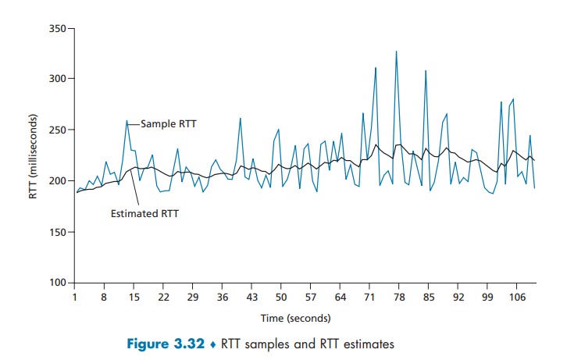
Timeout Event Handling
On Timeout Occurrence
- Double TimeoutInterval: Prevents premature timeouts for subsequent segments
- Exponential backoff: Continues doubling on repeated timeouts
On Segment Reception
- Recalculate immediately: TimeoutInterval reset using formula
- Uses updated: EstimatedRTT and DevRTT values
Uncertainty Handling
TCP cannot distinguish between:
- Lost segments
- Corrupted data
- Delayed transmission
- Lost ACKs
Response is always the same: Retransmit the segment
Adaptive Nature
- Dynamic timeout: Adjusts to network conditions
- Fast recovery: 3 Duplicate ACKs trigger quick retransmission. If sender receives 3 additional ACKs for same data (“triple duplicate ACKs”), resend unACKed segment with smallest seq #, likely that unACKed segment lost, so don’t wait for timeout.
- Throughput optimization: Pipelining with controlled window sizes
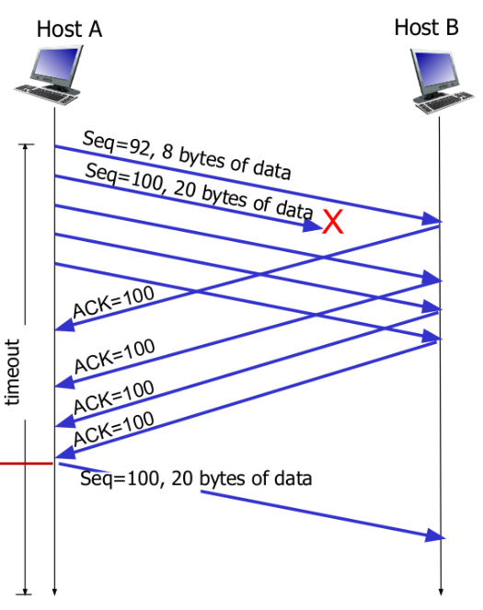
Principles of TCP Reliability (rdt 3.0 in Practice)
TCP uses several mechanisms to provide reliable data transfer, similar to simpler protocols like rdt 3.0 but enhanced for a real network:
- Core Mechanism: TCP relies on positive acknowledgments and timers to detect missing data. If the timer expires before the ACK arrives, the segment is retransmitted.
- Pipelining: TCP uses pipelining, allowing the sender to transmit multiple segments before receiving an ACK. This significantly improves network throughput.
- Implicit NAK (Fast Retransmit): Certain versions of TCP use an accelerated recovery method: receiving three duplicate ACKs for the same segment acts as an implicit Negative Acknowledgment (NAK). This immediately triggers the retransmission of the likely missing segment without waiting for the timer to expire.
- Sequence Numbers: Sequence numbers are used to help the receiver identify and discard duplicate segments.
- Flow & Congestion Control: The total number of unacknowledged, outstanding segments the sender can have is determined by additional mechanisms:
  - Flow Control: Prevents the sender from overwhelming the receiver's buffer capacity.
  - Congestion Control: Prevents the sender from overwhelming the shared network links.
These mechanisms—dynamic RTT estimation, exponential backoff, and pipelining—are what make TCP's reliability adaptive and efficient.
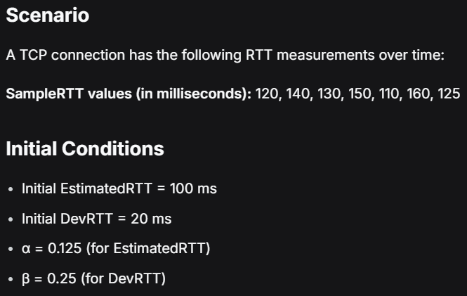
Part 1: Calculate Timeout Intervals
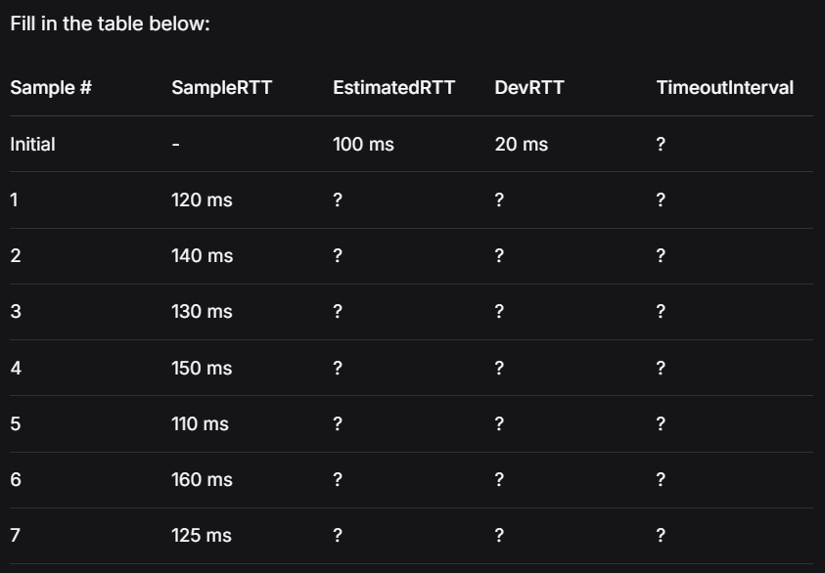
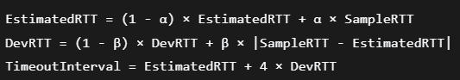
Sample 1: SampleRTT = 120 ms
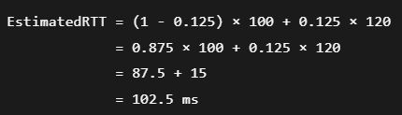
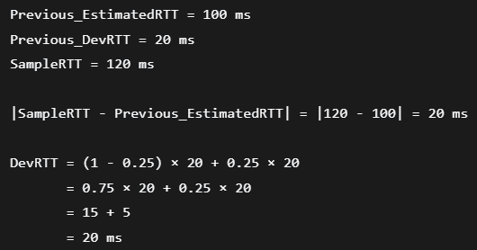
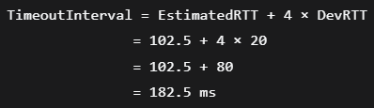
Sample 2: SampleRTT = 140 ms
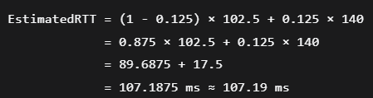
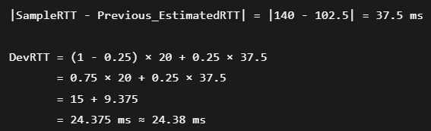
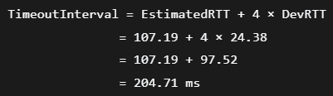
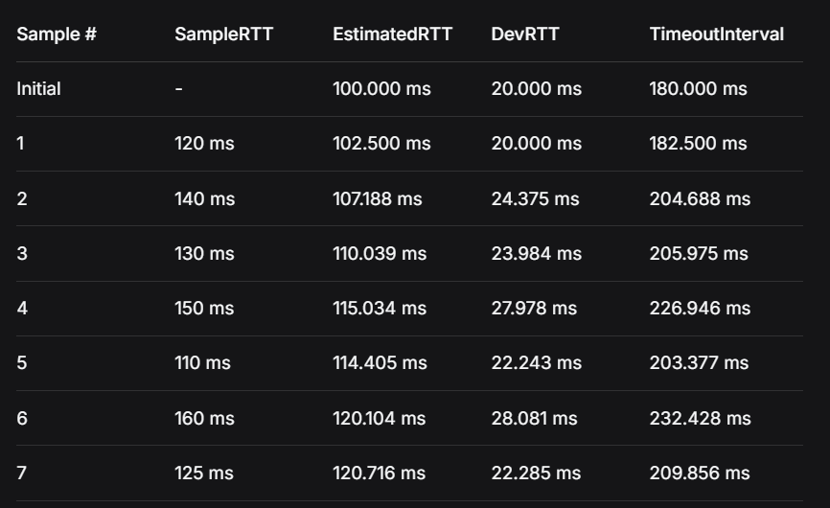
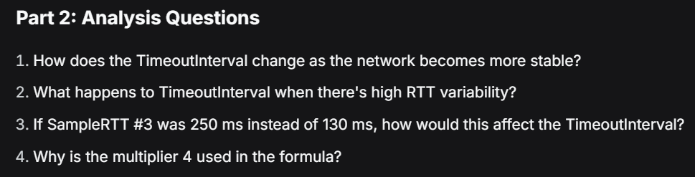
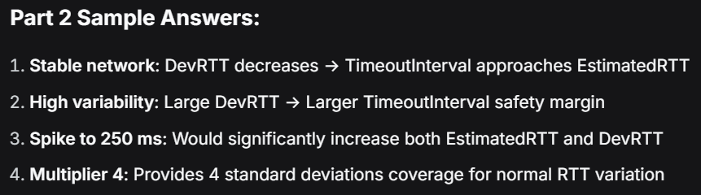
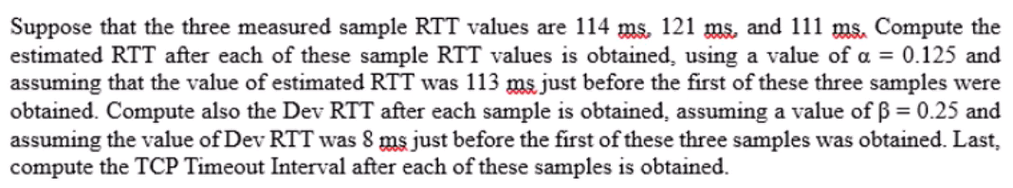
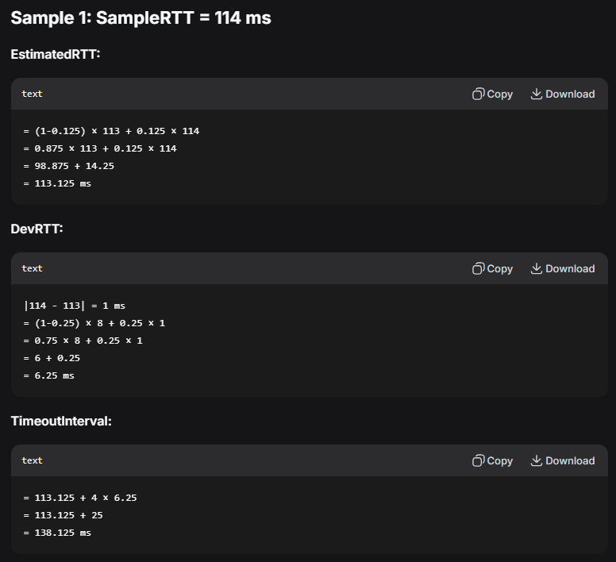
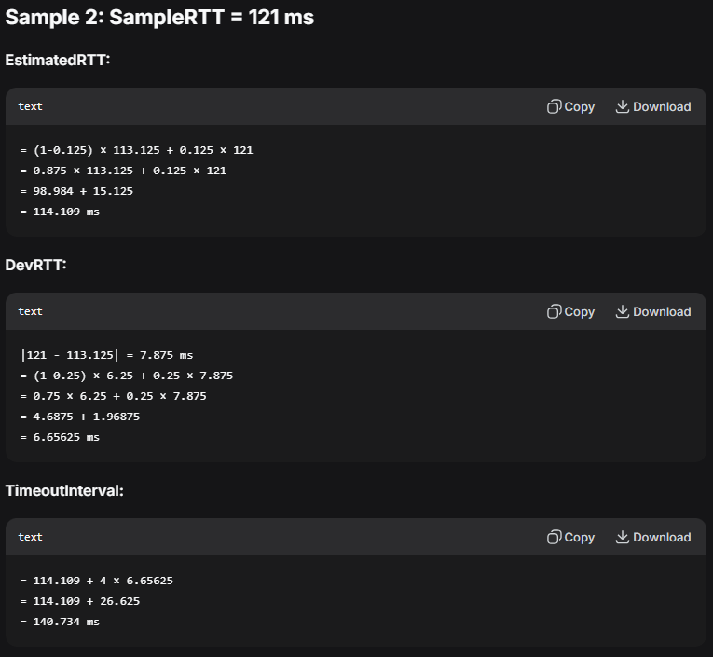
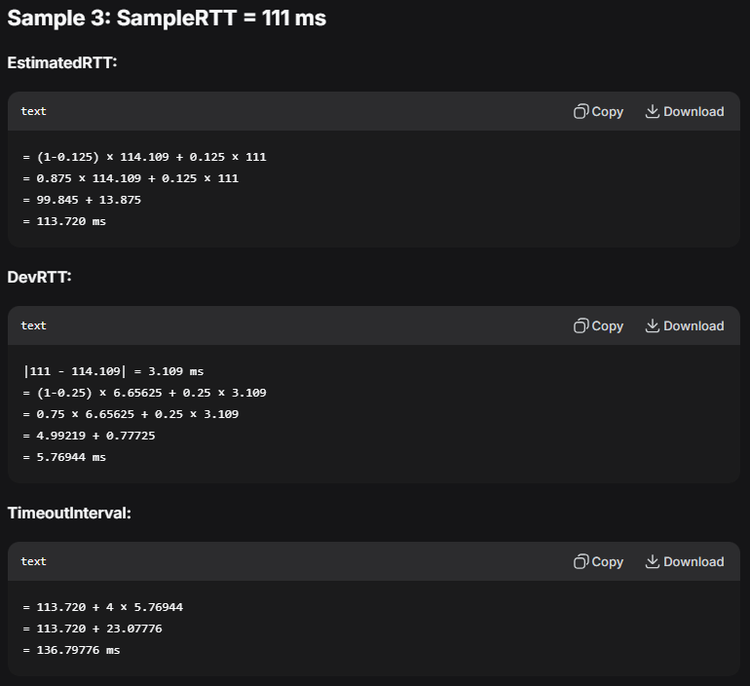

3.5.4 Reliable Data Transfer
The fundamental job of TCP is to take the Internet's inherently unreliable service (IP, where packets can be lost, corrupted, or reordered) and transform it into a reliable service.
This means that the data stream delivered to the application at the receiver is guaranteed to be uncorrupted, without gaps, without duplicates, and strictly in the correct order.
- Foundation: TCP uses the principles of rdt 3.0: sequence numbers, cumulative acknowledgments (ACKs), and timers.
- Simplified Timer Management: Unlike the theory where every segment has its own timer (which creates too much overhead), the standard TCP protocol uses only a single retransmission timer. This single timer is always associated with the oldest unacknowledged segment.
- SendBase: The TCP sender tracks the sequence number of the oldest unacknowledged byte using a state variable called $\text{SendBase}$. (Thus, SendBase is the last byte confirmed as received in order).
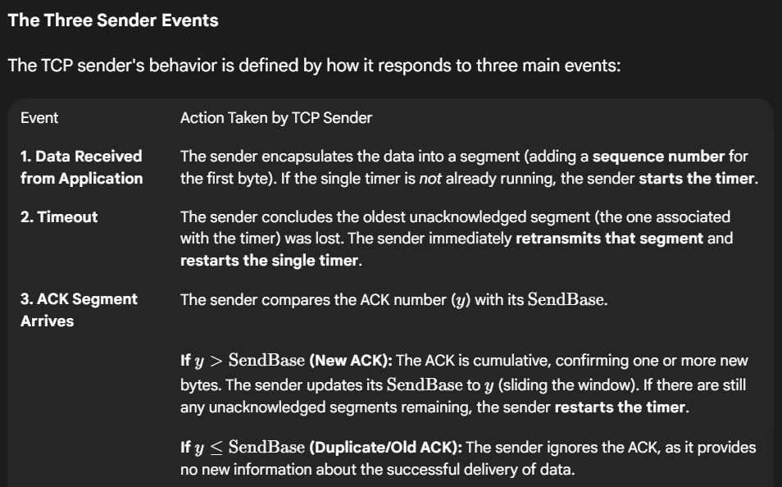
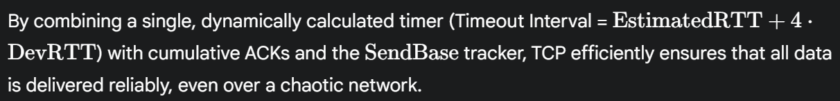
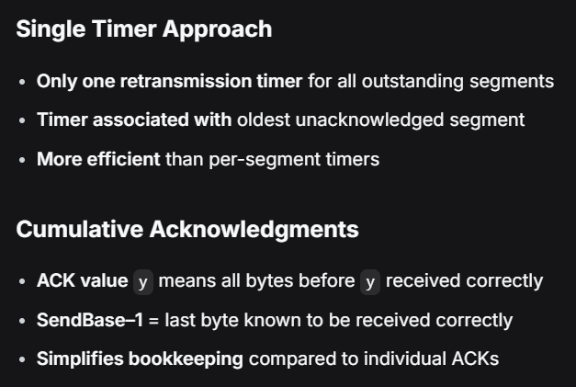
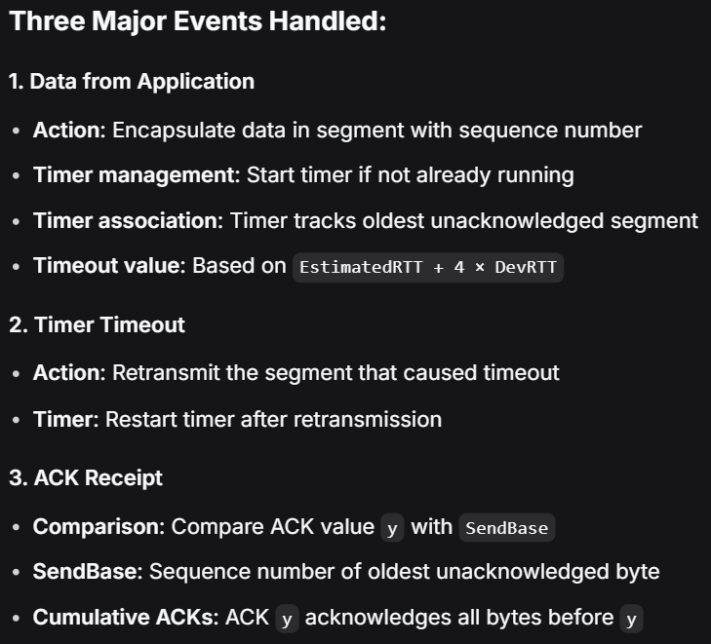
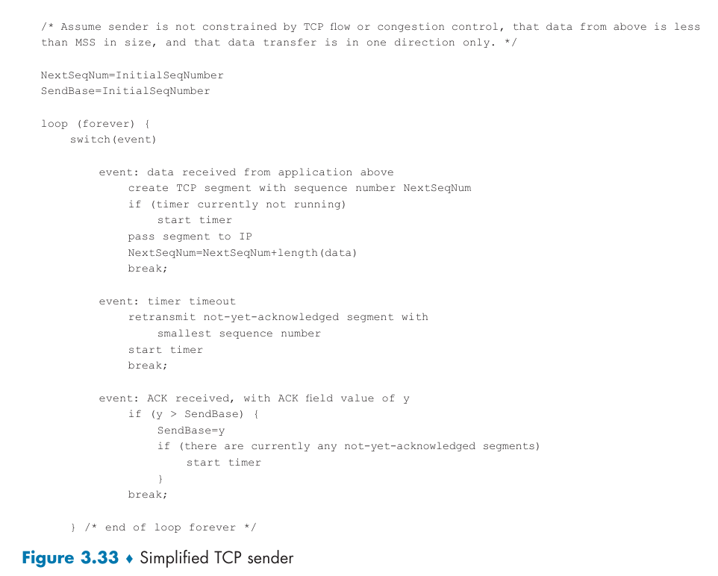

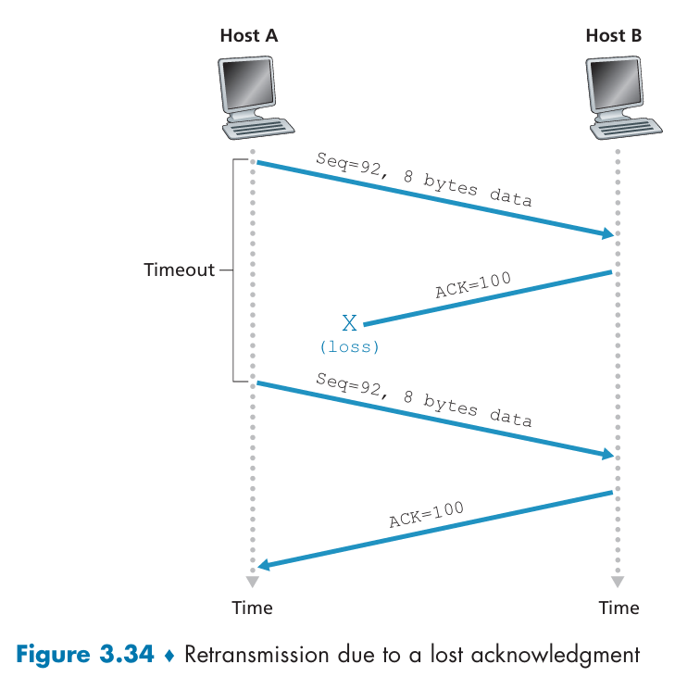

Doubling the Timeout Interval
The core rule for setting TCP's retransmission timer is to dynamically calculate the Timeout Interval using the $\text{EstimatedRTT}$ and $\text{DevRTT}$. However, when a segment is repeatedly lost, TCP overrides this calculation with a stricter, simpler rule known as Exponential Backoff.
The Exponential Backoff Rule
When a timeout event occurs, TCP takes two specific actions:
- Retransmit: TCP retransmits the oldest unacknowledged segment.
- Double the Timer: TCP sets the new Timeout Interval to twice the previous value. It ignores the EstimatedRTT and DevRTT calculation for this next retransmission attempt.
- Example: If the current Timeout Interval is 0.75 seconds, the first retransmission uses a 1.5-second timer. If that times out, the next retransmission uses a 3.0-second timer, and so on. The interval grows exponentially.
Why Double the Timer? (Congestion Control)
TCP uses this strategy because a timeout is a strong indicator of network congestion (router buffers overflowing and dropping segments).
- If the sender immediately retransmitted the segment at the original, short timeout, it would only worsen the existing congestion.
- By doubling the timeout interval after each failure, TCP "backs off" and acts more politely. It waits longer before trying again, giving the congested network time to clear its queues.
When the Timer Resets
The exponential backoff rule only applies after a timeout event.
- Whenever the timer is restarted due to a successful event (like receiving a new ACK or sending new data from the application), the Timeout Interval immediately reverts to the calculated value (EstimatedRTT + 4 * DevRTT).
This approach ensures TCP is aggressive when the network is clear but slows down gracefully when the network shows signs of overload.

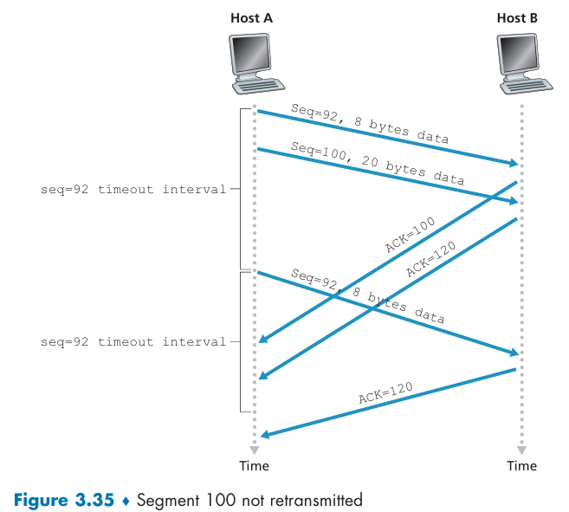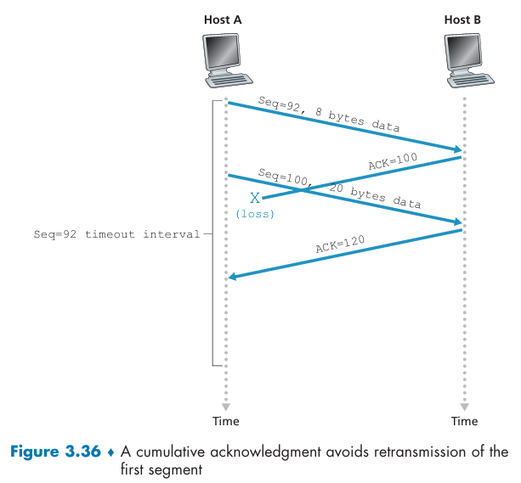

Fast Retransmit
TCP's crucial mechanism for recovering quickly from segment loss without having to wait for the lengthy timeout period.
The problem with relying solely on the timeout mechanism is that the Timeout Interval can be very long. If a segment is lost, waiting for the timer to expire significantly increases the delay. Fast Retransmit solves this by detecting lost segments early using Duplicate ACKs.
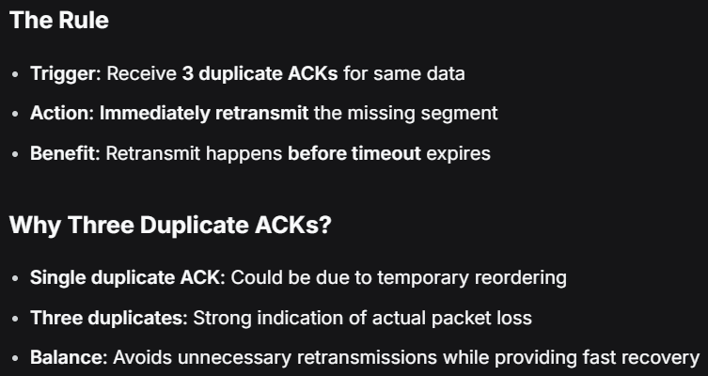
1. The Receiver's Role: Generating Duplicate ACKs
When a TCP receiver detects a gap in the byte stream (meaning a segment is missing or arrived out of order), it must alert the sender without violating the rule against sending Negative Acknowledgments (NAKs).
- The Trigger: A segment arrives with a sequence number larger than the next expected in-order sequence number.
- The Action: The receiver immediately generates a Duplicate ACK for the last in-order byte it successfully received. This ACK effectively tells the sender: "I am still waiting for byte $X$ (the missing one)."
2. The Sender's Role: The "Three Duplicate ACKs" Rule
Since the sender often sends data back-to-back, if one segment is lost, subsequent segments will arrive at the receiver out-of-order, causing the receiver to send multiple Duplicate ACKs.
- The Threshold: The TCP sender performs a Fast Retransmit when it receives three duplicate ACKs for the same data.
- The Rationale: Waiting for three Duplicate ACKs (not just one) minimizes the chance that the out-of-order arrival was due only to harmless segment reordering in the network, rather than an actual loss.
- The Action (Fast Retransmit): Upon receiving the third duplicate ACK, the sender retransmits the missing segment immediately—before the segment's timer has expired.
This mechanism allows TCP to achieve faster recovery from common segment losses, dramatically improving performance and reducing end-to-end delay.
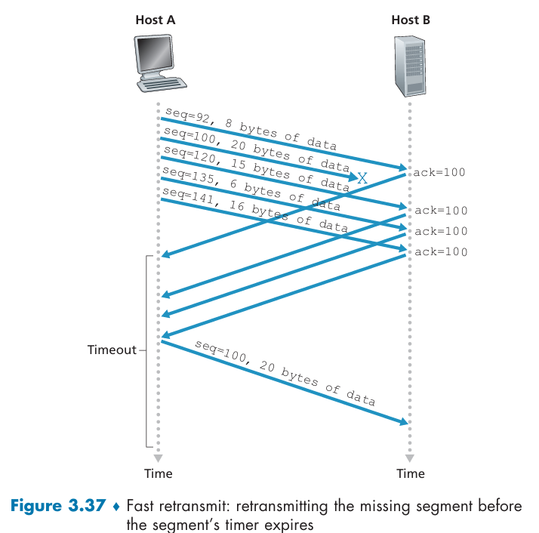

Go-Back-N or Selective Repeat?
TCP uses elements of both, making it a powerful hybrid protocol.
TCP's error recovery doesn't fit neatly into either the GBN or SR category. Instead, it combines the simplicity of GBN's acknowledgment system with the efficiency of SR's buffering.
1. The Go-Back-N (GBN) Side
TCP’s most fundamental mechanism resembles GBN:
- Cumulative ACKs: TCP only acknowledges bytes up to the first missing byte ($\text{SendBase}$). The receiver does not individually acknowledge out-of-order segments. If a packet is lost, the sender keeps receiving ACKs for the packet before the lost one.
- Simple State: The TCP sender's primary state variables are simple:
  - SendBase (the oldest unacknowledged byte).
  - NextSeqNum (the next byte to be sent).
This limited state is characteristic of the GBN sender.
2. The Selective Repeat (SR) Side
TCP’s key difference from GBN lies in how the receiver handles data:
- Out-of-Order Buffering: Unlike classic GBN, which immediately discards any out-of-order segment, the TCP receiver keeps (buffers) correctly received but out-of-order segments. This is a defining characteristic of SR, as it prevents unnecessary retransmissions.
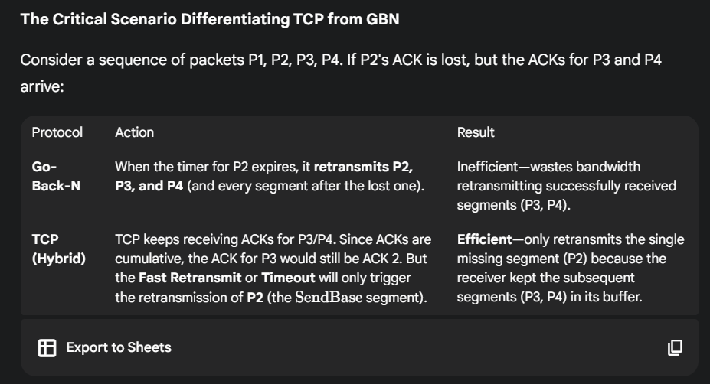

3.5.5 Flow Control
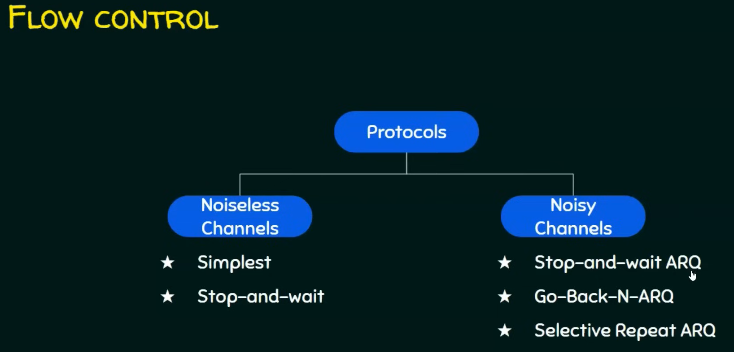
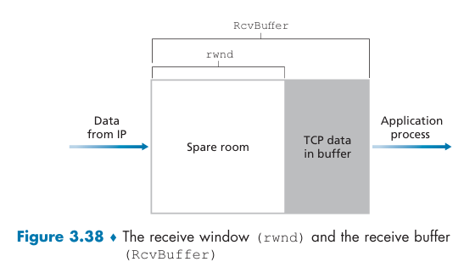
Flow Control is a service provided by TCP to prevent the sender from transmitting data faster than the receiving application can read it, which would cause the receiver's buffer to overflow and result in data loss.
If the buffer fills completely, any newly arriving data segments must be discarded, leading to unnecessary retransmissions.
- Crucial Distinction: Flow control addresses receiver buffer limits, whereas congestion control addresses limits (congestion) within the network itself.
The TCP connection places correctly received data into a receive buffer at the receiver. The receiving application process reads data from this buffer. If the sender's transmission rate is much faster than the application's reading rate, the buffer will fill up.
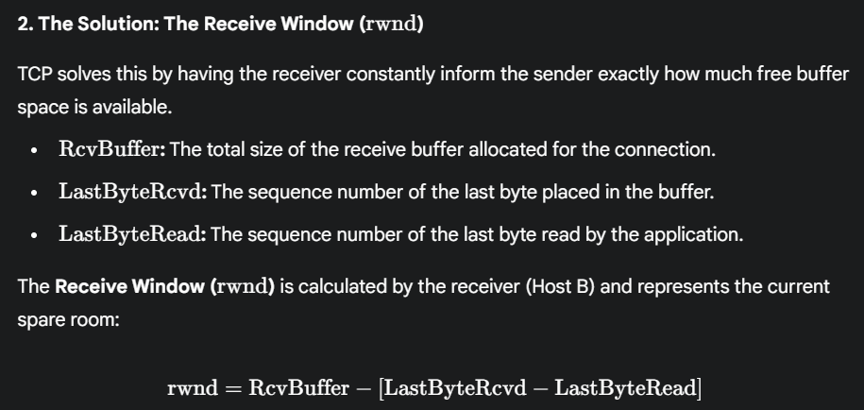
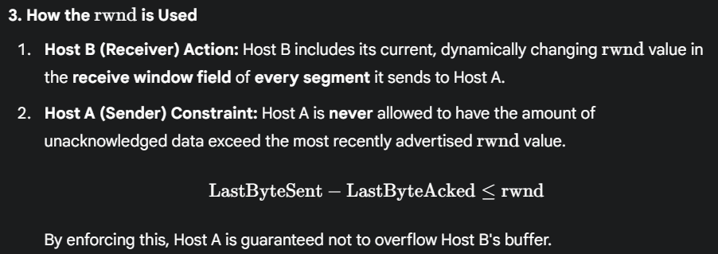
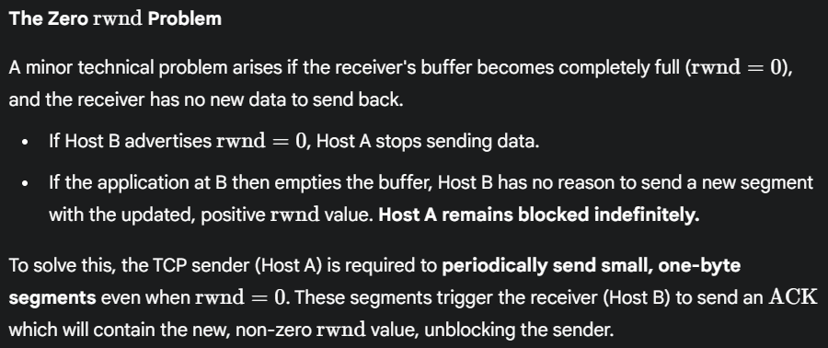
UDP Contrast: It is important to note that UDP does not provide flow control. If a UDP sender transmits data too fast, the receiver's buffer will simply overflow, and segments will be dropped.
This mechanism ensures TCP is a "speed-matching service" between applications.
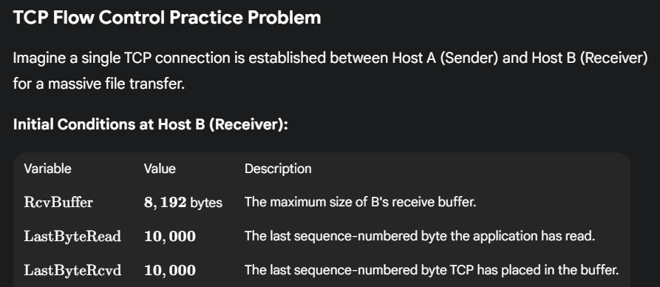
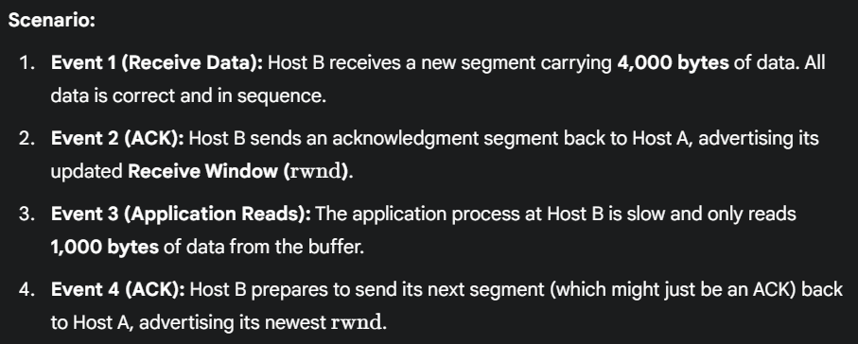
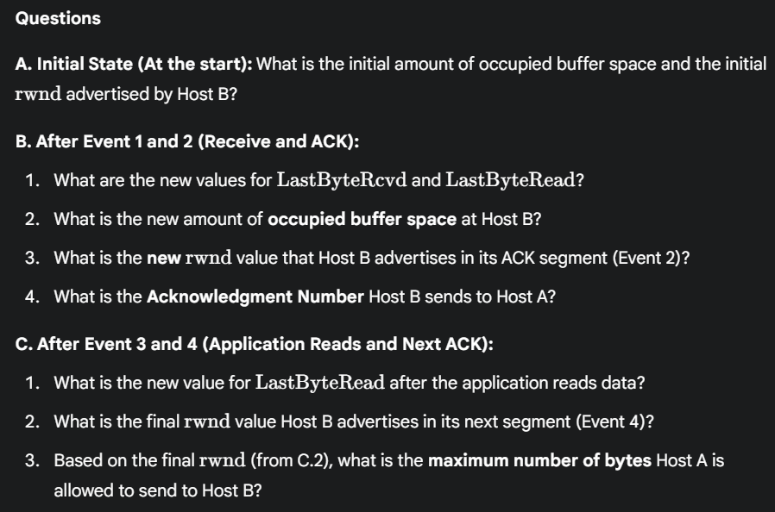
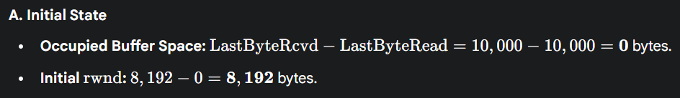
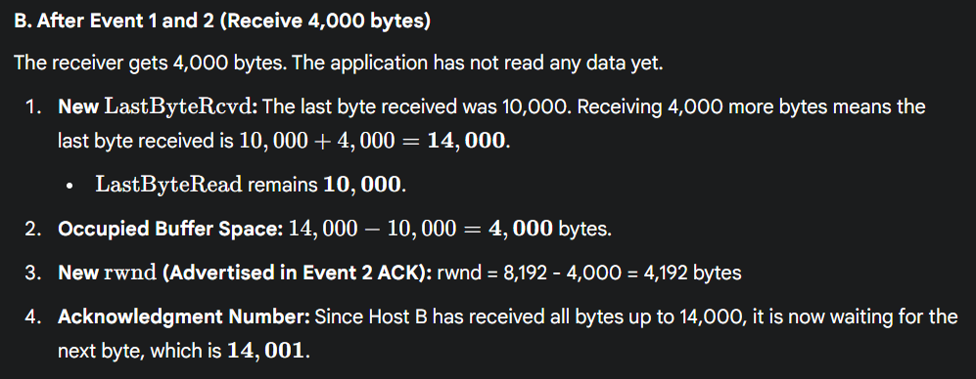
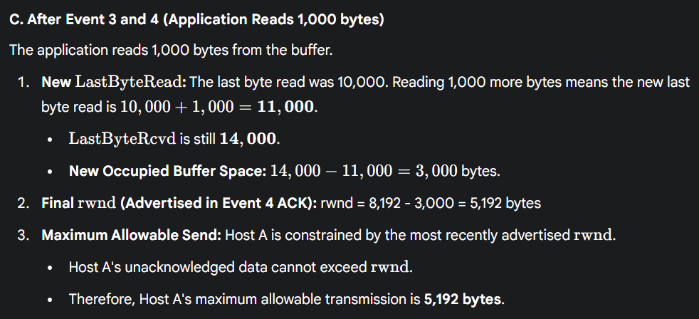

2-Way Handshake vs. 3-Way Handshake
The "handshake" is the process two network hosts use to establish an agreement on sequence numbers and connection parameters before data transfer begins.
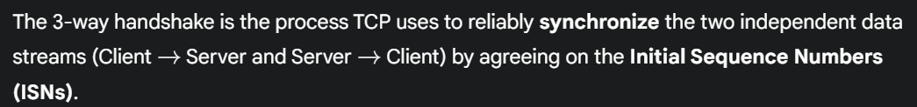
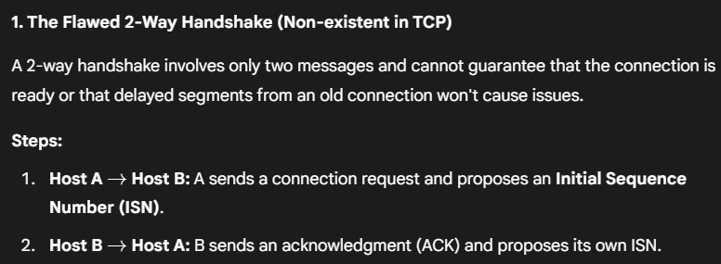
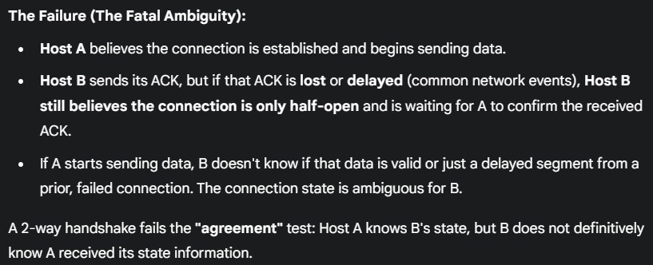
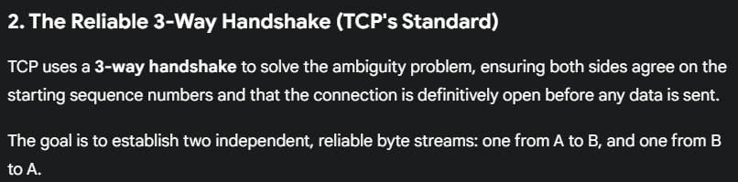
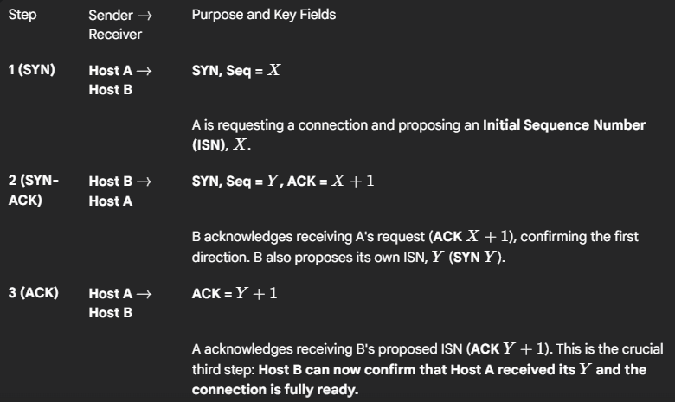
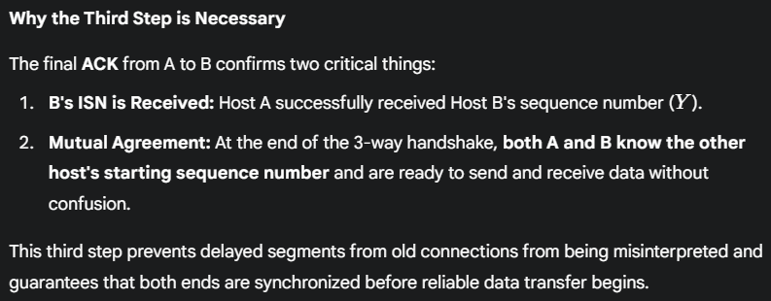
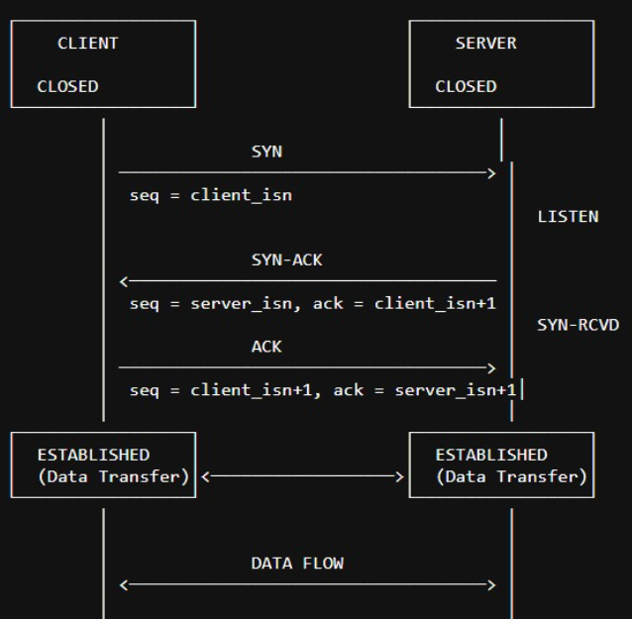
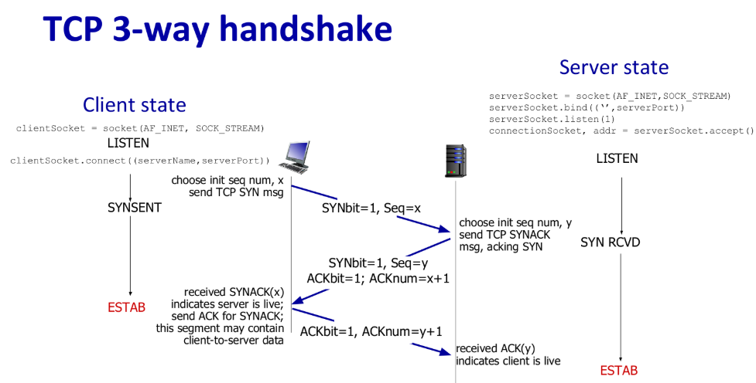
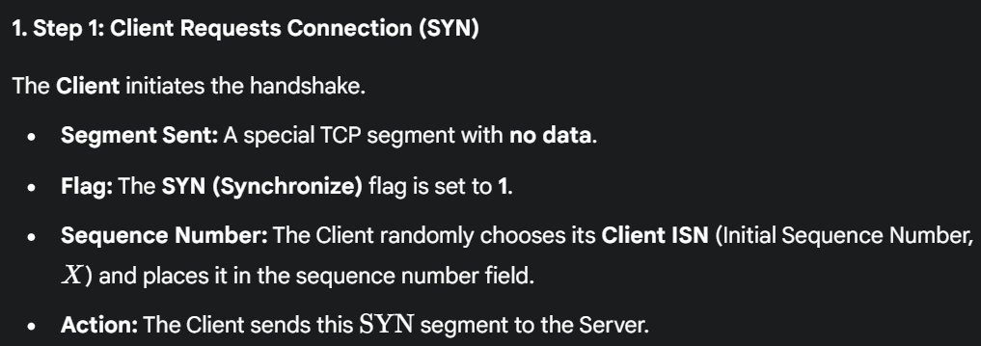
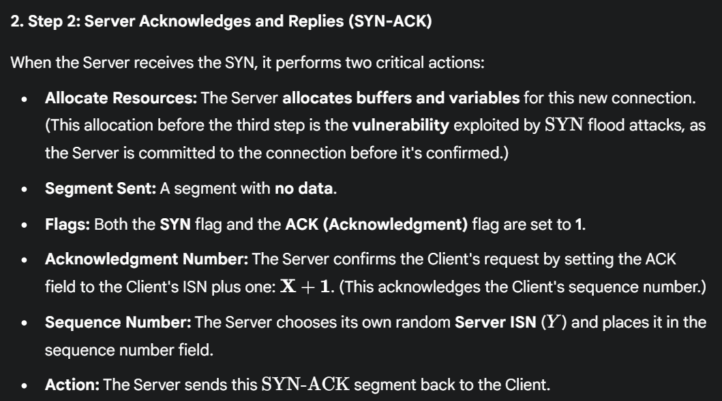
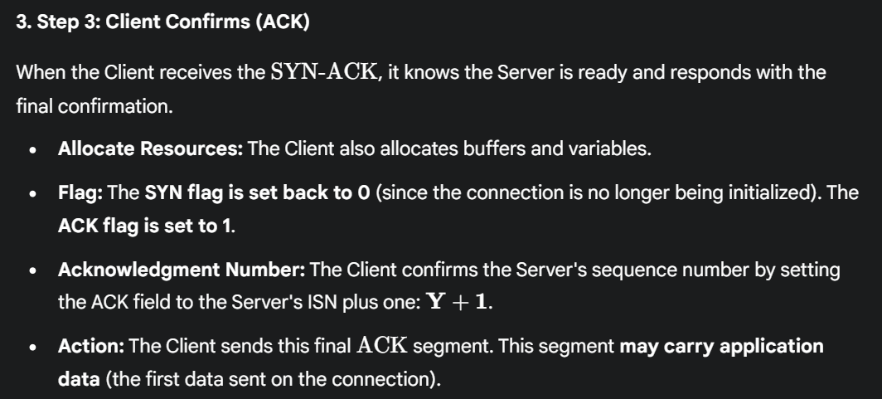

4-way Termination Handshake
TCP Connection Termination: (4 Way Handshake)
- 1st: Client: "I'm done sending data, but I can still receive"
- 2nd: Server says "OK, I got your FIN. I'll close my side soon, but let me finish sending any remaining data"
- 3rd: Server says "Now I'm also done sending data"
- 4th: Client says "Got your FIN, we're both done now!"
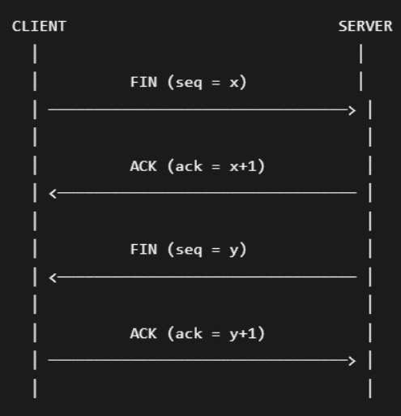
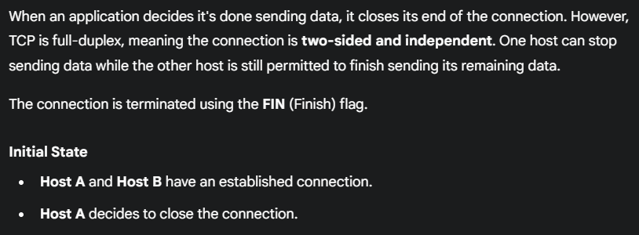
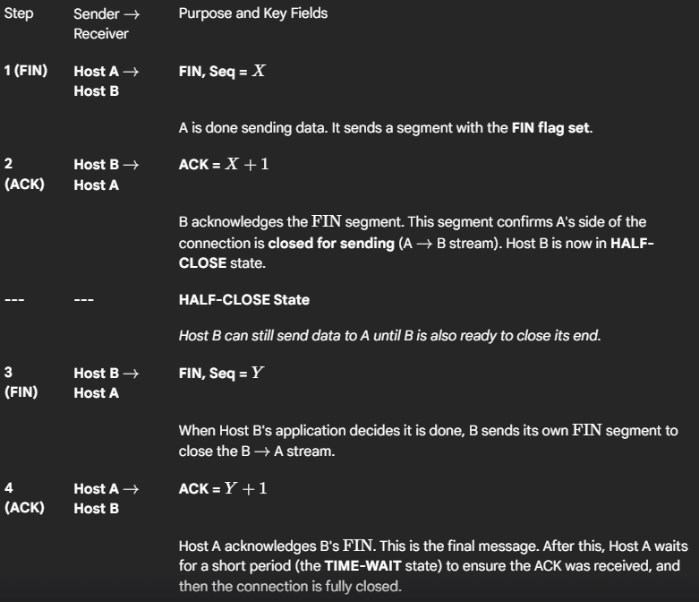
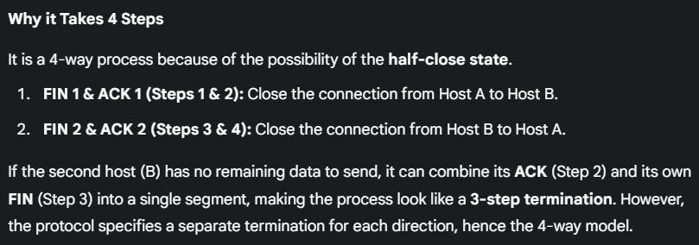
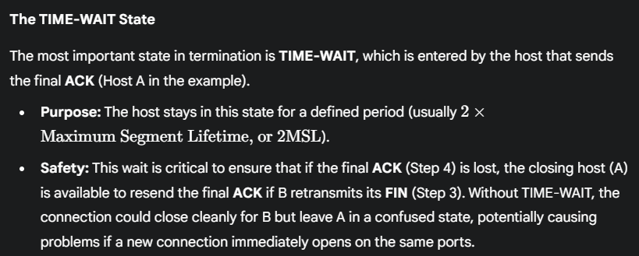
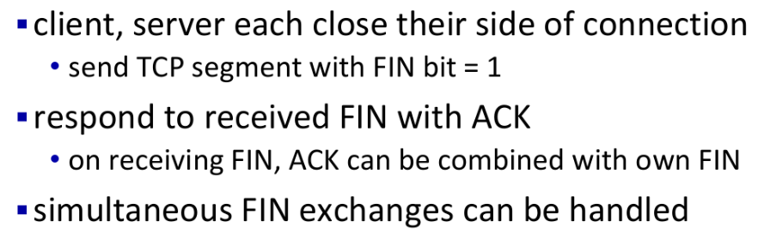

3.6 Principles of Congestion Control
- Reliability vs. Congestion: TCP's retransmission mechanism handles packet loss (a symptom), but it doesn't fix the root cause.
- The Root Cause: In a shared network, packet loss is typically caused by network congestion, where router buffers overflow because too many sources are sending data at too high a rate simultaneously.
- Vicious Cycle: If senders only react to loss by retransmitting immediately (without slowing down), they just add more data to the already congested network, making the problem worse (Exponential Backoff, which we previously discussed, is one small step to prevent this).

3.6.1 The Causes and the Costs of Congestion
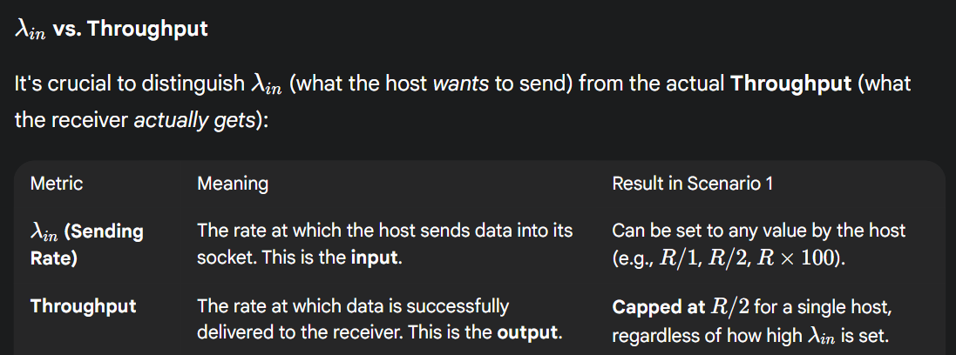

Scenario 1: Two Senders, a Router with Infinite Buffers
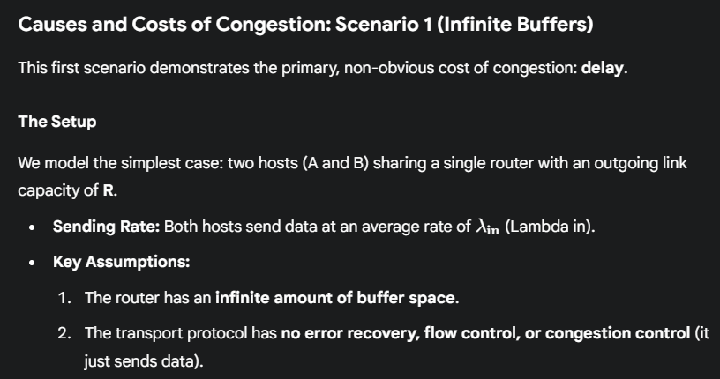
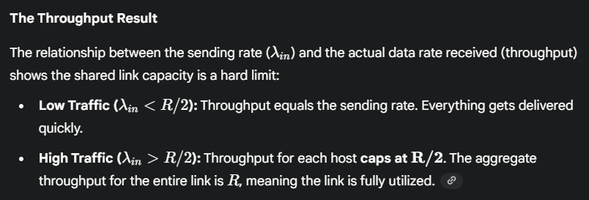
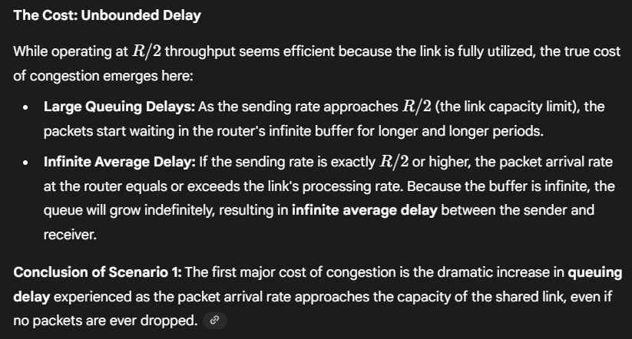
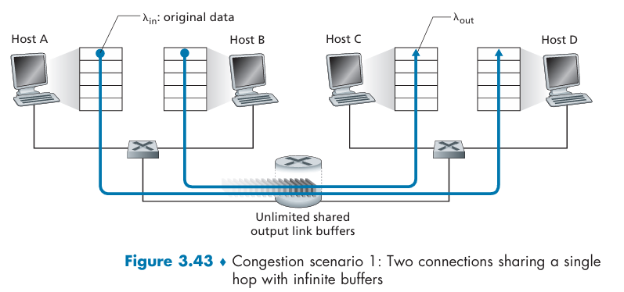
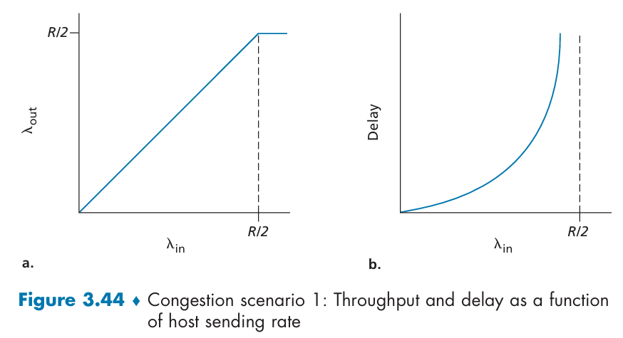
No matter how high Hosts A and B set their sending rates, they will each never see a throughput higher than R/2. Achieving a per-connection throughput of R/2 might actually appear to be a good thing, because the link is fully utilized in delivering packets to their destinations. The right-hand graph in Figure 3.44, however, shows the consequence of operating near link capacity. As the sending rate approaches R/2 (from the left), the average delay becomes larger and larger. When the sending rate exceeds R/2, the average number of queued packets in the router is unbounded, and the average delay between source and destination becomes infinite
Large queueing delays are experienced as the packet-arrival rate nears the link capacity.

Scenario 2: Two Senders and a Router with Finite Buffers
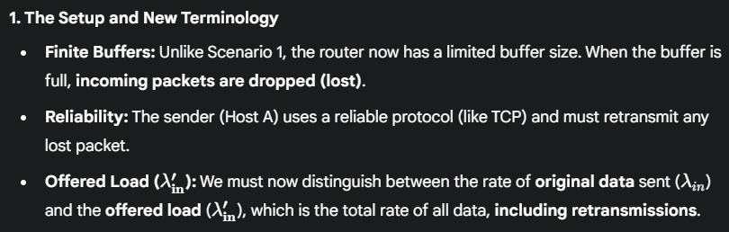
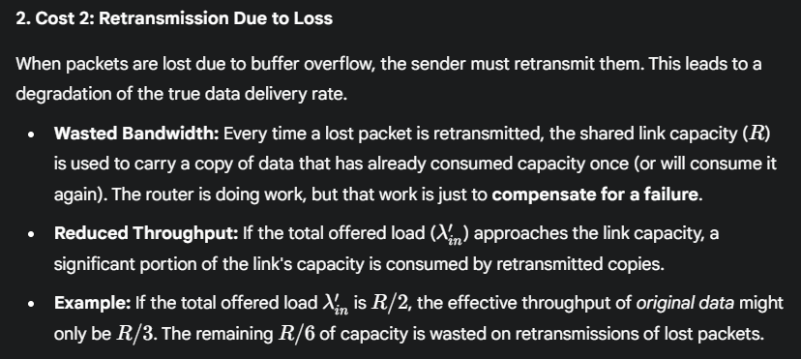
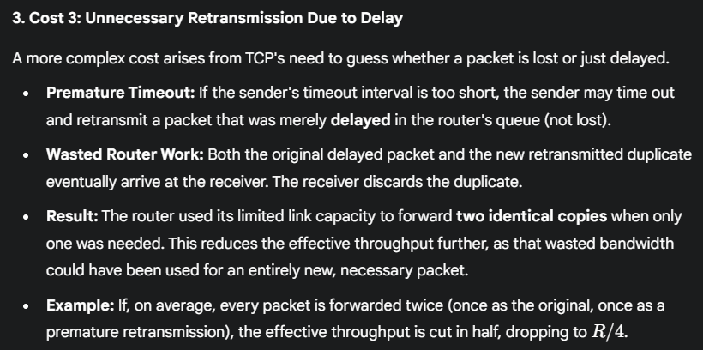
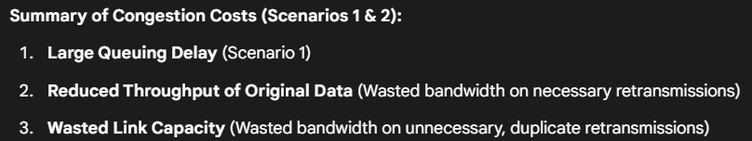
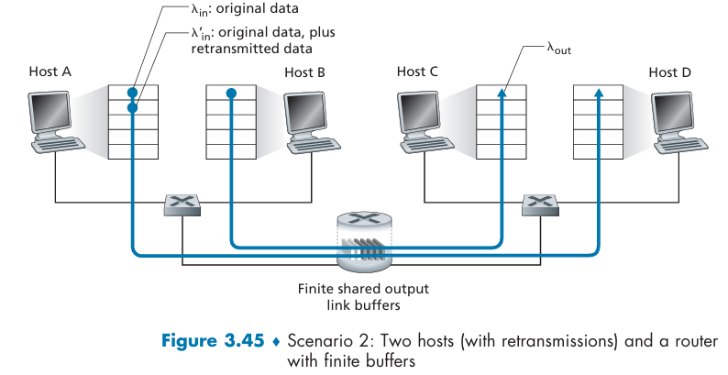
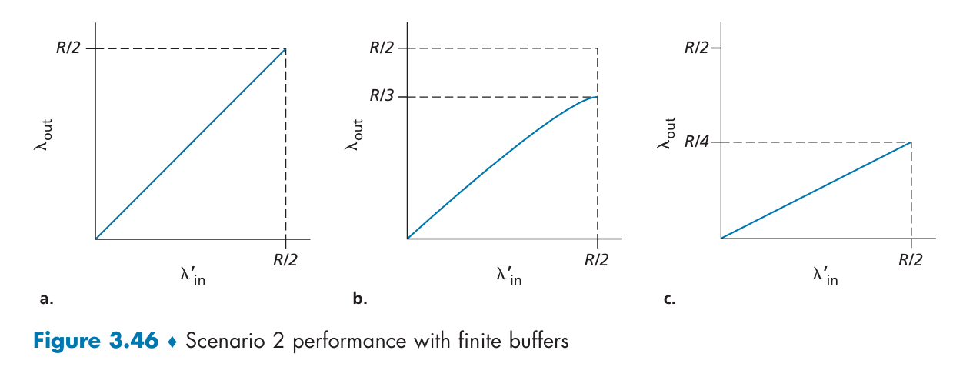
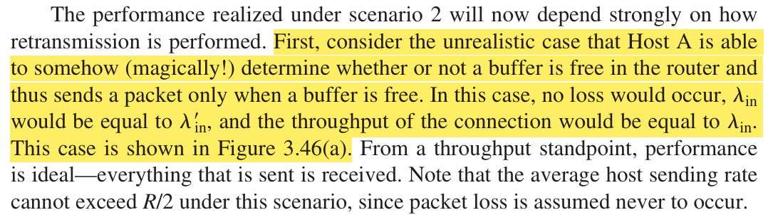
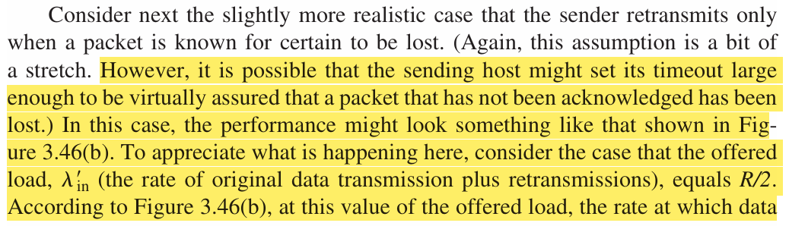
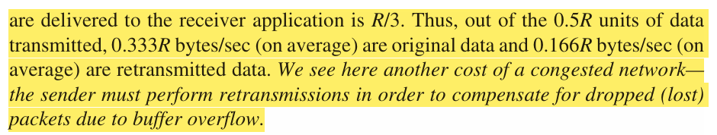
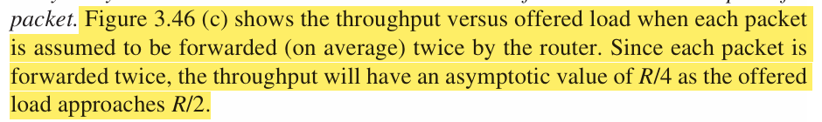

Scenario 3: Four Senders, Routers with Finite Buffers, and Multihop Paths
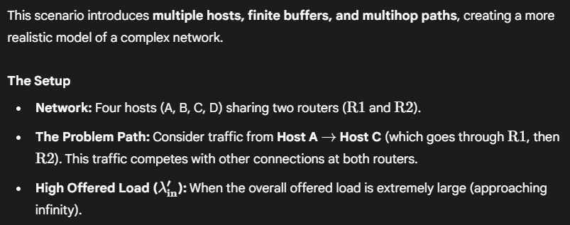
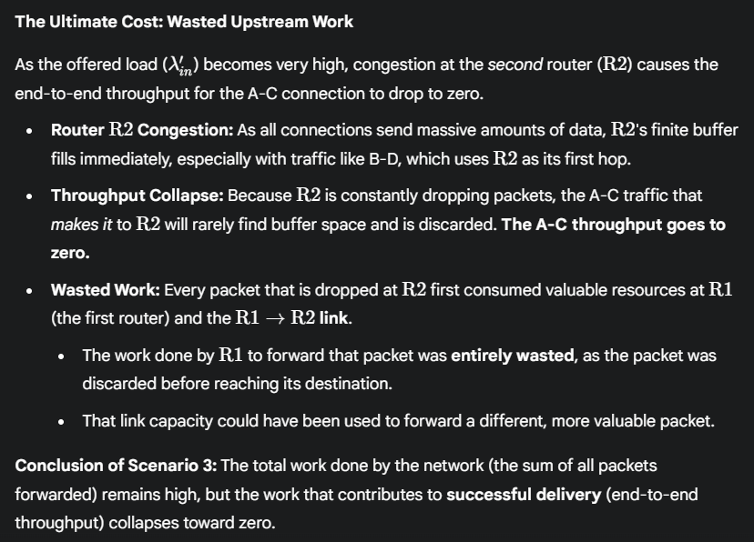

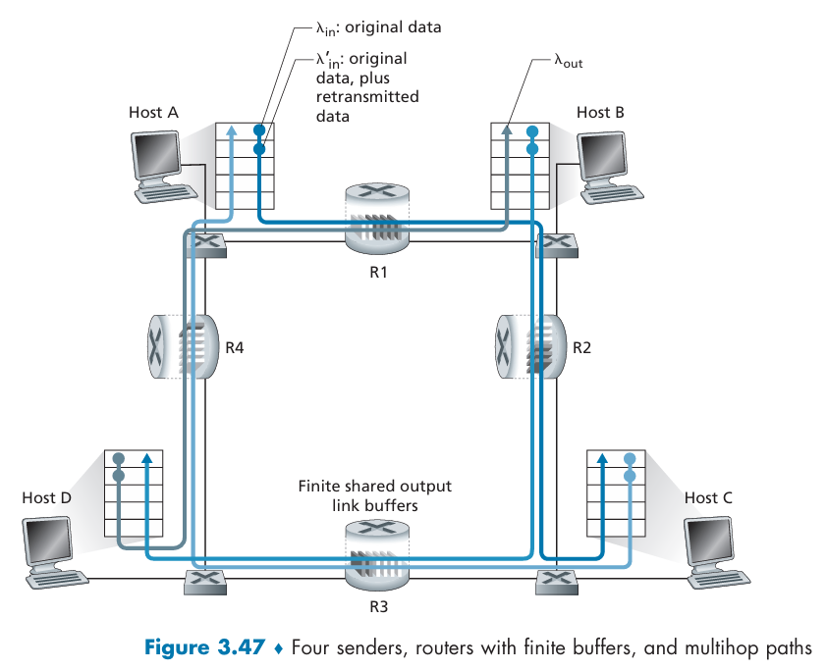
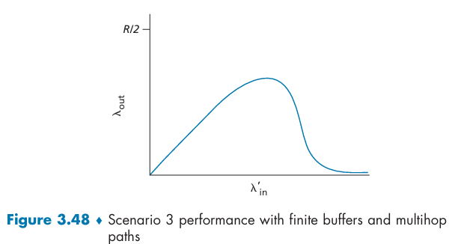
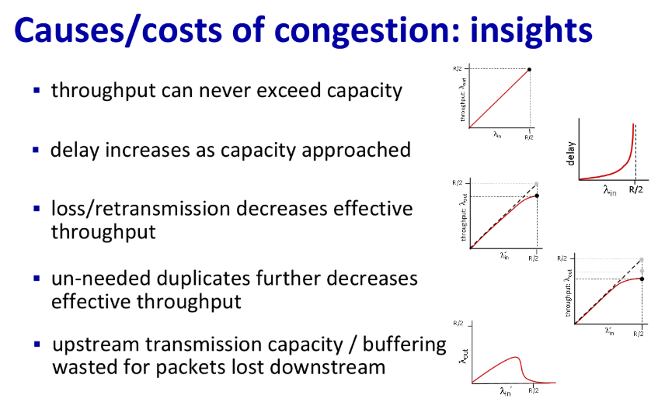
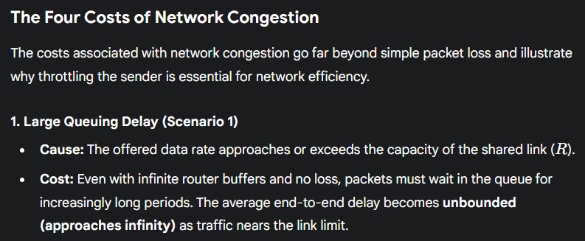
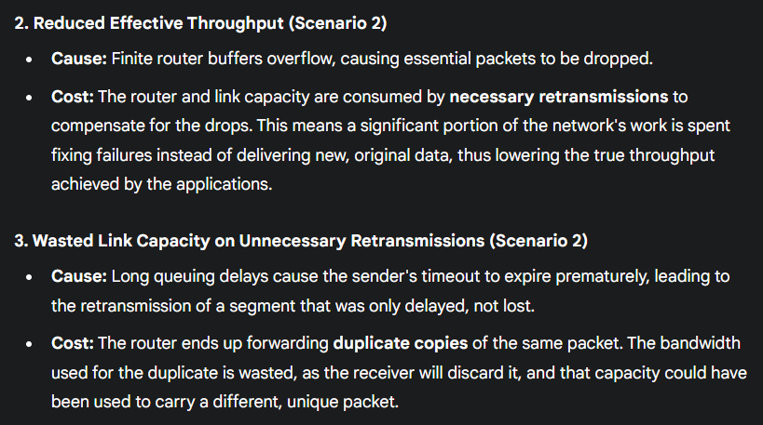
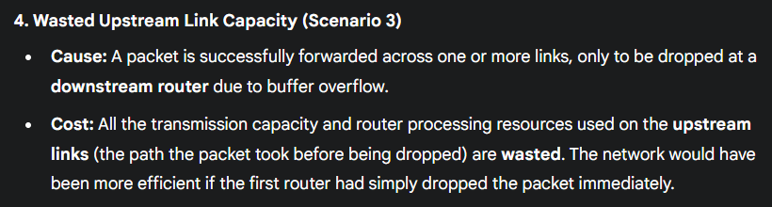

3.6.2 Approaches to Congestion Control
Congestion control mechanisms fall into two main categories, distinguished by how much help the network routers provide to the end hosts.
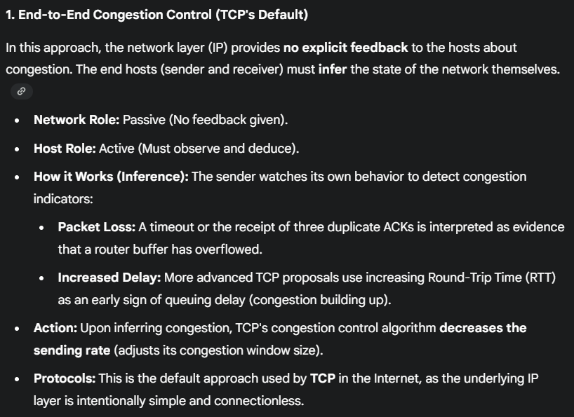
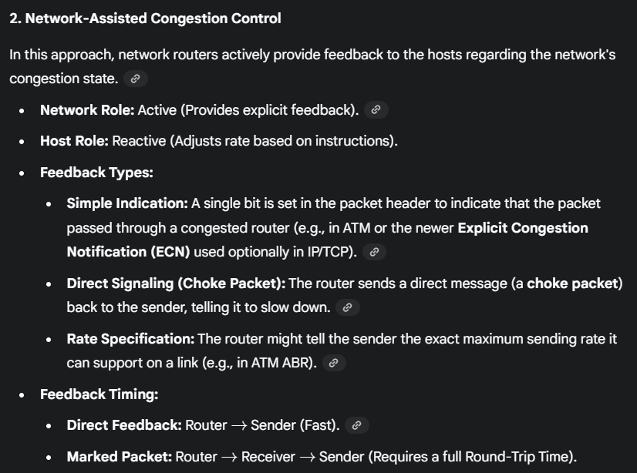
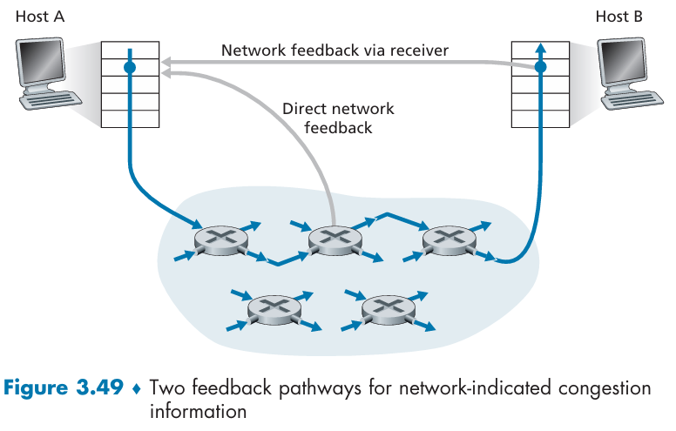

3.7 TCP Congestion Control
Classic TCP uses an end-to-end approach, meaning it must infer the network's state without explicit help from routers. The entire system is built on adjusting the Congestion Window (cwnd).
cwnd stands for congestion window, a sender-side limit in the TCP protocol that determines the amount of data that can be sent before waiting for an acknowledgment, in order to prevent network congestion. It is a dynamic value that is adjusted based on the network's capacity, unlike the receiver window, which is for the receiver's buffer and is advertised in the TCP header.

3.7.1 Classic TCP Congestion Control
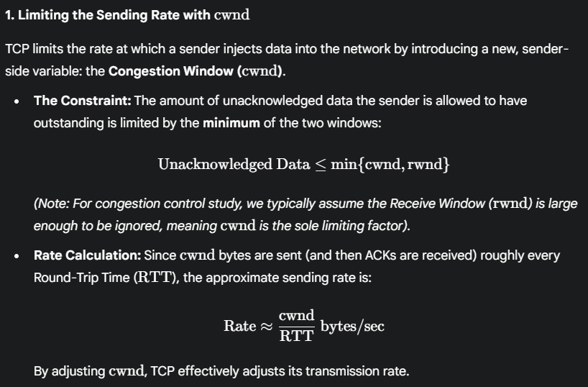
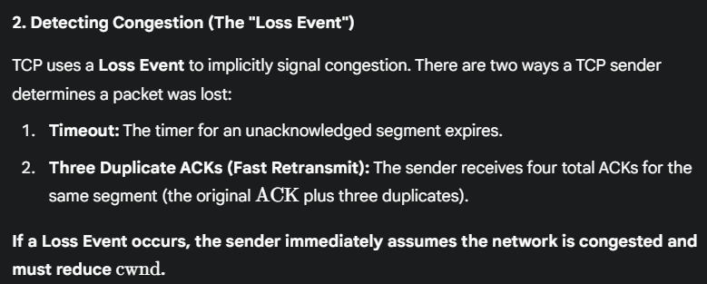
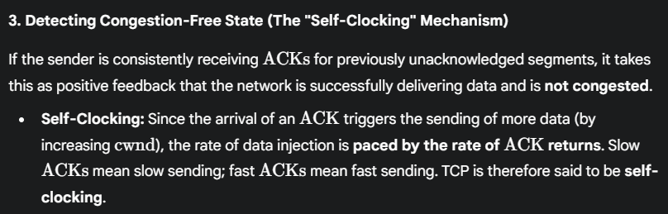
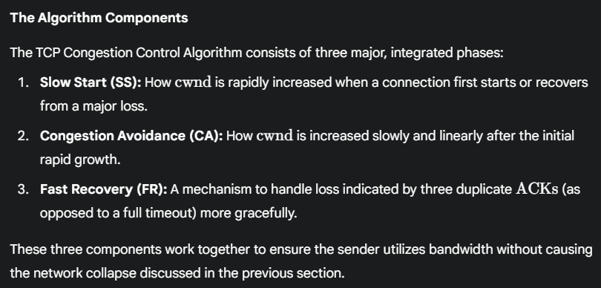

Slow Start
The primary mechanism for rate control is the Congestion Window (cwnd). Slow Start is the state where the sender rapidly increases cwnd until it hits a pre-defined threshold or encounters the first sign of congestion.
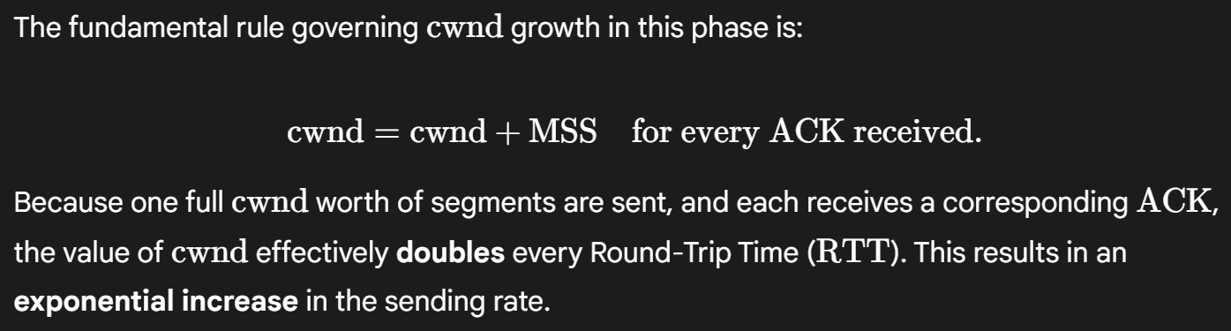
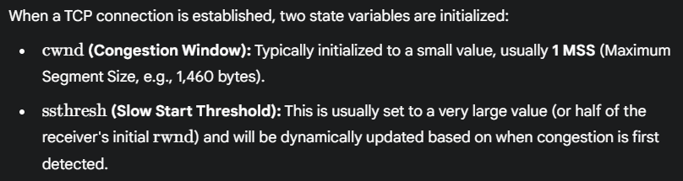
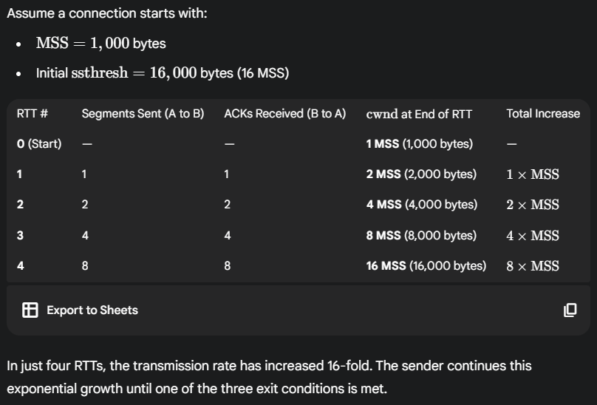
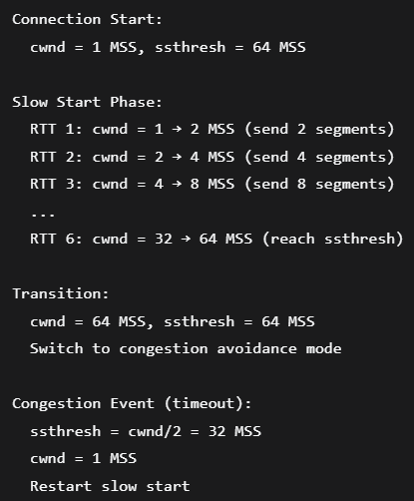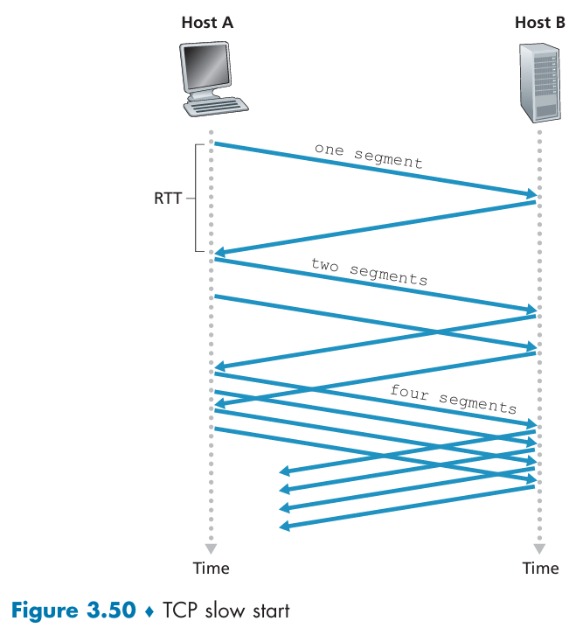
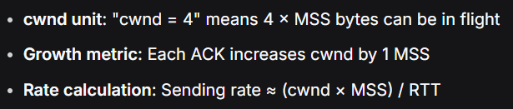
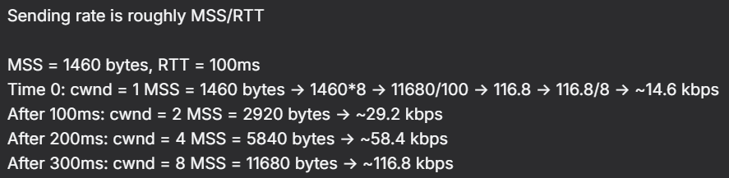
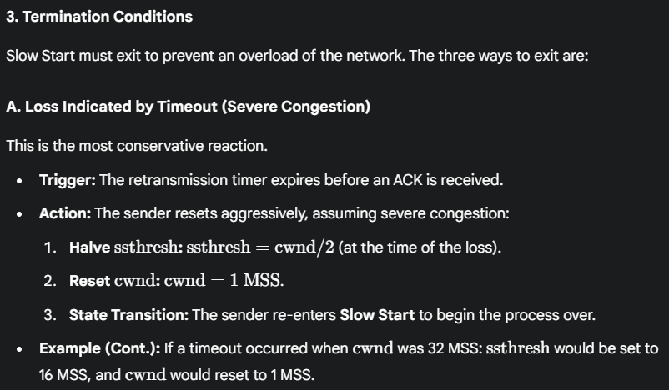
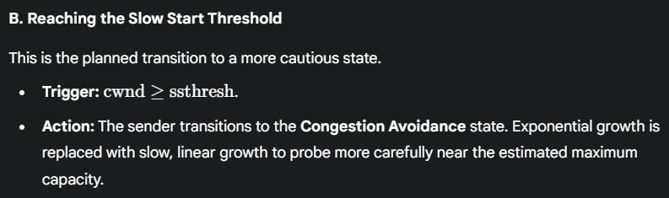
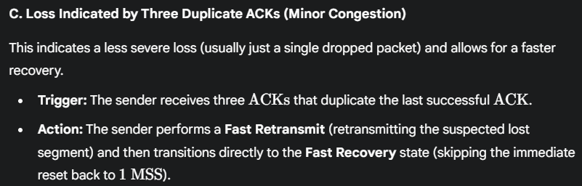

Congestion Avoidance
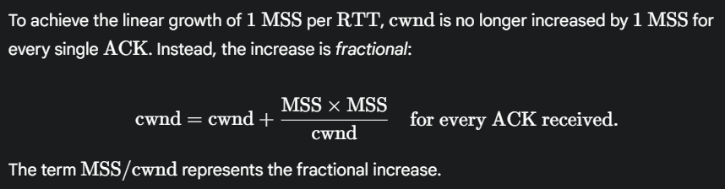
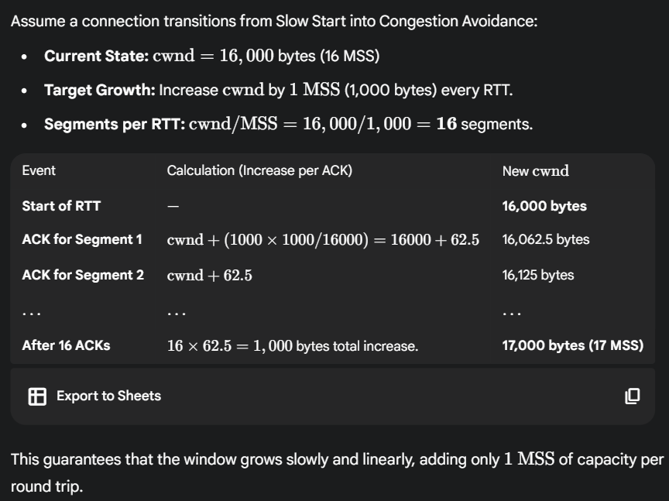
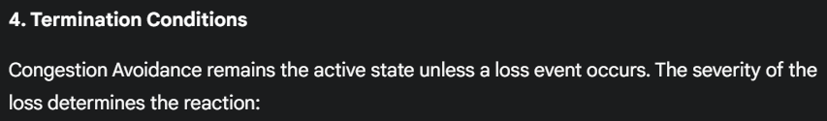
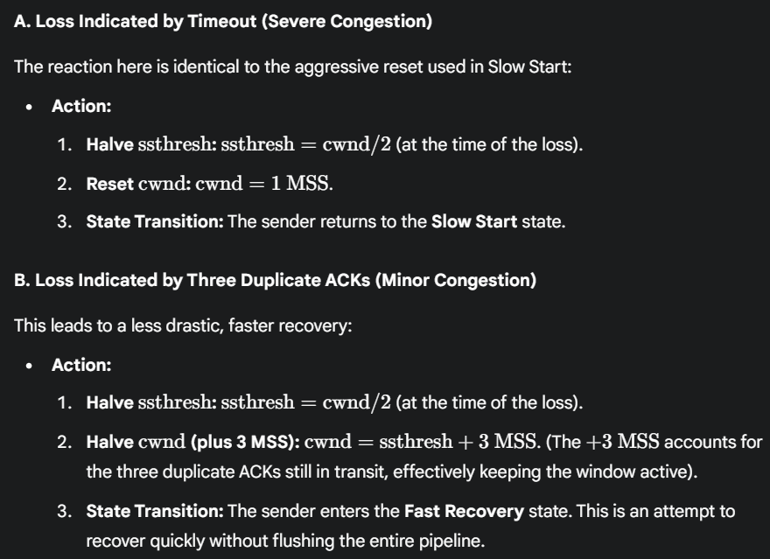
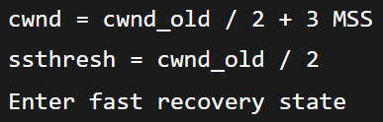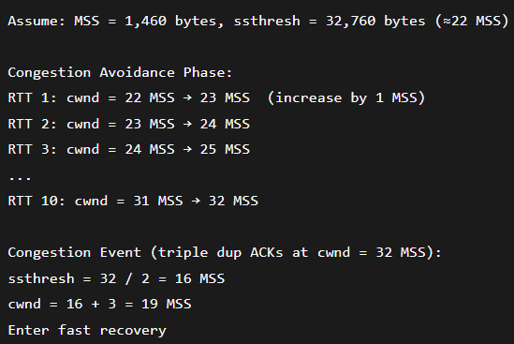

Fast Recovery
Fast Recovery is the state entered when congestion is detected via three duplicate ACKs, which is considered less severe than a full timeout. The presence of duplicate ACKs proves that some segments are still reaching the receiver, meaning the network isn't completely saturated.
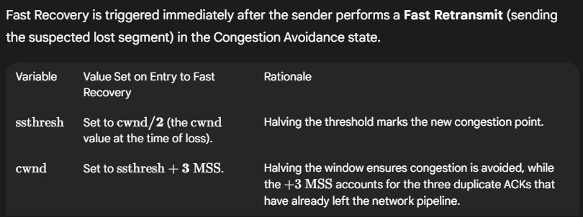
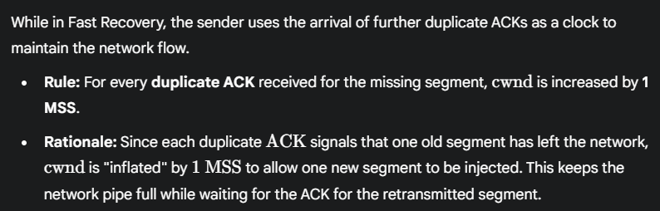
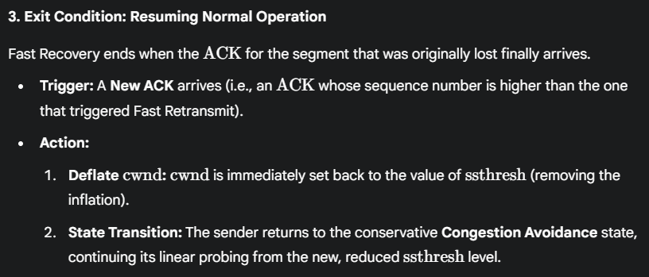
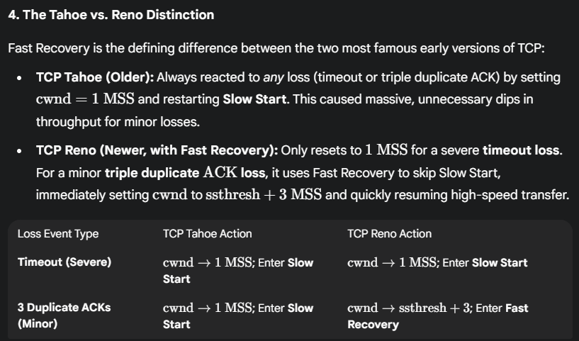
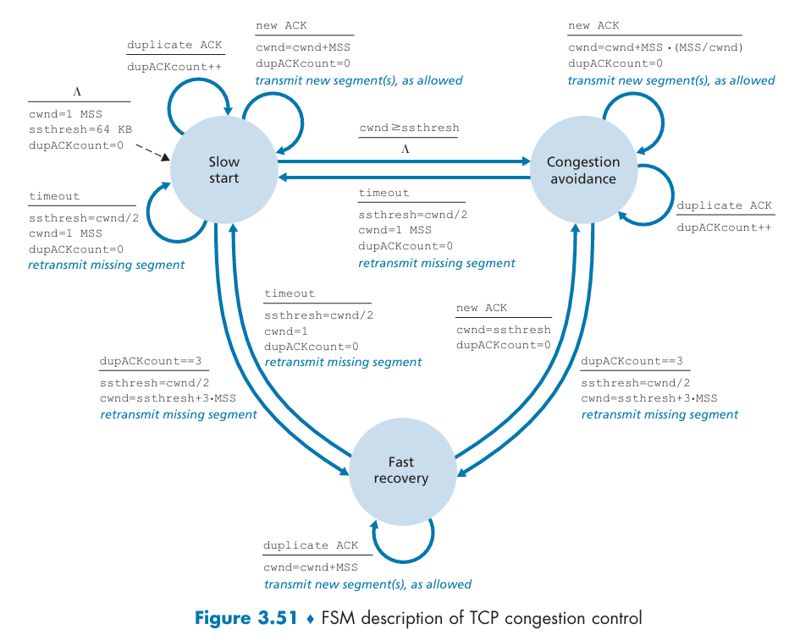

TCP Congestion Control: Retrospective
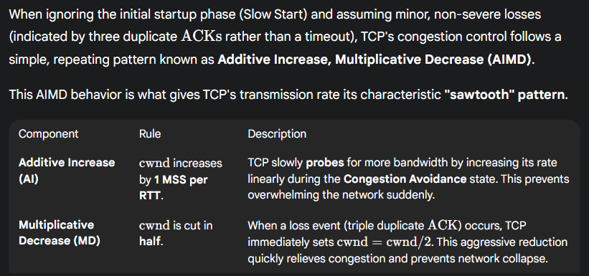
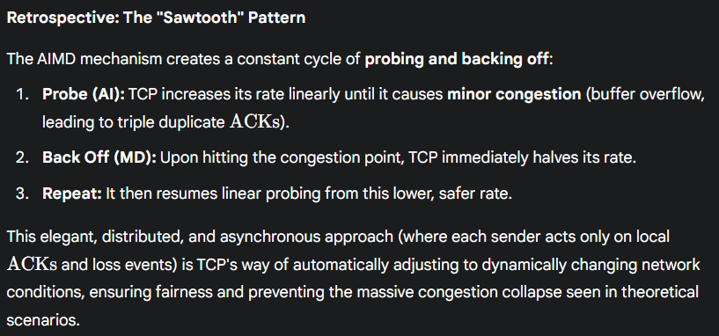
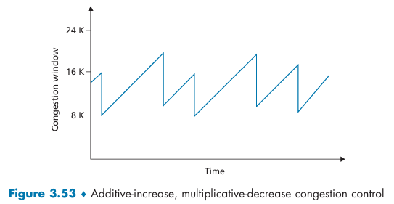

TCP Cubic
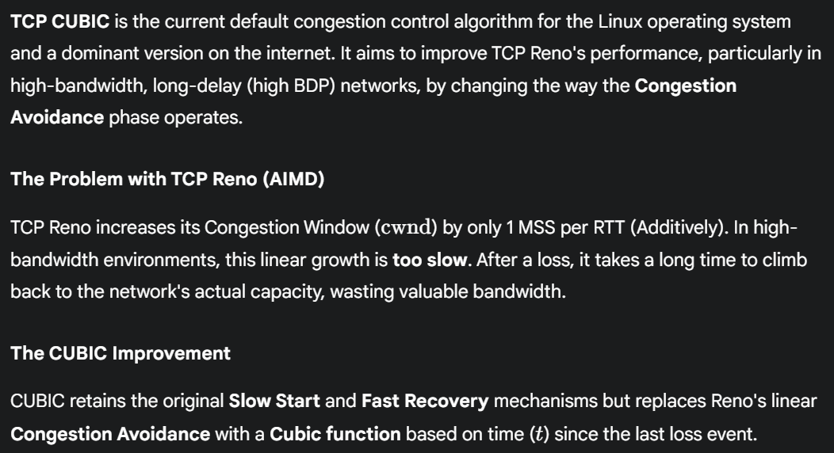
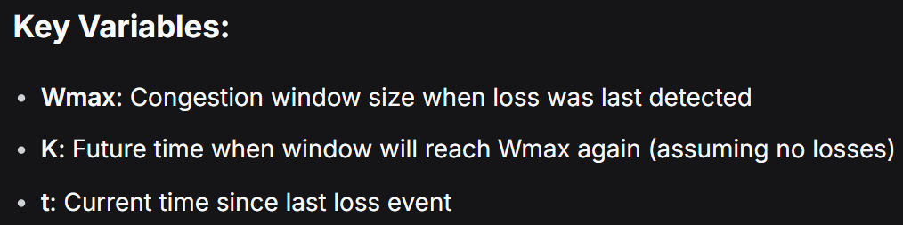
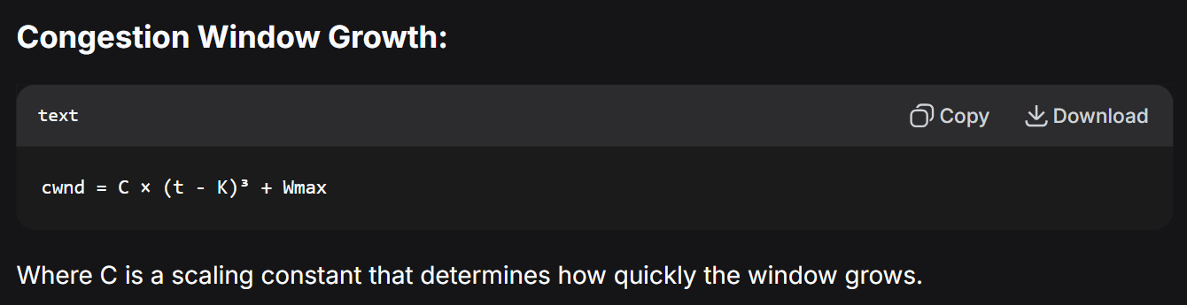
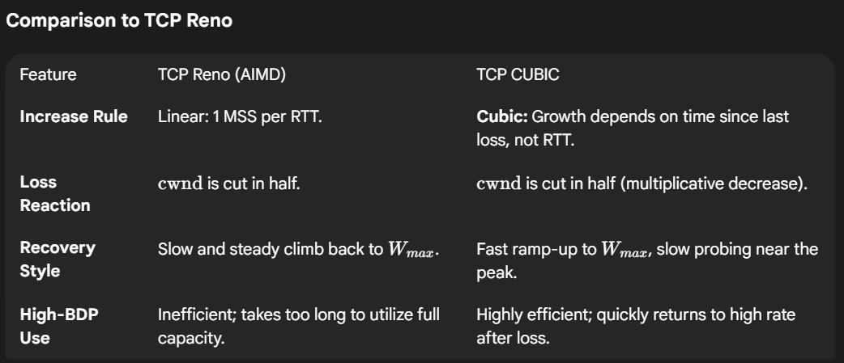
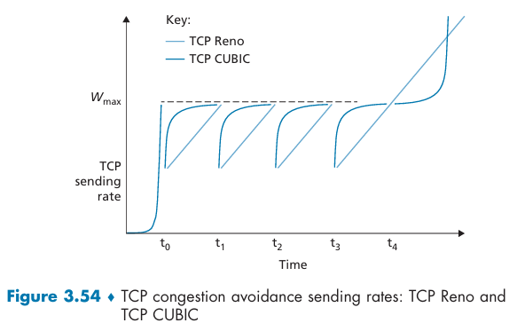
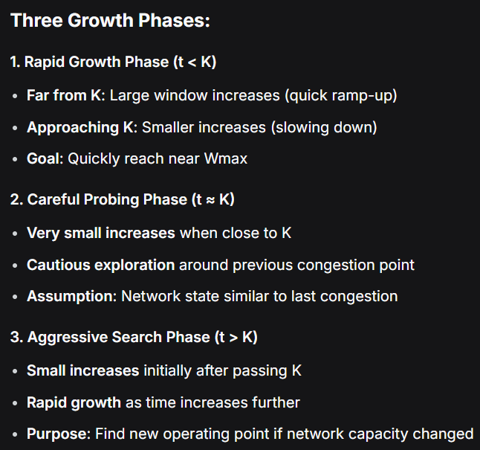

Macroscopic Description of TCP Reno Throughput
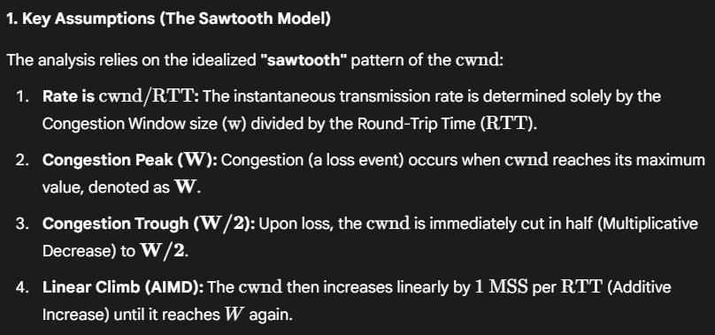
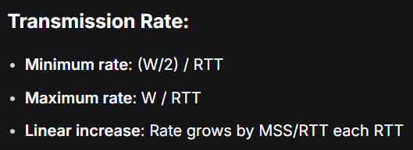
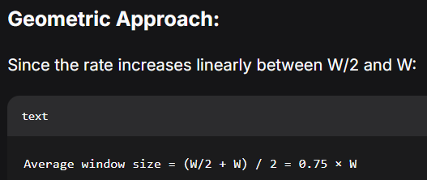
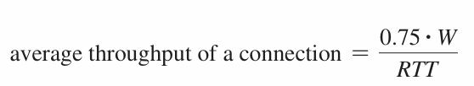
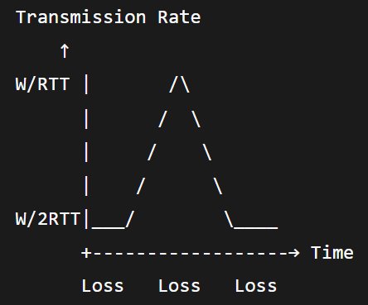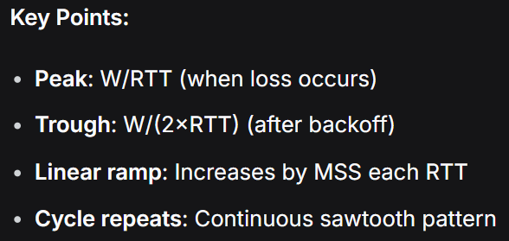

3.7.2 Network-Assisted Explicit Congestion Notification and Delayed-based Congestion Control

Explicit Congestion Notification
While classic TCP relies on the end hosts to infer congestion (by observing loss), newer extensions allow the network to explicitly signal congestion, leading to more efficient performance.
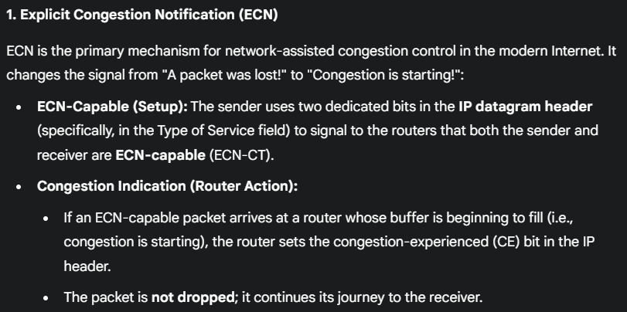
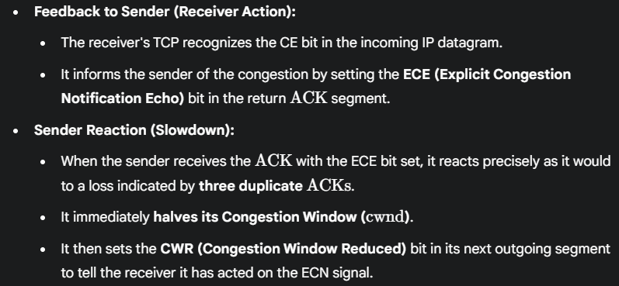
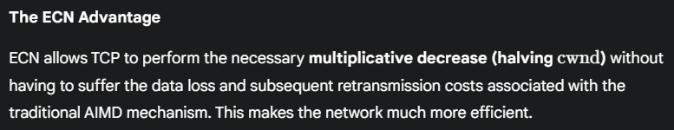
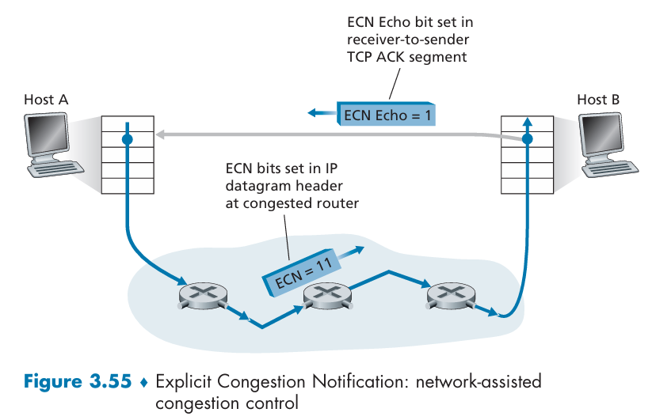

Delay-based Congestion Control
The core idea of delay-based protocols is to avoid the cost of packet loss entirely by detecting the onset of congestion before the router buffers become full and overflow. They achieve this by constantly monitoring queuing delays.
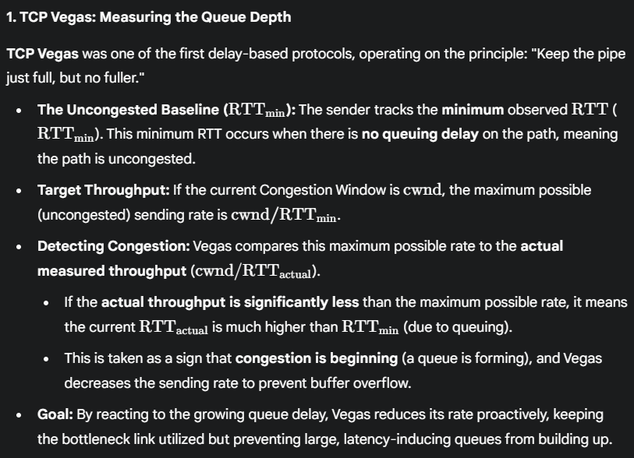
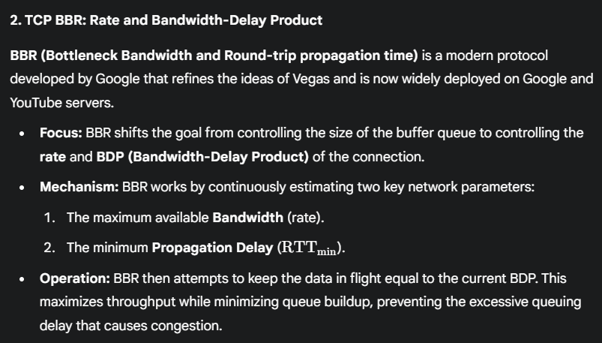
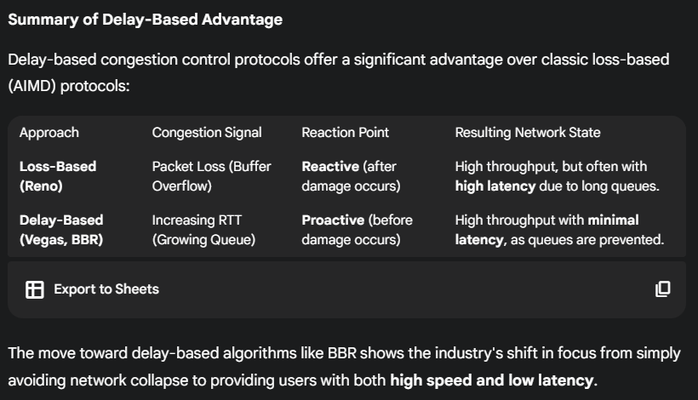

3.7.3 Fairness
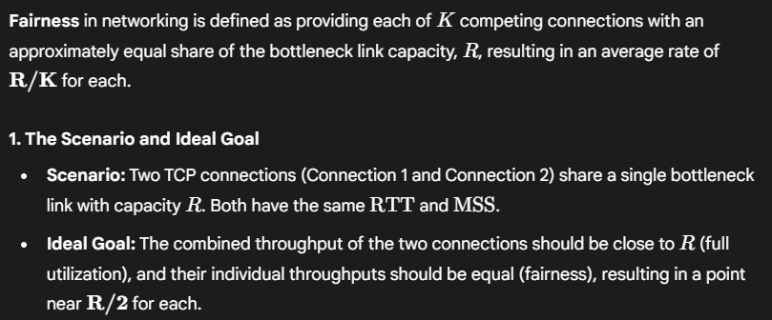
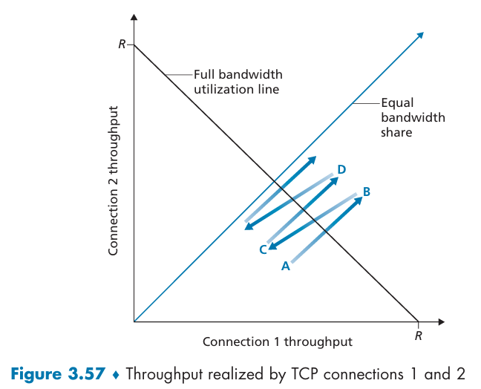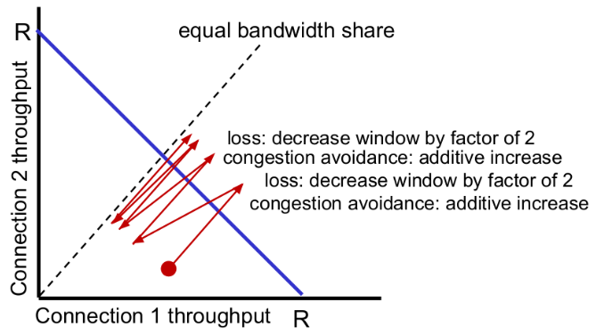

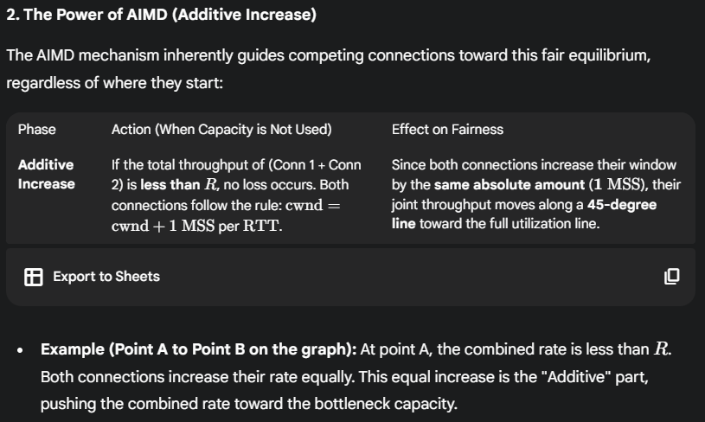
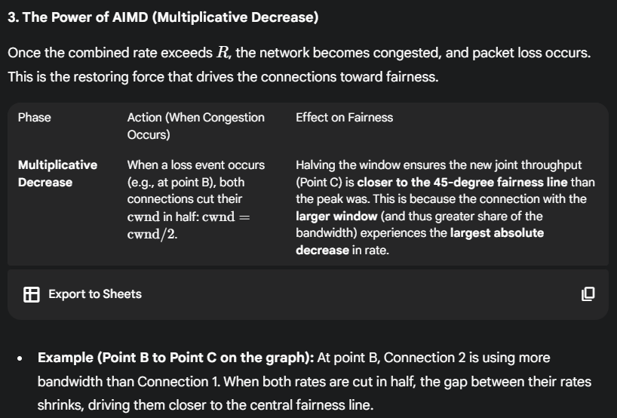
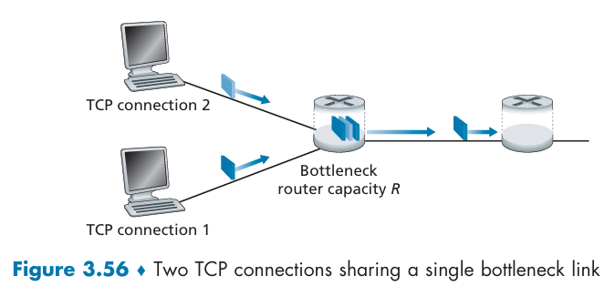
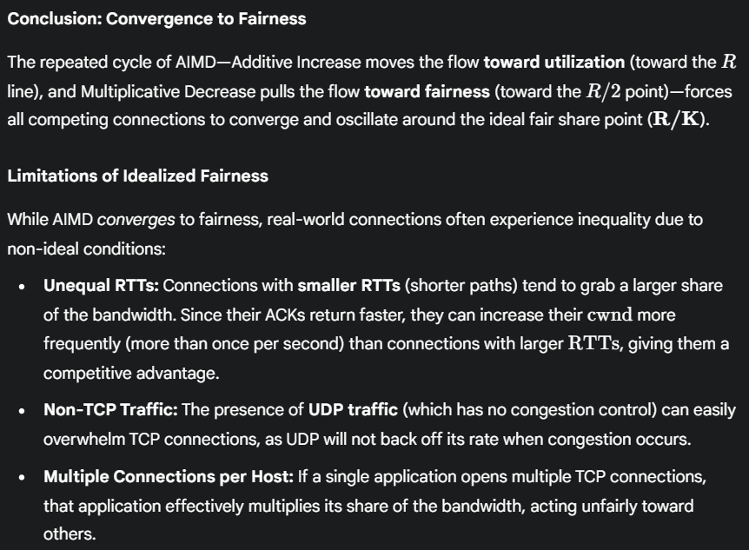

Causes of TCP Unfairness
While TCP's AIMD algorithm theoretically ensures fair sharing of a bottleneck link, two common real-world scenarios violate this principle, leading to some applications hoarding bandwidth at the expense of others.
